St. Catherine’s are supporting CAFOD during Lent 2021
St Catherine’s are supporting CAFOD’s Lent Walk for Water campaign through the Family Fast Day Gift Envelopes and a sponsored walk.
The walk can take place any day during Lent so we decided to hold our event now our new half term has started.
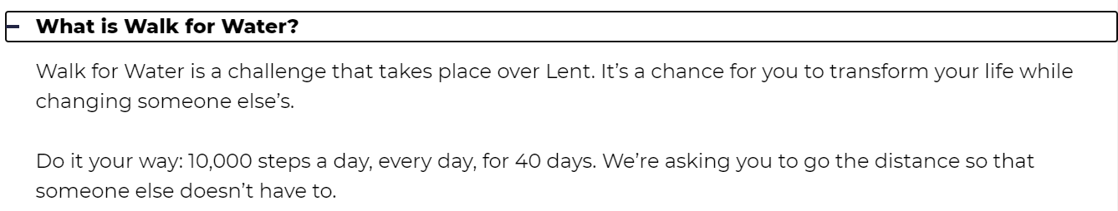
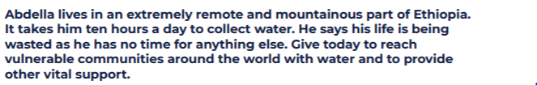

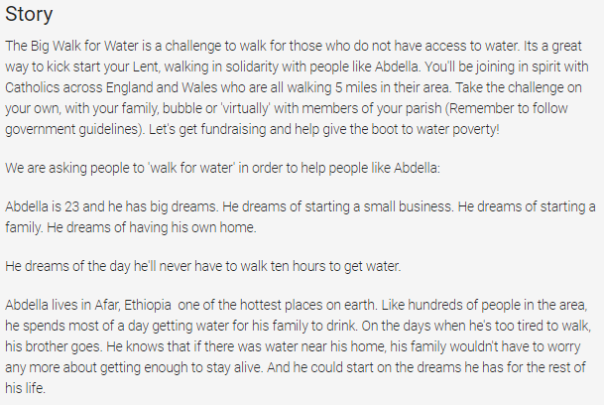

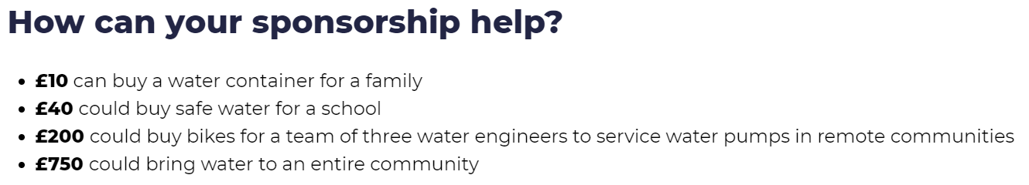

This is what we have decided to do with the children, share the load between the 1st – 12th March.
Your child will be walking between 1000 and 3000 steps each week during the weeks of the 1st March and the 8th March. You can decide if you want to do this at home with your child or wait for them to return and do their share at school.
We are sending home a sponsorship form and we would like you to do 2 things please:
* For any walks completed by children at home, please let us know by Tuesday 16th March, how many steps they have taken in total over the 2 week period. Liz Harris will then update the justgiving page with the total number of steps so we log our overall achievement.
*You can ask people to donate to our team justgiving page, and this will mean you don’t have to collect in any sponsorship money.
You may find it useful to use the sponsorship form though when asking people to sponsor your child.
https://walk.cafod.org.uk/fundraising/st-catherines-catholic-school-bridport-walk-f

