 | St Catherine’s Catholic Primary School Newsletter
October 2020 | Live, Love and Learn Together
Important dates for your diary:  Coming up…  School open-  Virtual Book Fayre  1st December  Deadline to Order Christmas School Lunch  9th December  Breakfast Club: from 7.45 am  SPORTS COACH SESSIONS  Wednesday for HAZEL CLASS, please wear PE kit.  Forest school sessions  BIRCH CLASS, every Friday please wear play clothes and supply wellies.  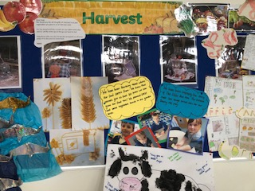  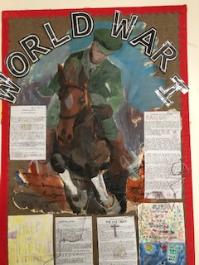  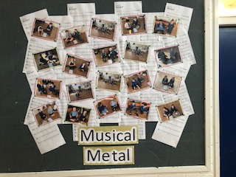  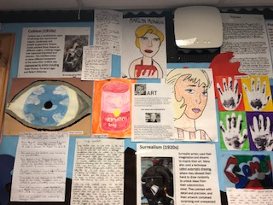  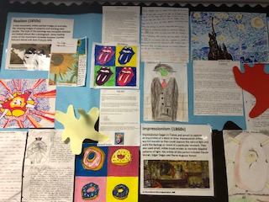 | Message from Mrs Terrey.  We are all back at school hard at work and as the photos show the children are producing plenty of interesting work linked to the new curriculum. School attendance remains very good, better than before Lockdown! The Forest School Camp was well attended and the children had a wonderful time with Mrs Stiles. We hope to offer this again in the Spring. As you are probably aware the school was remotely inspected by OFSTED on the 5th of November. This was to discuss the school’s COVID response and the plans we have in place to support learning. We were all very pleased with how the inspection went and it was very positive. There will be a letter to parents that will follow shortly.  The School Governing Body  The school continues to make progress and attached to this newsletter and on the website is information about becoming a School Governor. We hope that any parents interested in supporting the school will apply. The meetings are planned for Thursday evenings after school.  First Holy Communion  It is now time for interested parents to register their child's name for inclusion in this programme. To be eligible, your child will currently be in year 3 or above at school. To register your child's details please contact Faith Leborgne in the PARISH office as soon as possible. A letter will be sent to all registered parents during December with further details of the programme. God willing, the programme will start in January 2021 and culminate on the Feast of Corpus Christi in 2021, which falls on Sunday 6th June. Faith can be contacted on 01308 422594 or email bridport@prcdtr.org.uk  Breakfast Club  The school Breakfast Club is being run and organised by Mrs Pattison- Smith and Mrs Tschuchno. The provision is running from 7.45 until the start of school. Please contact the school Office by email to request a place.  Christmas Lunch  On the 16th of December there will be a hot Christmas meal offered to all pupils- both in Key Stage 1 and 2. This will mean a slightly longer lunch break to allow for cleaning in between 2 sittings. Parents are able to order the hot Christmas dinner online. The deadline for ordering and payment is the 9th December. All the children, within their Bubble will eat in the main hall on that day.  Break the Rules Day  On the 16th of December there will also be a “Break the Rules Day”. This is to fundraise for the school and has been organised by the PTFA. A flier is attached. There are several school rules that the children and staff can pay to break- on the 16th of December!  Reading at St Catherine’s  The reading in Key Stage 2 continues to go from strength to strength, the children in Ash, Hazel and Maple have completed 603 books so far this term and have read 2,798,022 words. This is really amazing reading!  Virtual Book Fayre  During the week of 1st December, we are holding a virtual Book Fair. An email with all the information on will be sent out soon. This is a great way to support the schools reading scheme, as any orders placed generate points for the school to use to buy books.  Parent Questionnaire Feedback  Thank you to all the parents who returned the school feedback form. It was great to hear that the children at St Catherine’s feel safe and happy and that staff have high expectations for the children. Parents are pleased with IXL for English and Maths homework and in Key Stage 2 Accelerated Reader has had a good impact on home reading. The feedback regarding parents evening has helped us to plan for the next meeting and if social distancing restrictions remain in place, we will offer a zoom meeting or telephone call in response to parent feedback.  Anti Bullying Week  In classes we have been focusing upon friendship and understanding what bullying is and what it does to people. I held my first zoom assembly with the whole school from my office which was very strange! The children have learnt about STOP- Several Times On Purpose, to help understand what bullying is. The school is holding a poster competition to promote friendship and kindness towards each other.  Parking  Can I please request that parents do not block the entrance and exit gates at the start and end of the day? The reduced access becomes challenging for staff and parents at the end of the day when they are ensuring that children are being collected. Thank you for your co-operation.  COVID Symptoms.  We would like to thank all parents and children for following our routines in school and on the playground. There is information on the school website providing advice regarding remote home learning if your child is absent from school with any of the following symptoms: A temperature above 38 degrees Celsius, a new change in taste or loss of smell or a new continuous cough. If you are unsure please check the website, call the school office for advice or use the following link:  https://mailchi.mp/dorsetcouncil/latest-coronavirus-covid-19-news-and-information-17-march-3121566
 | The Team at St Catherine’s Catholic Primary School.

