 | St Catherine’s Catholic Primary School Newsletter
October 2019 | Live, Love and Learn Together with God
Important dates for your diary:  Harvest assembly - donations gratefully received up to 14th-16th October  Wednesday 9th October 8am School council  Monday 21st October Parent forum 4.15 – 5.00pm  Wednesday23rd October 2.30  Celebration assembly – parents invited.  31st October Peter and the Wolf theatre visit for all children  Deadline for parents of children in Year 6 to complete application for a Secondary school place.  Half term  Week commencing 28th October  INSET DAYs Monday 4th and Tuesday 5th November  Teacher meetings November 6th and 7th – letter out 14th October .  Dates for the KS1 Nativity coming soon.  And quite far ahead …parents are reminded of the deadline for applying for a place in Reception for September 2020 – which is January 15th . Open days for St Catherine’s Reception are on our website.  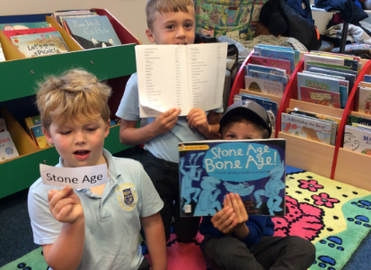  Serious research  Behind the scenes  at the library.  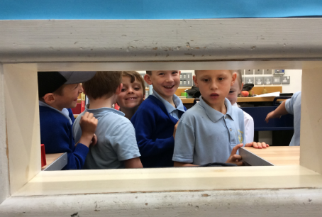  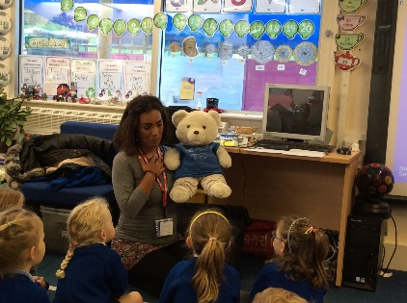  THANK YOU! | Message from Mrs Burt- Interim Head teacher  Autumn is really with us now and the leaves are blowing off the trees.  The children are much more settled and our youngest entrants in Reception are beginning to find their feet. It is a delight to see the older children in Years 1 and 2 supporting the younger ones in the playground – the reality of our Gospel Values.  The tractors trundling along the A35 in front of me each day continue to remind me we are at harvest time; this is when we remember all those who rely on the generosity of others to keep themselves alive. This Friday 4th is CAFOD Family Fast Day and our monetary donations will be added to those across the country to support those who do not have enough to feed their families. Year 6 will be running a Harvest Assembly for the school on 16th October and we will be asking for food donations which will then be taken to Bridport Food Bank. A separate letter will go out about this and please visit the website.  This newsletter has important information but also news and photos of the children enjoying their learning.  Clubs  You should have had a list of these. I have tried to make as many of these happen without a contribution required so that anyone can access them. A record of those who are accessing a free club will be kept so that those on the waiting list can be prioritised next term.  Administration and living out our values.  Liturgy and celebration assemblies- at 9am each Monday morning, all our children are joining together in the school hall for a celebration of the previous week’s successes. The weekly assembly focuses on our values, and teachers and pupils are now identifying and celebrating our values in action - our Stars of the Week. We have had some lovely examples in the last weeks and are really proud of St Catherine’s children.  Our end of half term Celebration Assembly will have a different feel and parents who wish to are warmly invited to attend. Children are being acknowledged for their efforts every week through the awarding of house points for their own House – St Andrew, St Patrick, St David or St George and we have been announcing the running total each week. Our house captains have been supporting our values and I am hoping that as they gain confidence they will be able to hold house meetings and that each house will have a different sense of purpose, working towards our goals. At the Celebration assembly, the house with the most points for the period will be announced. All members of winning houses will be allowed to have a non-uniform day on Friday 26th October. Each child in that House will have a note to remind them on the Wednesday after the assembly.  School Council. I now have all the names in from the teachers and will hold the first meeting of the Council at 8.00am on Wednesday 9th October. Please bring your child to the front entrance of the school where I will meet them. Thank you.  Daily mile. Many children and teachers are becoming very enthusiastic. We will not implement this when the weather is poor. Thank you for your support with this.  Safeguarding and security morning and afternoon.  Morning: our premises are not the easiest to monitor so please help me to make your child and all other children as secure and safe as possible by not coming further than the front playground on the school grounds before 8.30am. This means I do not want parents waiting by the classrooms having accessed the school by the field gate and then across the field before that time. Please come to the front playground and wait with your children.  A member of staff is waiting by the Year 3 classroom to welcome the children and let them through from 8.30 and younger children can be escorted by our older children or their parents at that point. Thank you for your co-operation with this. Classroom doors open at 8.30 and we expect children to be in class ready to work by 8.40. Thank you.  Likewise in the afternoon please do not enter the premises beyond the front playground before 2.55pm.  Please can I continue to ask you respect our neighbours by parking considerately. I had a reported incident recently of a car engine being left running in Coneygar Close whilst one parent took two children to school and the other parent watched over the cars; clearly this is an unthinking act.  St Catherine’s arrangements moving forward  There will be a separate letter from Mrs Burt and Mrs Brown – the school’s Education Standards Manager for CAST coming out early next week.  There will be an informal parents’ forum on Monday 21st October from 4.15 – 5.00 pm when Mrs Burt, Mrs Blake and Mrs Brown will be available.  News from the Classes  Year 3 had a great trip to Bridport library on Monday of this week. We wanted to learn how to use the library to research topics we cover in school. We completed a task where we were given a topic title, and then had to use the special Index Book to find the Dewy Decimal number and then locate the books on the library shelves. We also had a ‘VIP behind the scenes tour’ of the library, and finished off with story. Thank you to all the parents who gave up their time to support this trip.  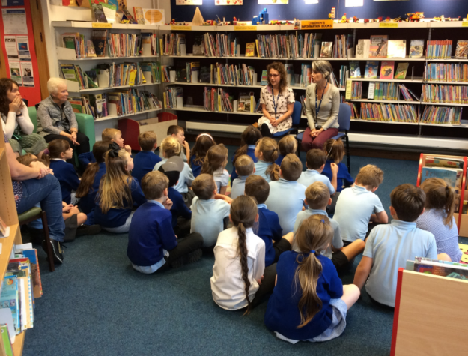  RAPT listening !!!  Reception Class of 2019  Our new Reception class have made a fantastic start to school, and have all begun to settle really well. They are learning to sit still on the carpet and put their hands up to answer questions, and are showing how knowledgeable they are about our topic- People Who Help Us. They have thought about what they would like to learn about the fire and ambulances services so far, and we have then all worked together to answer their questions. We have begun Phase 1 of our phonics programme, with the children developing the essential listening skills needed. We will begin learning our first sounds in the coming week, with books for story telling also coming home. Thank you so much for your ongoing support at this precious time.  SOME FINAL ODDS and ENDS  Thank you to ‘The Decorator Centre’ Bridport for donating paint for our Early Years’ outdoor area!  Felting a shed roof. Can anyone with knowledge/ experience come and give us an idea of the scope of a job for re-felting one of our sheds. This is not asking for a job to be done – just some advice. Many thanks.  Peter and the Wolf theatre trip. Huge thanks go to the PTFA who are funding the entire cost of this whole school visit on 31st October.

