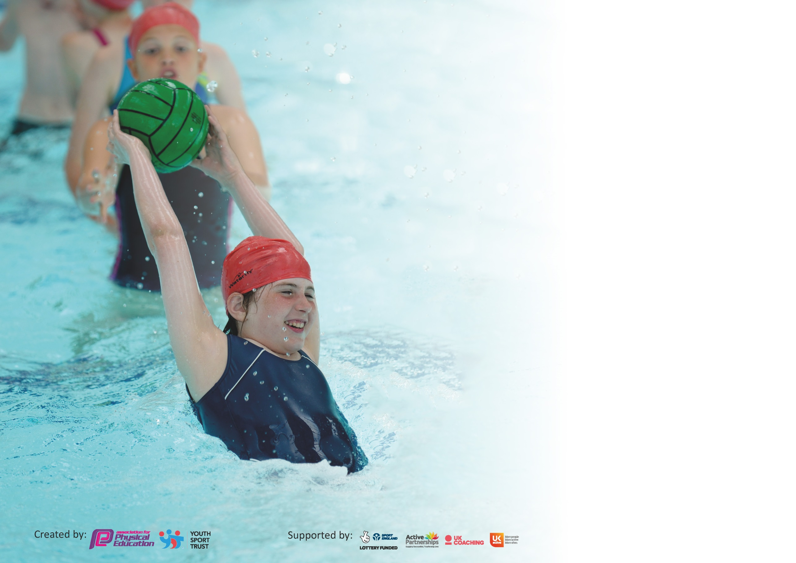

It is important that your grant is used effectively and based on school need. The Education Inspection Framework (Ofsted 2019 p64) makes clear there will be a focus on ‘whether leaders and those responsible for governors all understand their respective roles and perform these in a way that enhances the effectiveness of the school’.

Under the Quality of Education criteria (p41) inspectors consider the extent to which schools can articulate their curriculum (INTENT), construct their curriculum (IMPLEMENTATION) and demonstrate the outcomes which result (IMPACT).

To assist schools with common transferable language this template has been developed to utilise the same three headings which should make your plans easily transferable between working documents.

Schools must use the funding to make additional and sustainable improvements to the quality of Physical Education, School Sport and Physical Activity (PESSPA) they offer. This means that you should
use the Primary PE and Sport Premium to:

- Develop or add to the PESSPA activities that your school already offer
- Build capacity and capability within the school to ensure that improvements made now will benefit pupils joining the school in future years

Please visit gov.uk for the revised DfE guidance including the 5 key indicators across which schools should demonstrate an improvement. This document will help you to review your provision and to report your spend. DfE encourages schools to use this template as an effective way of meeting the reporting requirements of the Primary PE and Sport Premium.

We recommend you start by reflecting on the impact of current provision and reviewing the previous spend.

Schools are required to publish details of how they spend this funding as well as on the impact it has on pupils’ PE and sport participation and attainment by the end of the summer term or by 31st July 2020 at the latest.

We recommend regularly updating the table and publishing it on your website throughout the year. This evidences your ongoing self-evaluation of how you are using the funding to secure maximum, sustainable impact. Final copy must be posted on your website by the end of the academic year and no later than the 31st July 2020. To see an example of how to complete the table please click HERE.

Support for review and reflection - considering the 5 key indicators from DfE, what development needs are a priority for your setting and your pupils now and why? Use the space below to reflect on previous spend and key achievements and areas for development.

Key achievements to date until July 2020: | Areas for further improvement and baseline evidence of need:
Currently spend approximately 2 hours a week on physical activity including daily mile  Children in key stage 2 compete and are successful in a huge range of physical competitions – running , tag rugby and football  School have won Tag Rugby and Cross Country local schools competitions last year  Dedicated parents running after school sports clubs - Tag Rugby and Running  Specialised Sports teacher | All children spend at least 2 and half hours a week on PE  The profile of PE and sport is raised across the school for a higher percentage of pupils in both key stage 1 and key stage 2 to take part in a physical after school clubs  Raise the opportunities for afterschool fitness for all ages, especially key stage 1  Raise the percentage of girls who take part in both afterschool clubs and competitions/ tournaments  Provide a broader range of activities both within curriculum time and after school  Use PE to boost mental health for our vulnerable children  Increase confidence, knowledge and skills of all staff in teaching PE and sport with new PE scheme  Encourage children to take part in physical afterschool clubs outside of school  Raise the profile of sports leaders – running an afterschool club, arranging physical activity fundraisers, promoting sports outside of school

Meeting national curriculum requirements for swimming and water safety. | Could not complete due to Covid Lockdown – Swimming lessons
What percentage of your current Year 6 cohort swim competently, confidently and proficiently over a distance of at least 25 metres?  N.B. Even though your pupils may swim in another year please report on their attainment on leaving  primary school at the end of the summer term 2020. | %  Year 4-78%  Year 5-77%
What percentage of your current Year 6 cohort use a range of strokes effectively [for example, front crawl, backstroke and breaststroke]? | %  Year 4-78%  Year 5—75%
What percentage of your current Year 6 cohort perform safe self-rescue in different water-based situations? | %  Year 4-78%  Year 5-75%
Schools can choose to use the Primary PE and Sport Premium to provide additional provision for swimming but this must be for activity over and above the national curriculum requirements. Have you used it in this way? | Yes/No

Action Plan and Budget Tracking
Capture your intended annual spend against the 5 key indicators. Clarify the success criteria and evidence of impact that you intend to measure to evaluate for pupils today and for the future.

Academic Year: 2020/21 | Total fund allocated: £17,570 | Date Updated: 17th July 2020
Key indicator 1: The engagement of all pupils in regular physical activity – Chief Medical Officer guidelines recommend that primary school pupils undertake at least 30 minutes of physical activity a day in school |  |  |  | Percentage of total allocation:
 |  |  |  | 37%
Intent | Implementation |  | Impact
Your school focus should be clear what you want the pupils to know and be able to do and about  what they need to learn and to  consolidate through practice: | Make sure your actions to achieve are linked to your intentions: | Funding allocated: | Evidence of impact: what do pupils now know and what can they now do? What has changed?: | Sustainability and suggested next steps:
Ensure timetables reflect 2 and half house a week of PE and where possible 30 mins a day goal. | Ensure equipment is purchased to cover what is needed to teach the new pe scheme, including portable music system.  Monitor timetables to ensure 2 and half hours of pe is covered each week  Staff supported with schemes of work and opportunity to watch each other teach PE  Leader to update PE curriculum coverage yearly planner  Football to be timetabled once a week for younger classes  Sports coach for oldest class once a week | £2075  £2,200  £2,200 | More opportunities offered, children can enjoy more sports .  Sports journals/ pupil voice  Children show increased fitness and participation – sports journals
Key indicator 2: The profile of PESSPA being raised across the school as a tool for whole school improvement |  |  |  | Percentage of total allocation:
 |  |  |  | 4%
Intent | Implementation |  | Impact
Your school focus should be clear what you want the pupils to know and be able to do and about  what they need to learn and to  consolidate through practice: | Make sure your actions to achieve are linked to your intentions: | Funding allocated: | Evidence of impact: what do pupils now know and what can they now do? What has changed?: | Sustainability and suggested next steps:
Encourage the children to see the benefits of daily physical activity both in regards of improving physical ability and helping develop their concentration and focus.  Ensure attendance at all sports competitions/ festivals offered, create risk assessments and training  Research applying for the School Games Mark | Communicate the physical activity achievements both in and out of school, focussing on the positive feelings that go alongside completing an activity/ winning a tournament and measuring what they have become better at ie- personal goals .  Ensure attendance at all sports competitions/ festivals offered, create risk assessments and training. Support running of Julia’s House Run and organise Sports Relief event.  Use journals to measure happiness and mind set with the children before and after sport, demonstrating the positive effects it has on their ability to focus , feel happy and be motivated to perform. Use journals to measure fitness and personal goals.  PE leaders to work together to apply for school games award | £360  £360 | Pupils feel more motivated both at school and at home  Pupils feel happier and recognise the mental health benefits of exercise  Pupils start to pursue sports out of school  Pupil voice / sports journals

Key indicator 3: Increased confidence, knowledge and skills of all staff in teaching PE and sport |  |  |  | Percentage of total allocation:
 |  |  |  | 20%
Intent | Implementation |  | Impact
Your school focus should be clear | Make sure your actions to | Funding | Evidence of impact: what do | Sustainability and suggested
what you want the pupils to know | achieve are linked to your | allocated: | pupils now know and what | next steps:
and be able to do and about | intentions: |  | can they now do? What has
what they need to learn and to |  |  | changed?:
consolidate through practice:
To ensure all staff are confident to teach the PE curriculum for their year group  Sports leader to attend sports meetings  Sports leader to identify specific PE CPD for staff members. | Sports leader to buy and introduce the Real PE scheme  to support all staff to feel confident to teach PE  Real PE INSET  Sports leader to report back to staff and organise events  Staff members to complete specific CPD in certain PE areas. | £560  Yearly subscription  £1,795  Training - £495  PE Hub £455  £180 – Meeting release | Pupil Voice / sports Journals  Initial, mid and final questionnaire  Children enjoy pe more  Children have developed and widened skills in PE  Children understand how to improve their skills  Children are having more opportunities for PE
Key indicator 4: Broader experience of a range of sports and activities offered to all pupils |  |  |  | Percentage of total allocation:
 |  |  |  | 33%
Intent | Implementation |  | Impact
Your school focus should be clear | Make sure your actions to | Funding | Evidence of impact: what do | Sustainability and suggested
what you want the pupils to know | achieve are linked to your | allocated: | pupils now know and what | next steps:
and be able to do and about | intentions: |  | can they now do? What has
what they need to learn and to |  |  | changed?:
consolidate through practice:
Increase the range of sports provided across the whole school and encourage the children who have not participated previously  Academic year 2019/2020  53% of school took part in a physical after school club | Sports leader to ensure all classes are completing the daily mile. Sports leader to promote couch to 5 k with parents – could be an after school club where parent attends with child/children.  Staff to run a variety of physical afterschool clubs to interest both boys and girls across all key stages.  Sports leader to contact parents to continue to run sports clubs.  Sports leader to continue to take children to attend local tournaments.  All classes to participate in Sports Partnership festivals.  Sports leader to organise a club specially designed for our most vulnerable to boost mental health.  Sports leader to make contacts with external coaches. Arrange taster sessions for local afterschool clubs – ie: paddle boarding, trampolining, badminton, orienteering and archery  Sports leader to organise swimming lessons for specific swimmers to ensure they meet with national curriculum expectations by the end of year 6 .  Sports leader to organise hiring of pools, lifeguards, swimming teachers and the correct staffing ratio.  Each year group –  R- Taster session of local sport/ Reception in-house sports festival  Yr 1 -Taster session of local sport /mini tournament to go towards whole school house points  Yr 2 -Taster session of local sport / mini tournament to go towards whole school house points  Yr 3 – WOEC/ mini tournament to go towards whole school house points  Yr 4- Bike Ability/ mini tournament to go towards whole school house points  Yr 5 – Sailing/mini tournament to go towards whole school house points  Yr 6 – outdoor education/ mini tournament to go towards whole school house points | Cost of time out to cover  £1,100  Sports Partnership Fee  £3,300  £1390 | Pupil voice / pupil journal  Pre middle and end questionnaire for outside sports clubs  Increased percentage in participation for clubs  Increased participation in number of clubs attended  Increased participation for key stage 1  Increased participation for girls  Increased participation in competitive sports  Increased participation in clubs outside of school

Key indicator 5: Increased participation in competitive sport |  |  |  | Percentage of total allocation:
 |  |  |  | 6%
Intent | Implementation |  | Impact
Your school focus should be clear | Make sure your actions to | Funding | Evidence of impact: what do | Sustainability and suggested
what you want the pupils to know | achieve are linked to your | allocated: | pupils now know and what | next steps:
and be able to do and about | intentions: |  | can they now do? What has
what they need to learn and to |  |  | changed?:
consolidate through practice:
To raise the percentage of children across the school taking part in competitive sports both during school time and afterschool | Include competitive sports within PE lessons using house colours , which will add to the sports day final figures  Sports leader to organise the running of a netball club to then be able to take part in the netball tournament  Sports coach to run a football, cricket and athletics club  Sports leader to organise a visit from an athlete to promote competitive sports and inspire children  Sports leader to run a parent/ child club, to motivate children and have support outside of school. | Club cost  £1,100 | Raise profile of pe in school  Pupil voice / pupil journal  Pre middle and end questionnaire for outside sports clubs  Increased percentage in participation for clubs  Increased participation in clubs outside of school  Increased participation in number of clubs attended  Increased participation for key stage 1  Increased participation for girls  Increased participation in competitive sports

Signed off by
Head Teacher: | Sarah Terrey
Date: | 17th July 2020
Subject Leader: | Lydia Blake
Date: | 17th July 2020
Governor: | Theresa Sturtivant
Date: | 17th July 2020

