St Catherine’s Catholic Primary School.
Intervention Menu.

Speech and Language  This intervention is provided with support and guidance from the NHS Speech Therapist. Pupils are externally assessed and a programme devised by the therapist is delivered regularly. | Direct Phonics  A Catch up phonics scheme used for pupils who need targeted support to address gaps in their phonic knowledge.  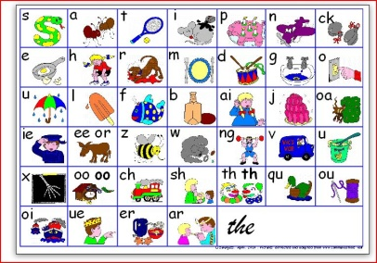 | ELS  Early Literacy Support a 16 week programme for Year 1 supporting early reading and phonic development. This intervention is designed to help children narrow the gap between them and their peers.
Target daily Reader  15 mins1:1 individual reading support with an adult. Reading and discussing books in order to develop reading confidence and comprehension skills. | Precision Teach  15 mins daily 1:1 using a pre-teaching flashcard method with rapid checking. This intervention supports pupils with short term memory issues. This method can be used for sight word reading, spelling and number facts. | Words First  A whole word reading scheme linked to visual support. Pupils are taught using pictures first then picture and word finally words only using flashcards. Reading books are used linked to sets of words.
Literacy +  A small group intervention for pupils with SPLD. Activities are linked to phonological awareness, rhyme, reading, spelling and comprehension. | Dorset Reading Volunteers  This external service of trained volunteers works with children 1:1 who need a boost with reading. The session of 30 mins involves reading and literacy based games. | Time to Talk  A lunchtime intervention to support pupils with social difficulties. This teacher led intervention focuses on turn taking, sharing and developing resilience.

The Power of 2  A daily numeracy intervention that is completed 1:1. The focus is upon developing number fluency and confidence with basic number work. | Class focus groups  Additional adult support used as directed by the teacher to provide support with learning concepts in Literacy and Numeracy. | Learn to move  A 10 week intervention to develop gross and fine motor skills. If no significant progress is made after 10 weeks school make a referral to the Occupational Therapy team at the Children’s Centre.
Breakfast Club  Daily provision from 7.45 for pupils Disadvantaged and SEND pupils. This provides support for pupils who find the transition to start the day challenging. | Boxall Profile  An attachment/nurture based intervention to support pupils with Social, emotional and Mental Health Needs. An assessment is completed and IEP created to develop emotional areas of development. | OT/Physio Support.  Support provided 1:1 by a trained TA with support from the OT and Physio from DCH. This support will be provided 3 times per week.
ELSA  Emotional Literacy Support assistants support pupils who experience difficulties with feelings and behaviour. There are 10 planned sessions. | Toe by Toe  A 1:1 reading programme designed to be delivered daily for approx 15 mins. This intervention improves reading decoding and fluency. | Home/school link book.  A book or record established when there is consistent concern for the behaviour and interaction of pupil and this needs to be communicated to parents daily.

Handwriting: Write from the Start.  A group intervention to be used to develop functional recording skills leading to joined handwriting. Children should start with book 1.  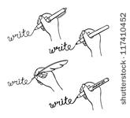 | Socially speaking  A group intervention for pupils with an ASD diagnosis. This weekly group is designed to improve social communication, eye contact and understanding of social rules. | Visual timetable  Visual support for pupils with ASD or anxiety. WIDGET symbols are used consistently to show the routine for the school day.
Social stories
A comic strip or visual method of teaching or explaining rules and expectations to children who can find processing social information or understanding language difficult.
