 | St Catherine’s Catholic Primary School Newsletter
February 2021 | Live, Love and Learn Together
Important dates for your diary:  Coming up…  Welcome back Monday 8th March  Breakfast Club: Hooray! Breakfast Club is back from 8th March. Please email the Office for places.  SPORTS COACH SESSIONS  Wednesday for ASH CLASS, please wear PE kit.  Forest school sessions  MAPLE CLASS, every Friday please wear play clothes and supply wellies.  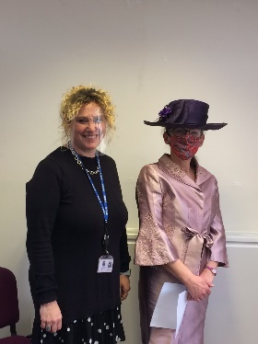  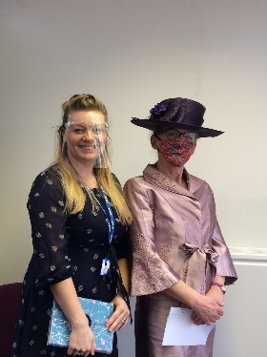  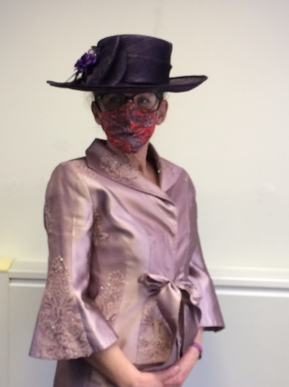 | Message from Mrs Terrey:  Well, what a whirlwind the past few days have been! We have all been working so hard to make sure we can welcome you back on the 8th March in a safe way and, oh my, all the staff are SO looking forward to seeing your smiling faces again! We also had a visit from OFSTED (albeit virtually) more about that later. Suffice it to say, we are thrilled with the improvements in the school! We have robust policies and procedures in place to ensure the safety of everyone in school. Reception/Year 1 had a VERY important visitor this week! I was very honoured to meet HRH (please see the photo on the blue stripe!) There have been some exciting changes to classrooms which include new Interactive White Boards that will make your learning experiences even more effective and fun!  Face Coverings and Contact Tracing:  A reminder that all parents must wear face coverings unless they are exempt. We will offer coverings if you have forgotten. It is Trust policy and the policy of all schools locally that this occurs.  Dorset Council have told us that schools will need to have a contact available for contact tracing for the start of term. This means that if you or anyone in your household have a positive test result for Covid-19 you will need to contact school so that we can inform close contacts and advise you what to do next.  We therefore ask that if you receive a positive result for Covid-19 up to and including March 8th please immediately email the school office at: office@stcatherinesbridport.dorset.sch.uk  Drop Off and Pick Ups:  We have decided to continue with the staggered drop off times for the time being so: Reception/Year 1 and Year 2 will be 08:45 Year 3 / 4, Year 5 and 6 will be 08:30. Collection times will be: Reception/Year 1 and Year 2 will be 15:10 Year 3 / 4, Year 5 and 6 will be 15:00. We respectfully ask that, when you drop off, please move away from the school gates to leave room for other pupils to walk through without having to go onto the road. Thank you so much.  Bubbles:  We will keep the bubbles we had in December which are Key Stage 1 and Key Stage 2. As time goes on and we move through the plan to come out of Lock Down we will progress the amalgamation of bubbles, keeping pupils, parents and carers informed of our plans.  School Lunches:  Hot lunches are back for Key Stage 1 from 8th March. We are continuing with packed lunches for Key Stage 2 until Easter. Please remember to order lunches by Monday 1st of March 2021.  LENT:  Why do we give things up for Lent? Well, Catholics believe that this is to represent Jesus’ sacrifice when he went into the desert to pray and fast for 40 days before later dying on the cross. If there’s one thing we DON’T need at the moment, it is having to give up something we like for Lent so, following on from advice from the Pope himself, let’s take them things UP instead!! Give up hurtful words, say kind words. Give up sadness and be filled with gratitude. Give up anger and be filled with patience. Give up pessimism and be filled with hope. Give up worries and have trust in God. Give up complaints; contemplate simplicity. Give up grudges and be reconciled. If that works out for you and you feel as though you’d like to do something to help others check out Mrs Harris’ suggestion for Walk for Water as a great project for the whole family!  Walk for Water:  Now that Spring is peeping over the horizon, how about getting out and about and raising some money for an amazing cause? St Catherine’s are supporting CAFOD’s Lent Walk for Water campaign through the Family Fast Day Gift Envelopes and a sponsored walk. The walk can take place any day during Lent so we decided to hold our event now our new half term has started. More information is attached.  Family Fast Day:  If walking isn’t your thing, how about a day of fasting instead! All you need to do is eat a little less and donate the money you save to CAFOD. CAFOD are an international development charity and the official aid agency of the Catholic Church in England and Wales. They reach out to people living in poverty with practical help, whatever their religion or culture.  The Month of March:  The month of March is dedicated to St Joseph. Joseph was the husband of the Blessed Virgin Mary and the father, on earth, of Jesus. Holy Scripture proclaims him as a “just man” and the Church has turned to Joseph for his patronage and protection. St Joseph loved Jesus and looked after him as his own son and we pray to him to protect and love us in the same way. In March we think about the ‘fathers’ in our lives, dads, brothers, grandads, uncles and everyone else that we are lucky enough to spend time with.  Family Reset Plan – A resource for All:  The Family Reset plan is a five module virtual workshop grounded in neuroscience and psychology that teaches emotional wellbeing tools to parents and caregivers who want their family life to feel calmer, happier and less stressful – even in these overwhelming and uncertain times.  Dorset Council have invested in this tool for all families to be able to use. More details can be found here - http://www.familyresetplan.co.uk/  If this resource would be helpful for families you work with, please follow these instructions to enable them to access this support. There will be no charge for families who use the code below when accessing this resource.  Instructions: > Go to familyresetplan.co.uk  > Scroll down to the green button and select Click here to buy  > Select 'Buy Now'  > Add the code DORSET1  Helpline for parents - 01258 474036  This helpline has been set-up to support those who are worried about their child or teenager during the lockdown. It is run by Dorset Council's Educational Psychologists and is completely free. The helpline is open from Monday to Friday from 9am to 4.45pm. Callers need to ring and make an appointment for a 30 minute phone consultation.  World Book Day 4th March:  Well, it’s that time of year again and we can’t WAIT!! Mrs Terrey has come up with a great idea for a competition! We would like Reception/Year One and Year Two pupils to make a potato character from their favourite book! The winner will receive an Easter Egg!! So, get started on your Optimash Prime or Tony Starch or even Spud Lightyear and see who you can create!! Judging will take place on Monday 8th March 2021 so please bring your SPUDtacular (that was Mrs Terrey’s pun!) creations with you.  Children will come home with their World Book Day Vouchers so check their book bags!  Jane King:  We are delighted to announce that Jane King will be with us until the end of the academic year. Jane is teaching Year 3 / 4 alongside Gen Dickson. Jane has been with us since the beginning of the year and we are so glad to have her.  A Right Royal Occasion!  The children in Reception and Year One had an extraordinary visitor on Tuesday. HRH Queen Elizabeth II popped by to talk to the children and answer questions on her life as part of a Topic Project on London. The children were curious as to: ‘How many corgis do you have?’ Where do you live?’ What car drove you here?’ ‘How old are you?’ and finally; ‘How is Prince Philip?’  The Queen graciously answered all the questions, mostly correctly, and the children were pleased to know Prince Philip is being well cared for!  Mrs Becky Treble masterminded the event; ‘I thought it would be a great way to add to our London project by meeting its most famous resident! I am very grateful to Mrs Buchart (Lady in Waiting to HRH) for helping me to make this monumental occasion happen. We had a Zoom meeting so all the pupils working from home could join in and everyone had a fantastic time!’  “O Saint Joseph, do assist me by your powerful intercession and obtain for me from your divine Son all spiritual blessings through Jesus Christ, Our Lord”  Thank you to all the staff, pupils, parents and carers, we look forward to seeing you all soon.  From the St Catherine’s Team

