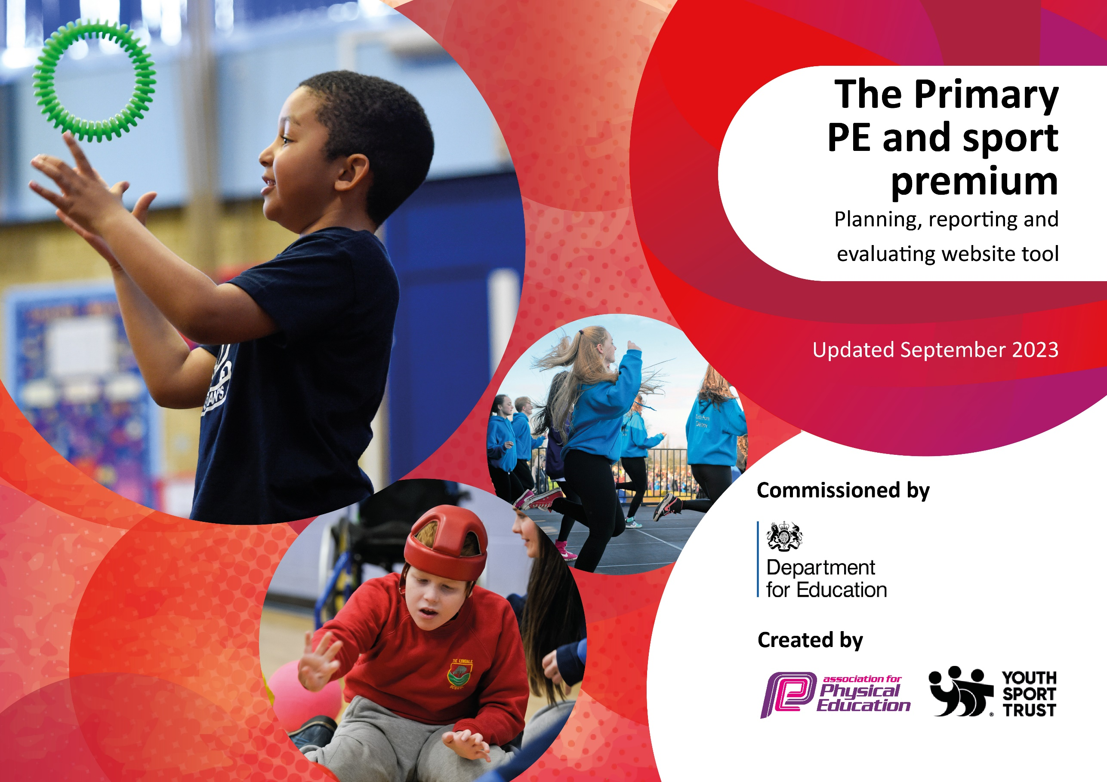

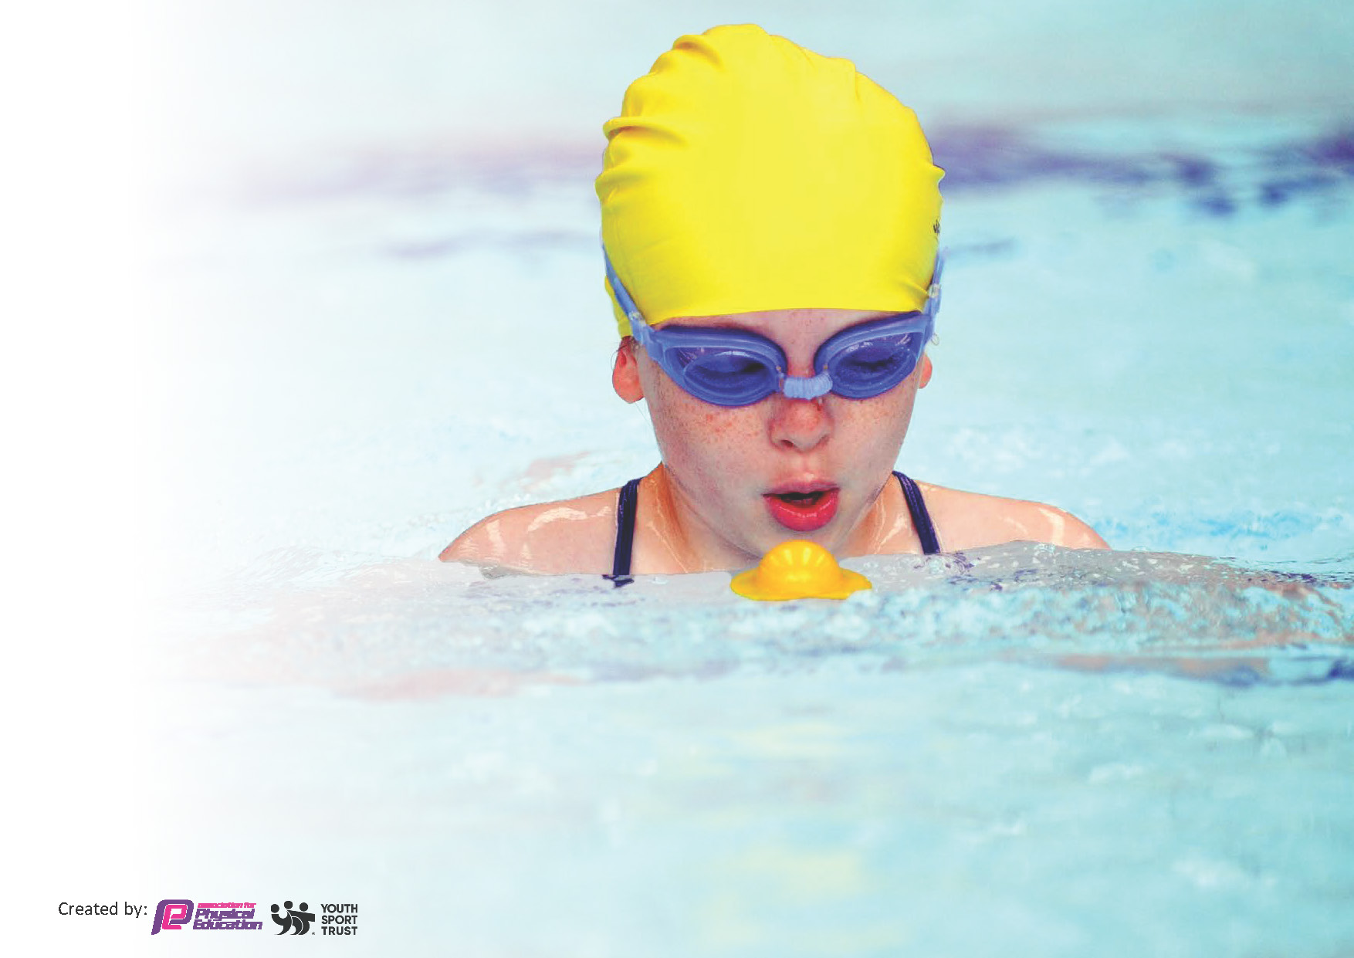
This template can be used for multiple purposes:
by:
- It enables schools to effectively plan their use of the Primary PE and sport premium
- It helps schools to meet the requirements (as set out in guidance) to publish information on their Primary PE and sport premium
- It will be an effective document to support Ofsted inspections enabling schools to evidence progress in Physical Education (PE) and evidence swimming attainment, which forms part of the PE National Curriculum. We would recommend schools consider
the Intent, Implementation and Impact of any spend, as examined within the Education Inspection Framework.

It is important that your grant is used effectively and based on school need.

Schools must use the funding to make additional and sustainable
improvements to the quality of the PE, School Sport and Physical Activity (PESSPA)
they offer. This means that you should use the Primary PE and sport premium to:

- Build capacity and capability within the school to ensure that improvements made now will benefit pupils joining the school in future years
- Develop or add to the PESSPA activities that your school already offers.

The Primary PE and sport premium should not be used to fund capital spend projects; the school’s core budget should fund these. Further detail on capital expenditure can be found in the updated Primary PE and sport premium guidance.

The Primary PE and sport premium guidance, outlines 5 key priorities that funding should be used towards. It is not

necessary that spending has to meet all the key priorities, you should select the priorities that you aim to use any funding towards.

Although completing this template is not a requirement for schools, schools are required to publish details of how they spend this funding. Schools must also outline what the impact this funding has had on pupils’ PE and sport participation and attainment and how any spending will be sustainable in the future. All funding must be spent by 31st July 2024.

The Department for Education has worked closely with the Association for Physical Education (afPE) and the Youth Sport Trust (YST) to develop this template and encourages schools to use it. This template is an effective way of meeting the reporting requirements of the Primary PE and sport premium.
Review of last year’s spend and key achievements (2024/2025)

We recommend you start by reflecting on the impact of current provision and reviewing your previous spend.

Activity/Action | Impact | Comments
Top up swimming lessons | 75% of pupils left primary school being able to swim 25 meters proficiently. | Children have swimming lessons in UKS2 however from academic year 25/26 pupils from beginning of KS2 will be offered swimming lessons. Pupils who have no prior experience of swimming lessons will be invited to additional lessons to support swimming development.
Staff CPD | Employment of specialist sports coach to support teaching staff when delivering a variety of sports. Specialist teaching has covered a variety of sports including football, tag rugby, cricket, basketball, gymnastics, dance, tactical games. Staff subject knowledge improved | BT to carry out DDIs to evaluate impact of coaching CPD. For academic year 25/26 sports coach to coach 1:1 and observe teaching staff and support staff to further improve quality of PE provision. Staff questionnaire on teaching confidence and areas to improve – via CPD.
Equipment | Equipment purchased to promote Physical activity during playtimes. Sports ambassadors lead a variety of games for all age groups. EYFS and KS1 pupils were encouraged to join in to promote active lifestyles.
Midday Assistant | Children had access to equipment and shown a variety of uses through fun games and activities lead by MDA. | MDA supervised and encouraged pupils active involvement on the playground. During pupil voice children will have a chance to share what they would like to do at playtimes and this can be organized by the midday supervisor.
Forest school | Children have had the opportunity to experience a variety of adventurous physical activities – including climbing, hanging, swinging etc.  Children have had the opportunity to work as part of a team. | Ensuring have autonomy over the forest school journal. Targeted children to support their physical wellbeing through forest school providers.
Participating in sporting events including SLA | Opportunities for all key stages to participate in a variety of events.  Opportunities to compete for awards against other local schools. | Events participated in: cross country, tag rugby, football, fotsul, dance festival, cricket.  Children look forward to events. Good culture surrounding sport within the school including from parent volunteers who help run running club and tag rugby club.
Extra curricular | More children spending increased amount of time at clubs due to variety of clubs on offer. | Clubs offered to pupils included: gymnastics, football, dance, tag rugby, running, dodgeball, athletics, cricket.

Key priorities and Planning
This planning template will allow schools to accurately plan their spending.

Action – what are you planning to do | Who does this action impact? | Key indicator to meet | Impacts and how sustainability will be achieved? | Cost linked to the action
Introduce swimming from beginning of lower key stage 2. | Key stage 2 pupils  Teaching staff (including support staff)  Lunchtime staff | Key indicator 2 -The engagement of all pupils in regular physical activity  Key indicator 4: Broader experience of a range of sports and activities offered to all pupils. | More pupils meeting end of KS2 swimming proficiency.  All pupils will have had an opportunity to partake in swimming lessons within KS2.  Less able swimmers to have further opportunities to meet swimming standard. | £1806 swimming pool hire + 2 swimming coaches
School games mark (60 active minutes) | All pupils  All staff | Key indicator 2 -The engagement of all pupils in regular physical activity  Key Indicator 3: Profile of PE and sport is raised across the school as a tool for whole-school improvement | School to improve on games mark  Children to be more active and healthier  Supporting pupils mental wellbeing | £0

Opportunities for all pupils to compete in local events/ competitions and inter house school events. | All pupils  Teaching staff  Support staff | Key indicator 2 -The engagement of all pupils in regular physical activity  Key indicator 4: Broader experience of a range of sports and activities offered to all pupils.  Key indicator 5: Increased participation in competitive sport. | Opportunities for all pupils to participate in sporting competitions within school and locally.  Promote positive sportsmanship and promoting team spirit.  Sports to be deemed as positive and opportunities to promote positive sporting experiences. | £2060 Sports local authority.  £700 extra-curricular clubs  £200 sports day  £1500 transport
CPD opportunities  specialist sports coach (Steve Treble)  PE hub |  | Key indicator 1 – increasing all staffs confidence and knowledge in teaching PE and sport.  Key indicator 2 -The engagement of all pupils in regular physical activity  Key Indicator 3: Profile of PE and sport is raised across the school as a tool for whole-school improvement  Key indicator 5: Increased participation in competitive sport. | Quality of PE and sports teaching improved.  Pupil engagement with PE improved  Staff confidence and subject knowledge and skills improved.  High level of specialised teaching weekly for all pupils.  Equipment monitored and suitability ensured by specialist sports coach. | £5700  £446
Equipment – update and purchase resources to support PE Hub planning scheme.  Playtime resources | All pupils  All staff | Key indicator 1 – increasing all staffs confidence and knowledge in teaching PE and sport.  Key indicator 2 -The engagement of all pupils in regular physical activity  Key Indicator 3: Profile of PE and sport is raised across the school as a tool for whole-school improvement  Key indicator 4: Broader experience of a range of sports and activities offered to all pupils. | Pupils can participate in a variety of different sports.  Equipment used to promote active play at playtimes.  Staff confident in using equipment.  All pupils and staff aware of safety when transporting and using equipment. | £1000  £3569 MDA
Forest school | All pupils  All staff | Key indicator 2 -The engagement of all pupils in regular physical activity  Key indicator 4: Broader experience of a range of sports and activities offered to all pupils. | Broader range of physical activity.  Physical games from outside learning activities.  Supporting of mental wellbeing. | £3040

Swimming Data
Meeting National Curriculum requirements for swimming and water safety.
Priority should always be given to ensuring that pupils can perform safe self-rescue even if they do not fully meet the first two requirements of the National Curriculum programme of study

Question | Stats: | Further context  Relative to local challenges
What percentage of your current Year 6 cohort can swim competently, confidently and proficiently over a distance of at least 25 metres? | 75% | Children have taught lessons in the summer term taught by swimming teachers.  Some children had a fear of water which impacted their progression, therefore moving forward for next academic year parental questionnaires around swimming will be sent out in advance to ensure swimming confidence is recognized before commencing lessons.
What percentage of your current Year 6 cohort can use a range of strokes effectively [for example, front crawl, backstroke, and breaststroke]? | 75% | As above.

What percentage of your current Year 6 cohort are able to perform safe self-rescue in different water-based situations? | 75% | All pupils participated in self-rescue and water safety lesson so were equipped of knowledge and experience of self-rescue with floats.
If your schools swimming data is below national expectation, you can choose to use the Primary PE and sport premium to provide additional top-up sessions for those pupils that did not meet National Curriculum  requirements after the completion of core lessons. Have you done this? | Yes/No
Have you provided CPD to improve the knowledge and confidence of staff to be able to teach swimming and water safety? | Yes/No | In house swimming teacher (support staff) regular CPD with swimming job

Signed off by:

Head Teacher: | Paula Fearn
Subject Leader or the individual responsible for the Primary PE and sport premium: | Becky Treble PE leader
Governor: | Nick Tindall (curriculum lead governor)
Date: | 29.09.25

