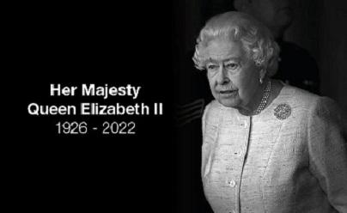
Plymouth CAST is joining with the rest of the country and the commonwealth to mourn the passing of Her Majesty Queen Elizabeth II.

