**Autumn Term**

**Year 6**

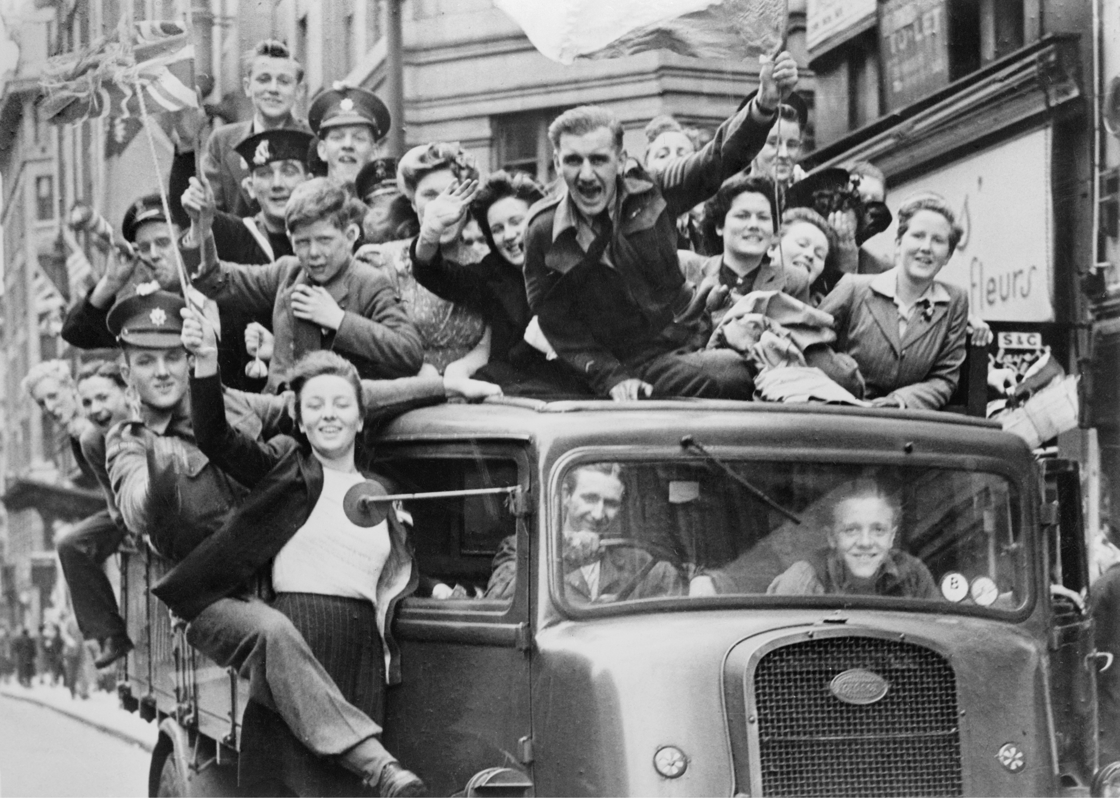

**Dates for your diary**

Sept 16th Residential and SATs meeting 5.50pm

Oct 11th Class liturgy 8.40am

Oct 18th Nothe Fort

Nov 6th/7th parents evening

Nov 15th – WWII maths Café 1.45pm

Dec 6th – Apprentice fair 2.00pm – 4.00pm

Jan 17th – Class liturgy 8.40am

Jan 17th – First swimming lesson

March 25th French Market 1.45pm

March Parliament visit (pending)

May 11th – 15th SATs week

July 6th – July 10th Residential

July 14th Leavers show 6.00pm

**Literacy**

Short Stories

Biography – Moses

Explanation - electricity

Report – WW2

Performance poetry

Diary writing – Anne Frank

As well as reading, spelling, punctuation and grammar!

**Maths**

We will cover the areas of the maths curriculum including place value, four rules, fractions, shape, space and direction as well as using data handling skills in our science lessons.

**Year 6**

**Autumn 2019**

**RE**

We will be researching the story of Moses and writing his biography. We lead the Harvest Festival later in the term and so will be preparing for this. Later in the term we will also be hearing the stories linked to Advent.

**ART/DT**  
Our art and DT lessons are heavily linked to our humanities topic. We will make gas mask boxes and WWII food. We will then move on to looking at Pop Art - focussing on Roy Lichtenstein.

**Computing**This term we will learn to use search technologies effectively. We will appreciate how results can be ranked and that some results are more useful than others.

**Science**

We will start the term looking at Electricity and make our own twin circuits.

We will then move on to light and learn about refraction, identify the visible spectrum and study Isaac Newton.

**French**

This term we will be revising what we have learnt so far and will be looking at the language associated with classroom routines, classroom objects and clothes.

**Humanities**This term our Humanities focus is on World War Two; the countries involved in it and the reasons behind it. We will look closely at what it was like to be a child during WWII and living conditions during the Blitz.

**PE –**

- circuits

-gymnastics

- Cross Country

-Netball and Ball Skills

**P.S.H.E.**

We will start the term by looking at our health and mental wellbeing. We also cover the ‘ Going for Goals’ unit in our Seal program.

**Music**Evacuee’s song series

The role of music in war

Dance music