A fully grown animal or plant.

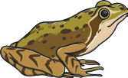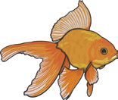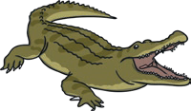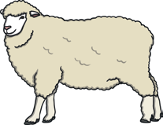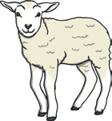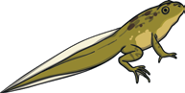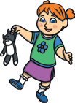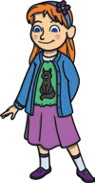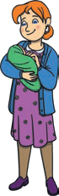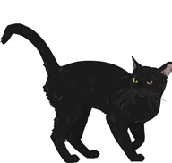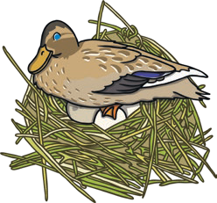

**Animals Including Humans**

**Year 2**

Some animals give birth to **live young**.

Some **offspring** look like their

**adult** when they are born.

Some animals lay eggs which the **young**

hatch from.

Some **offspring** do not look like their **adult** when they are born.

Both of these types of **young** then develop into **adults**.

frogspawn

baby

toddler

adult

**Human Life Cycle**

**Frog Life Cycle**

tadpole

All young animals change as they go through the different stages of their life cycle and grow into adults.

adult frog

child

teenager

froglet

**Key Vocabulary**

**adult**

**develop**

To grow bigger and become stronger.

**life cycle**

The changes living things go through to become an adult.

**offspring**

The child of an animal.

**young**

Offspring that has not reached adulthood.

**live young**

Offspring that has not hatched from an egg.

To stop germs from spreading, it is important to be **hygienic**.

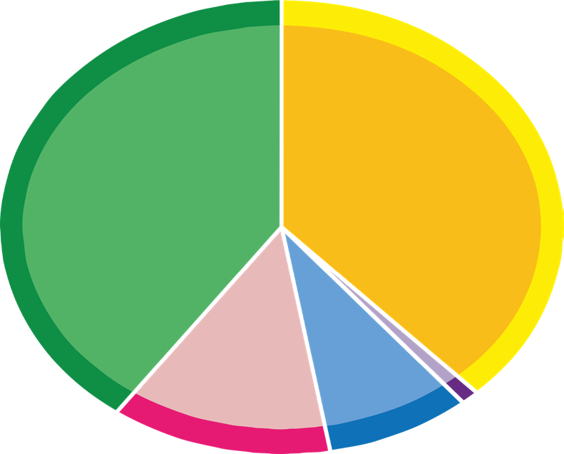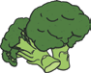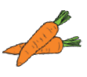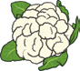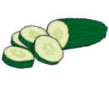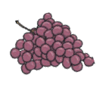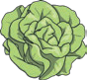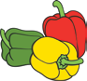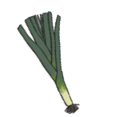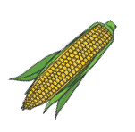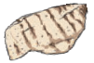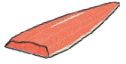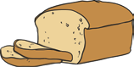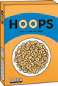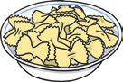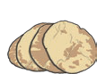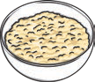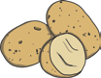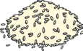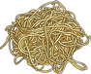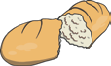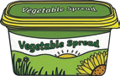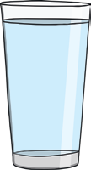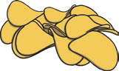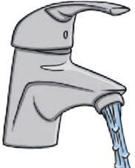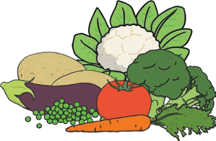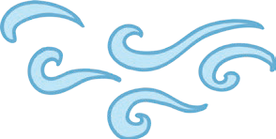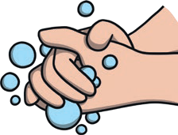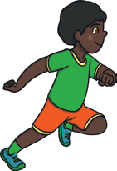

**Animals Including Humans**

**Year 2**

To stay alive, all animals have three basic needs for survival:

air

water

food

**Eatwell Guide**

To

grow

into

a

Eat less often and in small amounts.

healthy adult, we must eat the right types of food in the right amount and **exercise**.

**oil and spreads** Choose unsaturated oils and use in small amounts.

**6-8**

**a day**

Water, lower fat milk and sugar- free drinks.

Being active and **exercising** keeps our bodies and minds healthy.

**c**

**a**

**r**

**b**

**o**

**h**

**y**

**d**

**r**

**a**

**t**

**e**

**s**

**d**

**a**

**i**

**r**

**y**

**a**

**n**

**d**

**a**

**l**

**t**

**e**

**r**

**n**

**a**

**t**

**i**

**v**

**e**

**s**

**p**

**r**

**o**

**t**

**e**

**i**

**n**

**s**

**f**

**r**

**u**

**i**

**t**

**a**

**n**

**d**

**v**

**e**

**g**

**e**

**t**

**a**

**b**

**l**

**e**

**s**

**Key Vocabulary**

**diet**

The food and water that an animal needs.

**disease**

Illness or sickness.

**exercise**

A physical activity to keep your body fit.

**germs**

Tiny living things that can cause disease.

**hygiene**

How we keep ourselves and the world around us clean so we can stay healthy and stop germs spreading.

**nutrition**

Food needed to live.

**pulse**

The beating of the heart that can be felt in your neck and wrist.