Olly’s Rhyme
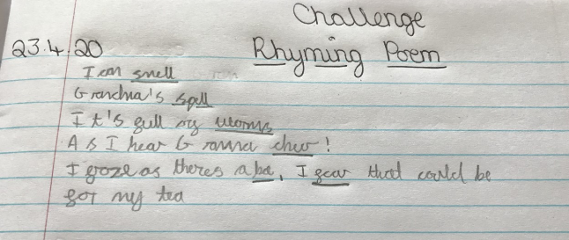
Jacob’s Rhyme
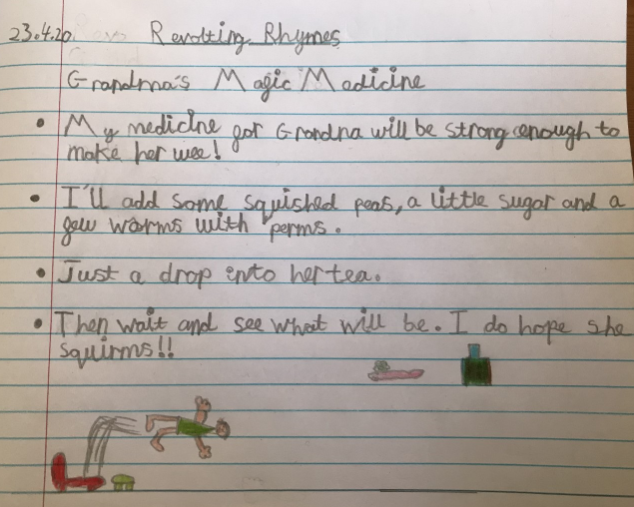
Thanks you two! Both of these are great. Funny, and silly and little bit REVOLTING.

Ellie’s Rhyme
