English Task 1 – Weather List Poem

You can use these word banks to help you.
For each object you choose, select an adjective to describe it.
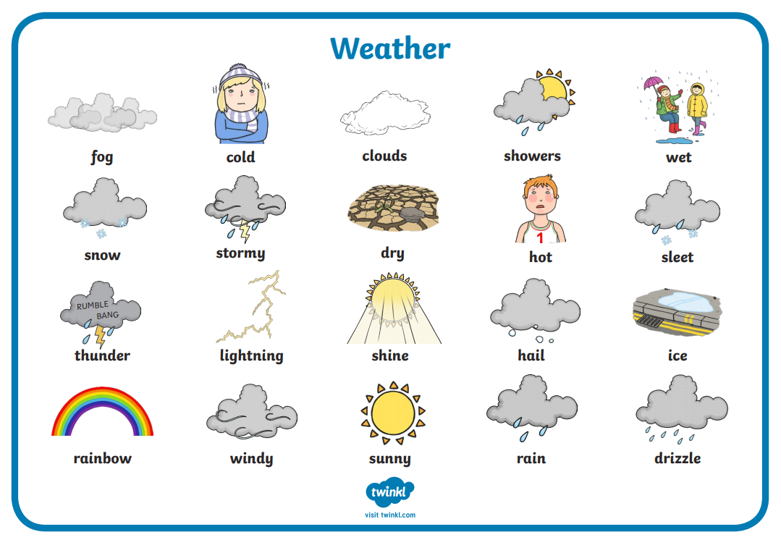

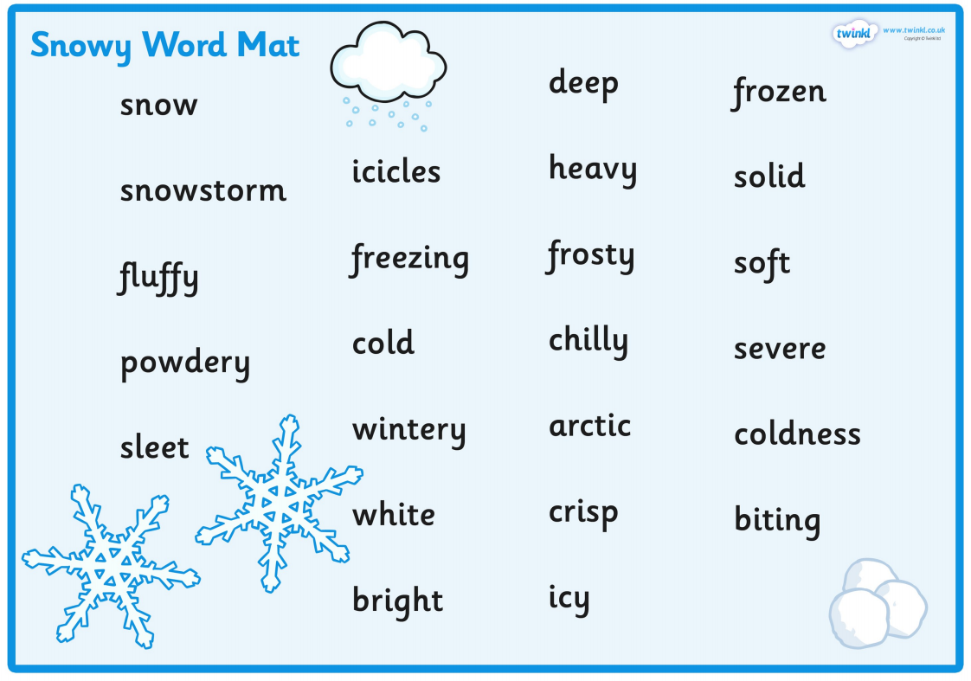

Weather list poem example

A cold day

Fluffy snow
Icy sleet
Bouncy hail
Crisp mornings
Winter clothes
Cold children.

Adjectives: Describing words
Nouns: objects

