Humanities Knowledge Organiser - Year ¾ - Autumn Term 1 – History Theme
Ancient Egypt
Key People |  | Civilization
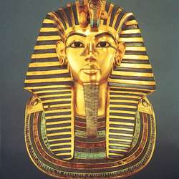  Tutankhamun – known as King Tut was an Egyptian Pharoah. He was discovered in the Valley of the Kings in 1922.  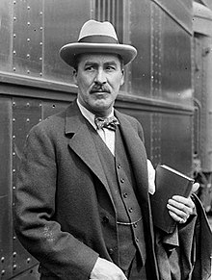  Howard Carter – an archaeologist who discovered Tutankhamun’s tomb in 1922. | 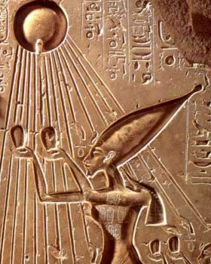  Moses – Hebrew prophet, teacher and leader. He wrote the Torah and lead the Israelites out of Egypt across the Red Sea.  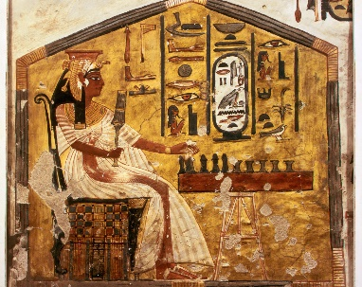  Nefertiti – Queen of Egypt and wife of King Akhenaton who played a key role in changing the Egyptians Religion. | 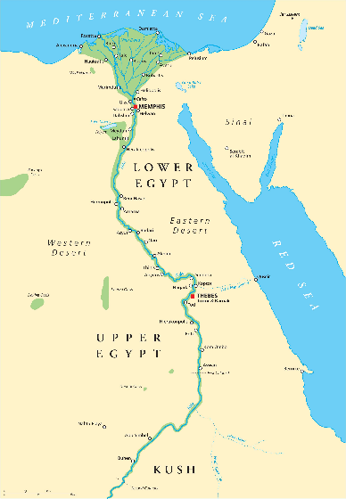  The River Nile  The most important thing the Nile provided to the Ancient Egyptians was fertile land. Most of Egypt is desert, but along the Nile River the soil is rich and good for growing crops. The three most important crops were wheat, flax, and papyrus. ... This was the main type of cloth used by the Egyptians.  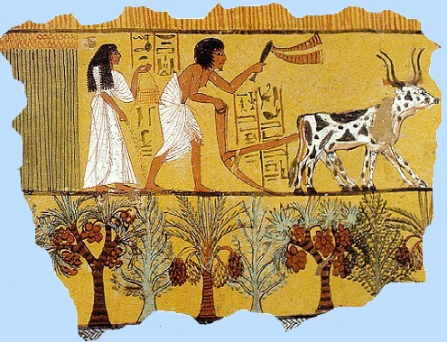  Farming  most of the people were farmers. They grew barley to make beer, wheat for bread, vegetables such as onions and cucumbers, and flax to make into linen. They grew their crops near the banks of the Nile River where the rich black soil was good for crops.

Achievements
Construction
The Egyptians building technology included the ability to build large construction projects such as pyramids and palaces using simple machines such as ramps and levers.

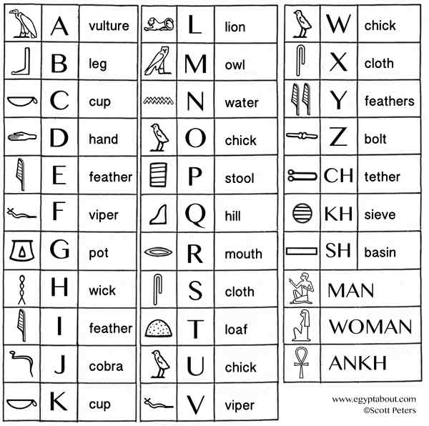
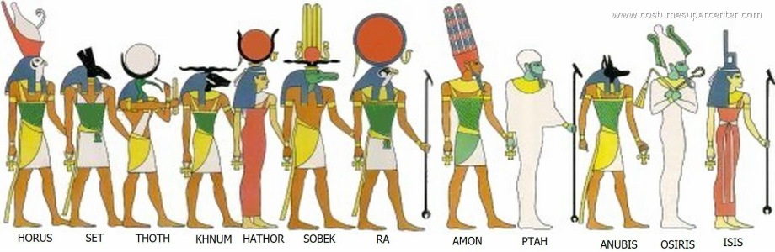
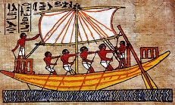
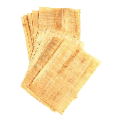
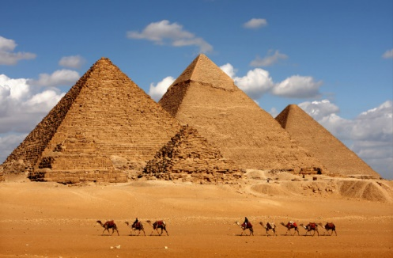
The Ancient Egyptians were one of the first civilizations to form in the ancient world. Their inventions and technology had an impact on many civilizations to come.
Writing
One of the most important inventions of the Ancient Egyptians was writing. They wrote in hieroglyphics. Writing allowed the Egyptians to keep accurate records and maintain control of their large empire.

God and Goddesses

Ship Building
With the Nile River playing a major role in the lives of the Egyptians, building ships was a big part of their technology. They originally built small boats from papyrus reeds, but later began to build large ships from cedar wood imported from Lebanon.

Making Papyrus Paper
The Egyptians learned how to make durable sheets of parchment from the papyrus plant. It was used for important documents and religious texts. The Egyptians kept the process to make the sheets a secret so they could sell the parchment to other civilizations such as Ancient Greece.

