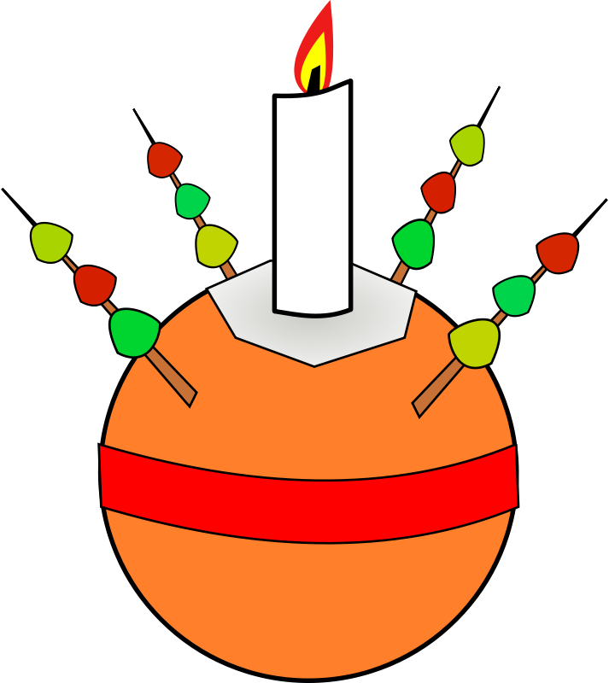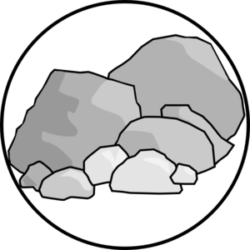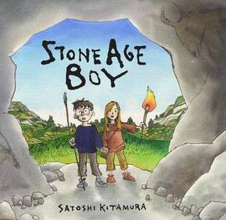

**Autumn Term**

**dates to note**

**Weds 11th Sept: Year 3 Information Sessions**

**Mon 30th Sep: Bridport Library Trip**

**Fri 4th Oct: Whole School Celebration 2:30**

**Weds 6th/**

**Thurs 7th Nov: Parent Evenings**

**Tues 15th Nov: Year 3 Liturgy 8:40 am**

**Fri 22nd Nov: Whole School Celebration 2:30**

**TBC December: Trip to Chideock Church**

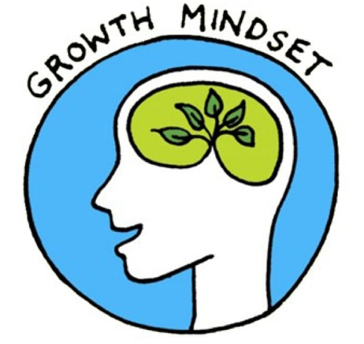

**Year 3**

**Autumn Term**

Autumn 2019

**Humanities**

The children will be learning all about the different challenges for survival of Early Man and how tools and homes and food changed during the Stone Age, Bronze Age and Iron Age.

**Music**

Marinating a beat at different speeds (pulse) and a collection of sounds of different duration (rhythm) and learning to distinguish between the two. Begin using own symbols to represent these and then moving onto the standard notation.

**Science**

We will be comparing and grouping different rocks. We will look at how fossils are formed when living things are trapped within rock. We will also study light (man-made and natural) and shadows.

**PE**

We will be building stamina and personal fitness through a range of activities. We developing our ball skills in a variety of activities. We will also be learning some principles and positions of yoga

**SEAL**

We will begin our year by creating our Class Charter and we will have weekly circle time sessions where we will focus on developing confidence, team work and listening skills.

**French**

As our introduction to French in KS2, we will be learning our numbers to 20 and greetings. We will also learn to introduce ourselves and begin a conversation.

**Art/DT**

This term we will be learning how Stone Age people made paint and cave art. We will move on to study how our ancestors would have made tools such as net.

We will also be tie dying fabrics to represent baptism.

**Computing**

We will be learning how to effectively use ICT for research and also for music making.

**RE**

RE teaching follows the Catholic/Christian ethos and values broadly in line with the church liturgical year. Children learn about religious stories and make links between beliefs and actions. They will also learn about other world religions. We will be visiting Chideock church in December to make Christingles.

**Maths**

In Maths this term we will be covering the topics of place value, addition and subtraction and then multiplication. We will learn to recognise the place vale of each digit in a three-digit number. We will find 10 or 100 more or less than a given number.

Children will be expected to know their 10x, 2x, 5x and 3x tables. We will also learn a formal written method of columnar addition and subtraction as well as adding and subtracting 3 digit numbers mentally.

.

**English**

This term we will be using poetry to explore themes of self-esteem and to introduce the Stone Age topic. We will be looking at instructional writing, play scripts and finally writing persuasive letters just in time for Christmas! Reading lessons will focus around the key skills of retrieving, summarising, inferring, predicting, comparing and understanding of vocabulary and author intent. Spelling lessons will follow the Autumn term Babcock No Nonsense spelling modules.