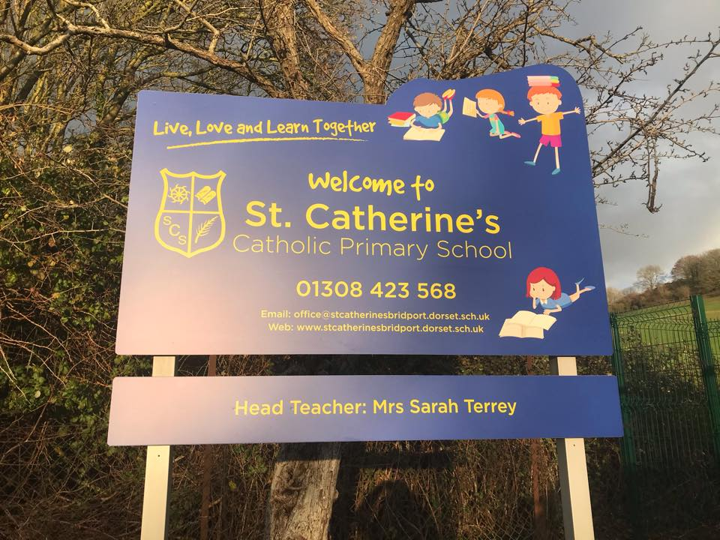  Welcome to St Catherine’s Catholic School.  We are a happy welcoming community and put children at the heart of what we do. We believe each child is unique and we aim, in partnership with our parents, to draw out their talents and to develop each child to strive to reach his/her potential.  To support us in these aims we are very fortunate to have a strong link with St Catherine's Catholic Church in Bridport and to be a part of Plymouth CAST, a multi -academy Trust which links Catholic schools across the Diocese of Plymouth.  Welcome to St Catherine’s Catholic School.  We are a happy welcoming community and put children at the heart of what we do. We believe each child is unique and we aim, in partnership with our parents, to draw out their talents and to develop each child to strive to reach his/her potential.  To support us in these aims we are very fortunate to have a strong link with St Catherine's Catholic Church in Bridport and to be a part of Plymouth CAST, a multi -academy Trust which links Catholic schools across the Diocese of Plymouth.  Starting at St Catherine’s……  Children starting at St Catherine’s are fully supported in our safe and inclusive environment. We have strong links with our preschool providers and we ensure that we know and understand the needs of your child as they begin their school journey with us. We do this by meeting with preschools and parents to ensure that we have a secure understanding of what your child likes to do and how, working with you we can ensure a positive start to school.  If your child has additional learning needs there will be detailed planning to ensure that appropriate support is in place. This will be done in discussion with the school SENCO and Headteacher. |  | Teachers in EYFS  Your child`s journey begins in Oak Class, a mixed Reception and Year 1 classes.  Class Teachers: Mrs R Treble and Mrs K Middleton  Teaching Assistants: Mrs L Pirus, Mrs B Pattinson-Smith, Mrs M Tyrell |  | 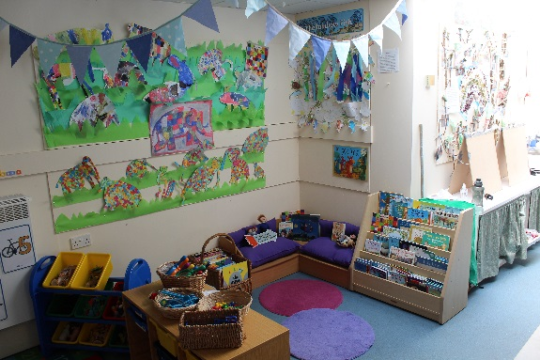  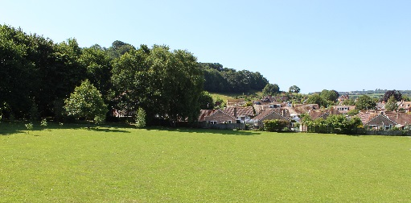  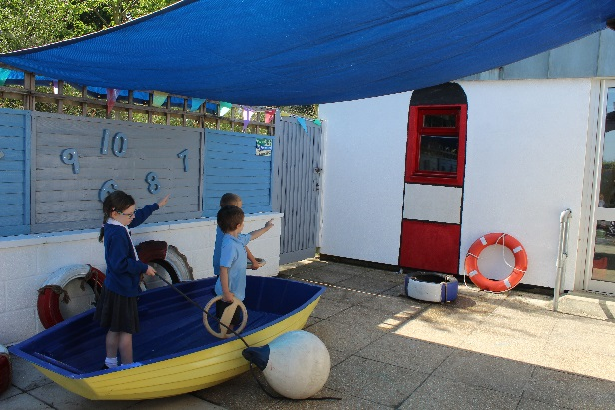

Starting at St Catherine’s……
Children starting at St Catherine’s are fully supported in our safe and inclusive environment. We have strong links with our preschool providers and we ensure that we know and understand the needs of your child as they begin their school journey with us. We do this by meeting with preschools and parents to ensure that we have a secure understanding of what your child likes to do and how, working with you we can ensure a positive start to school.
If your child has additional learning needs there will be detailed planning to ensure that appropriate support is in place. This will be done in discussion with the school SENCO and Headteacher.
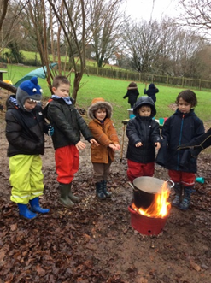
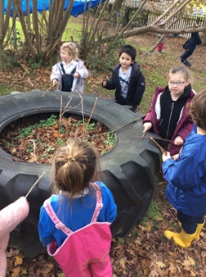
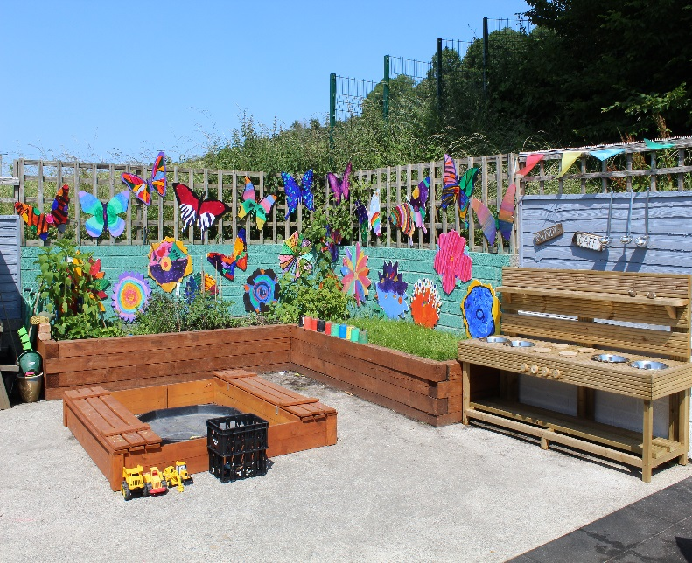 |  | Learning at St Catherine’s for your child.  Learning for children will be carefully planned and will respond to the interest and needs of the children in the class. This foundation year is crucial and at St Catherine’s we are committed to ensuring that your child has a secure basis to access their future learning. Your child will be taught daily phonics and reading using Read Write Inc. We will work with you to ensure that you understand this and can support this vital skill at home. Learning will be planned in topics and some of the topics for next year are: Who lives in A Rock Pool? Stomp and Roar! And The Enchanted Woodland.. With exciting visits and visitors to enrich learning.  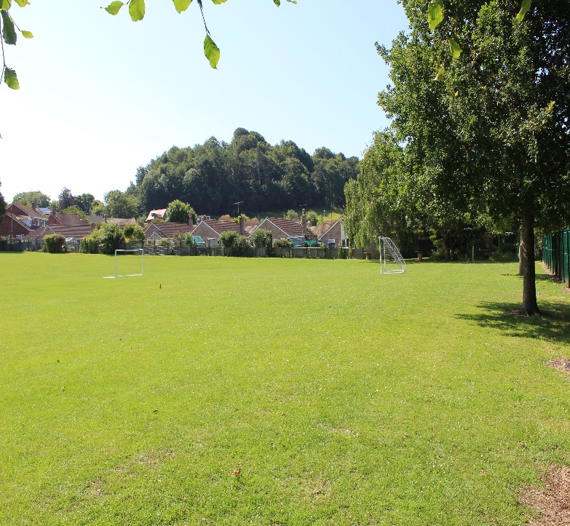  “Live, Love,  Learn Together”  School Uniform  At St Catherine’s being part of the school family is very important to us, we encourage this through many things and school uniform is just one.  - White shirt/Polo shirt or blouse.  - Grey skirt/pinafore  - Grey/black trousers  - Royal blue jumper or cardigan.  - Grey or white socks.  - Grey or royal blue tights  - Dark school shoes (No trainers.)  - Winter coat/Waterproof coat  - Wellies  - PE Kit- black plimsoles/trainers  - Navy/grey shorts  - White T-shirt  - Navy joggers/navy sweatshirt  Please name everything! |  | Learning is assessed and added to a system called Tapestry. This is accessible by parents at home and is great way of being actively involved in your child’s learning both at home and at school.  As a school we encourage positive and regular communication between school and home. There will be 2 parents’ evenings within the year where you will be able to discuss learning and progress in more detail.
We love being Active..  The outside environment at St Catherine’s is wonderful. We are very privileged to have an abundance of space and we encourage the children to access the outdoors often and in all weathers.  In Reception there is a safe outdoor area where the children will be encouraged to explore, climb and investigate making sure that as your child grows physically, they grow in confidence and independence. As a school we encourage our children to be physically active and promote exercise and sports, starting from Reception where your child will participate in the Daily Mile, Yoga- as well as gymnastics and other games..  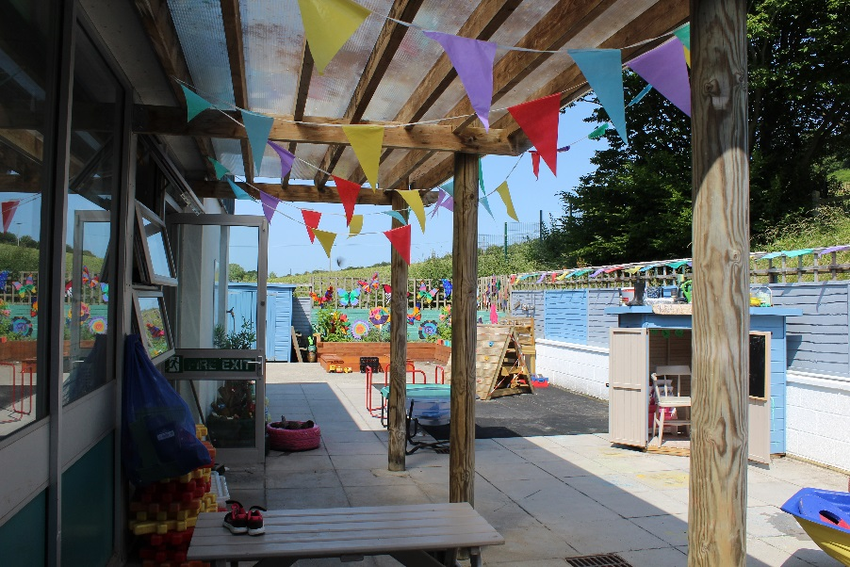  We have developed our Outdoor learning provision with the introduction of Forest School Provision to ensure that our children maintain a love and joy for the wonder of the outdoors and the world around them.  School House Teams.  Your child will be welcomed into the family of St Catherine’s and a school house team.  All the children belong to 1 of 4 Houses and everyone is encouraged to earn House points through good work, behavior and progress.  The children are very excited by the Friday assembly where we discover which House is in the lead. We also celebrate on a Friday with a certificate and the opportunity for children to chose a book of their choice as a reward for all their hard work and achievements.  The House Teams are:  - St George (Red)  - St Andrew (Blue)  - St David (Yellow)  - St Patrick (Green)  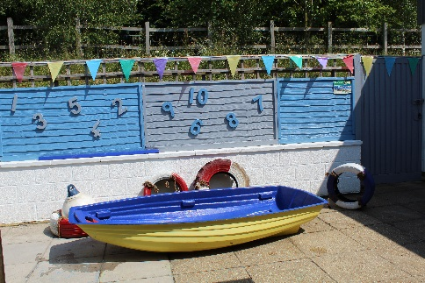  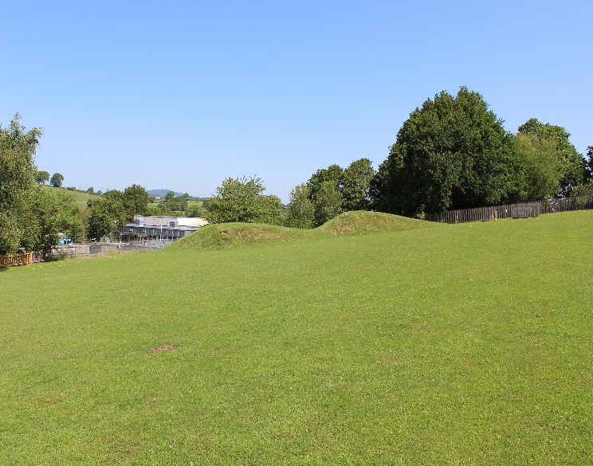  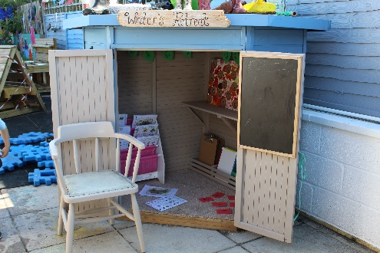 |  |  |  | Our Values  We are proud to be a Catholic school and have strong links with our parish. The children at St Catherine’s’ are encourage to live the Gospel values in their lives. Our Gospel Values are central to our school life  - Humility- seeing life as a gift.  - Compassion-Empathy.  - Kindness-Gentleness.  - Justice- Working for a fairer world.  - Forgiveness- Reconciliation.  - Integrity-Do what you say.  - Peace- Non-violence.  Your child will have opportunities to participate in daily acts of worship, class and school masses and liturgies as well as learning about other faiths and religions.  All school uniform can be purchased directly from the school website and it can be delivered directly to you.  School Milk: If you would like your child to have free milk you will need to contact the Office.  Free Fruit: All pupils in Key Stage 1 receive free fruit at break times or you may provide fruit for a snack at breaktime  The School Day  8.30 am Pupils go into class.  8.45 Registration  9.00- 9.15 Assembly  9.20-10.30 Session 1  10.30-10.45 Breaktime  10.45-11.45 Session 2  11.45- 12.45pm Lunchtime break.  12.45- 3.00 Session 3  3.00pm Home time  The Parent Teacher Friends Association.  This is a group of committed parents who work to fund raise to support the school. They welcome new supporters and volunteers.  Every pupil will receive a school bookbag funded by the PTFA.
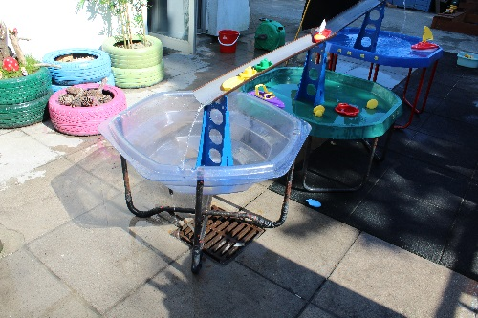
Breakfast Club
Important Contact information.
- Email:
office@stcatherinesbridport.dorset.sch.uk
- Tel no:
01308 423568
- Address
St Catherine’s Catholic Primary
Pymore Road
Bridport

There is an onsite Breakfast club that
can be booked directly. Please
contact the Office for further
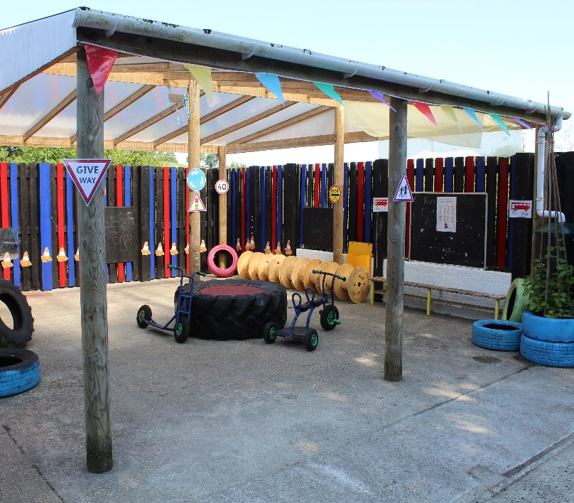
information.
Afterschool Clubs.
There are a range of After school clubs that
pupils can attend during the week from
3.15pm – 4pm
E - schools
The school uses E-Schools to communicate
with parents by text and email and to
organize payments for trips and visits.
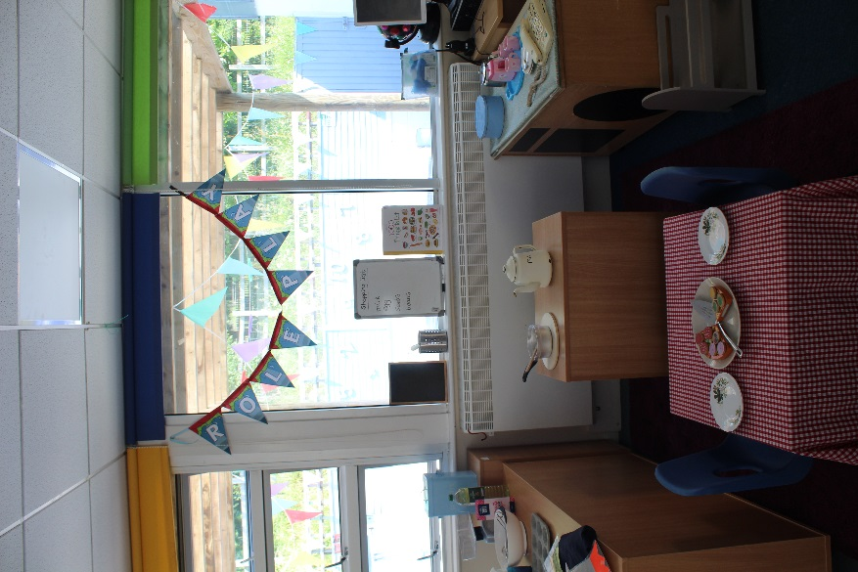
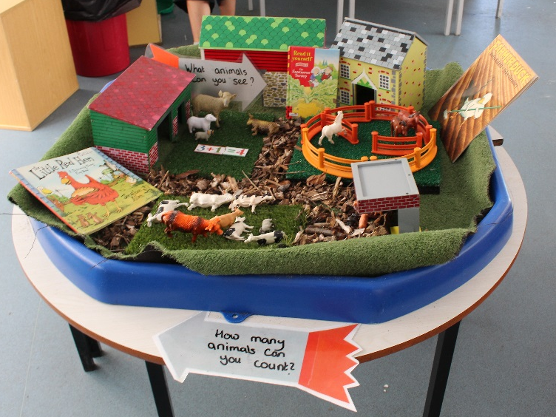
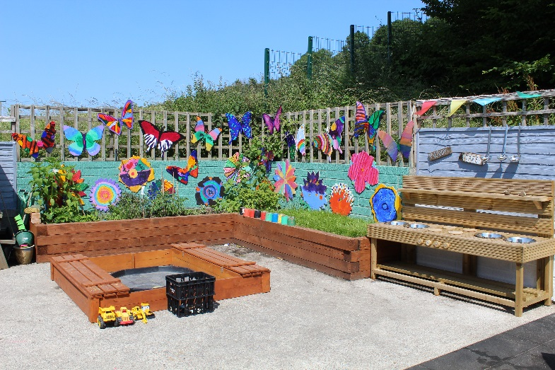
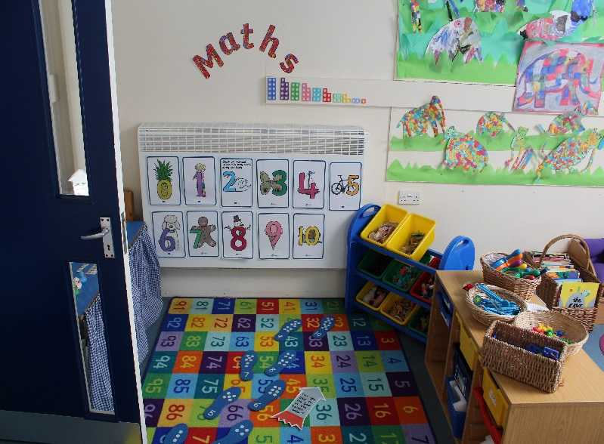
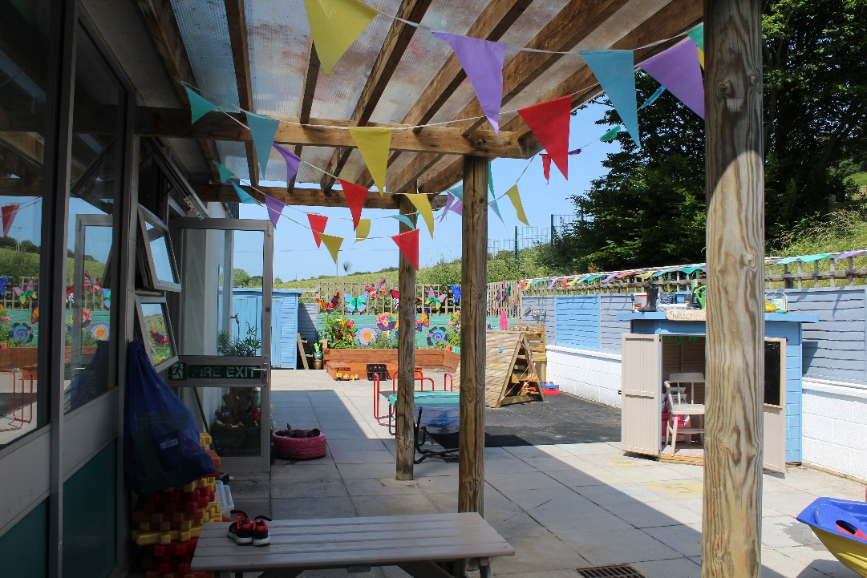
For more information including a video of our setting and meet the teacher stories please visit our website
https://stcatherinesrcs.eschools.co.uk/website

