word | meaning | word | meaning
United Kingdom  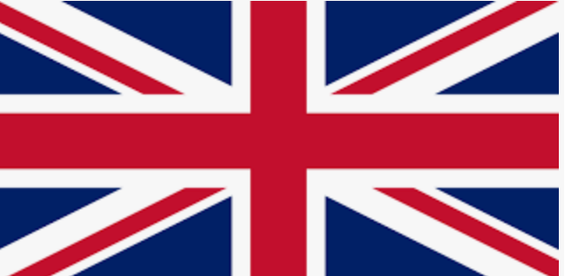 | A country in northwestern Europe on the islands of Great Britain and Ireland and made up of England, Scotland, Wales, and Northern Ireland | English Channel  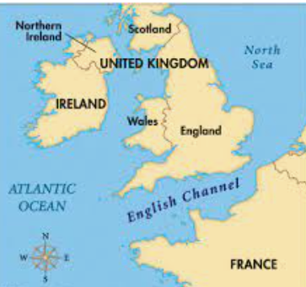 | The sea between England and France
England 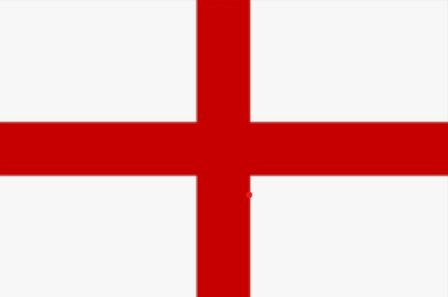 | The largest country on the island of Great Britain. | North Sea  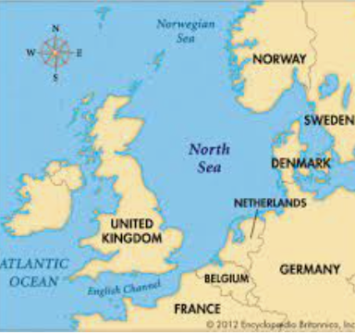 | A sea that is part of the Atlantic off the North of Great Britain
Scotland 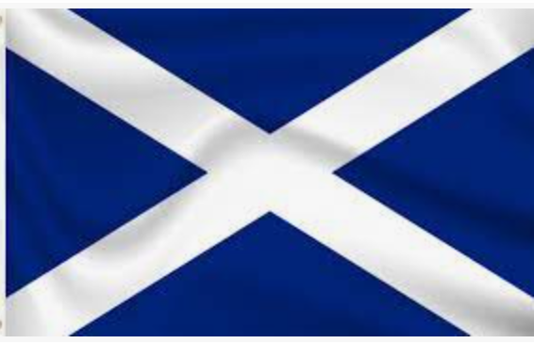 | A country in Europe on the northern part of the island of Great Britain.
Northern Ireland  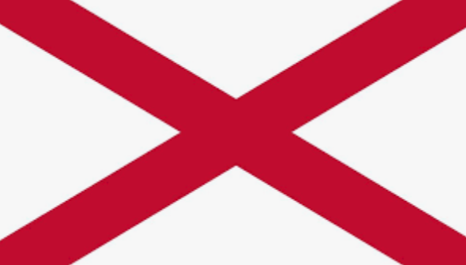 | An island in western Europe. Northern Ireland is in the northern Atlantic Ocean. | Ocean | The very big bodies of salt water over the surface of the Earth. There are 5 oceans.
Wales 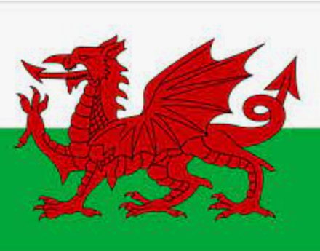 | A country in Europe on the southwestern part of the island of Great Britain. | Sea | A smaller body of salt water, completely or partly surrounded by land.
London | The capital city of England | Weather 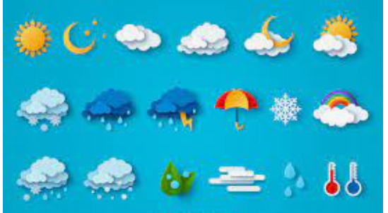 | What it is like outside at the time- sunny, rainy, windy
Edinburgh | The capital city of Scotland | Human 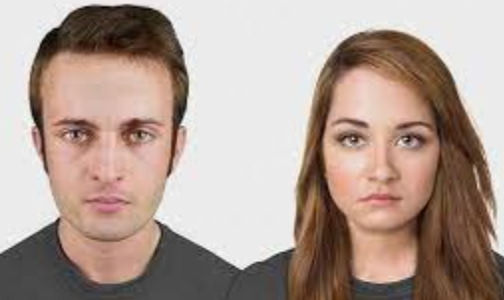 | Things made by people-man-made.
Belfast | The capital city of Northern Ireland | Physical 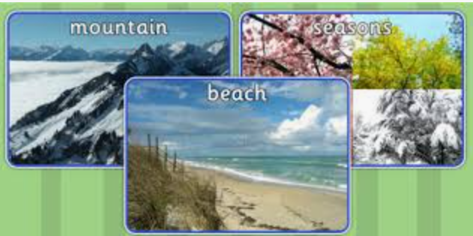 | The world around us like hills, rivers, cliffs.
Cardiff | The capital city of Wales | Farming/Farm  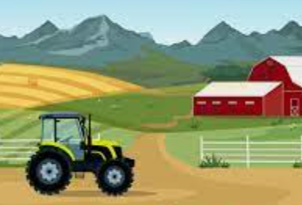 | When people grow crops and look after animals to make food.
Africa 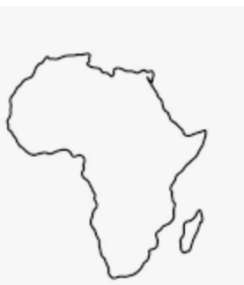 | The second largest continent. Africa is south of Europe and between the Atlantic and Indian Oceans. | Crops  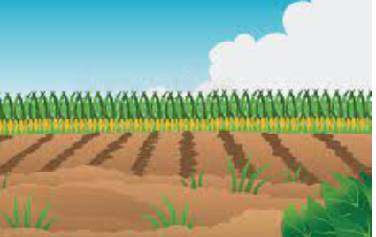 | Plants grown on a farm
Kenya  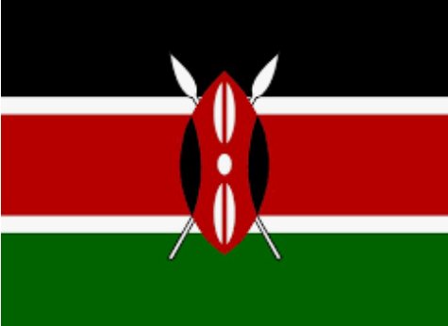 | A country in eastern Africa on the Indian Ocean. Nairobi is the capital of Kenya. | Tourists  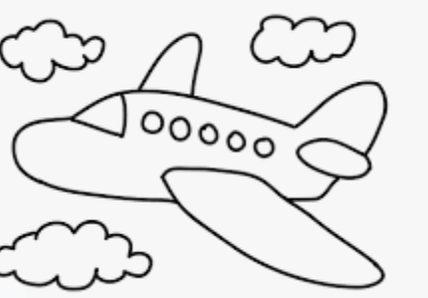 | A person who is travelling for fun.
Nairobi | The capital of Kenya. | Town  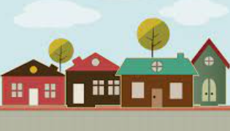 | A place with streets, houses, and buildings. It is bigger than a village but smaller than a city.
Dorset | A county in the south west of the United Kingdom | Village  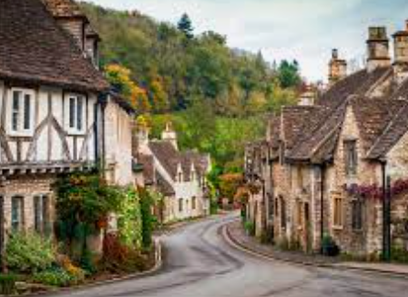 | A small place where people live often in the country.
Bridport | A market town in Dorset | City  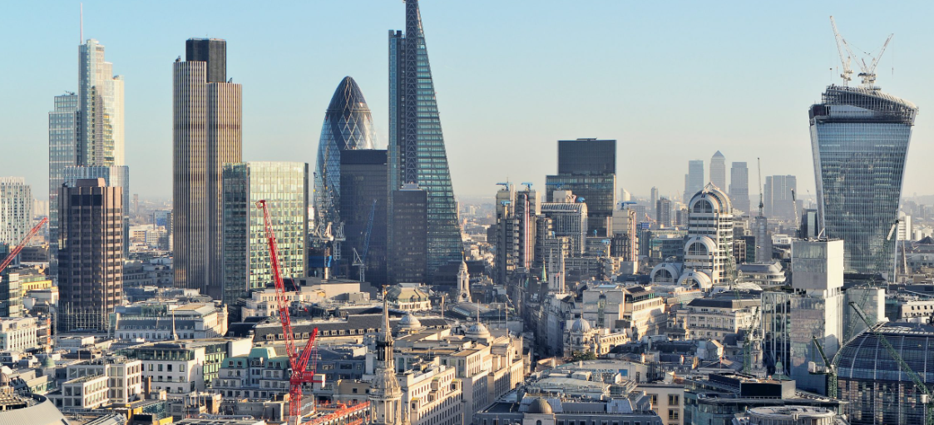 | A large and important town where many people live and work.
Equator  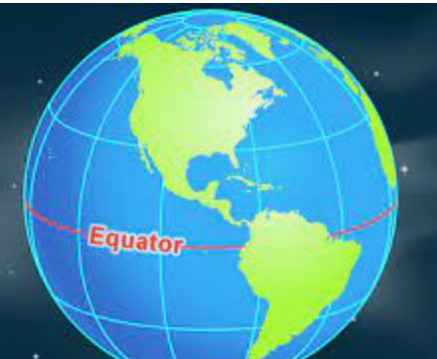 | The pretend circle around the earth that is halfway between the North and South Poles. | National Park | A large bit of land that is protected and looked after because it is special
North Pole 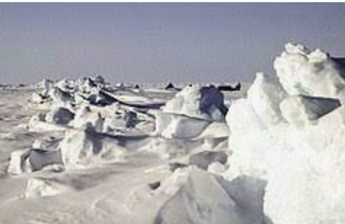 | The point on the earth's surface that is farthest north. | Animals 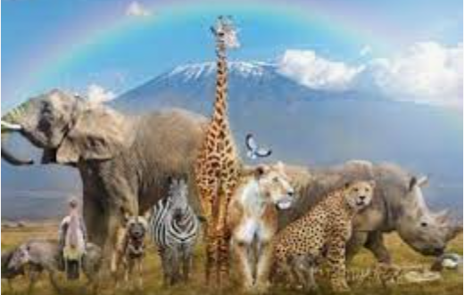 | a creature other than humans.
South Pole | The point on the earth's surface that is farthest south. | Fairtrade 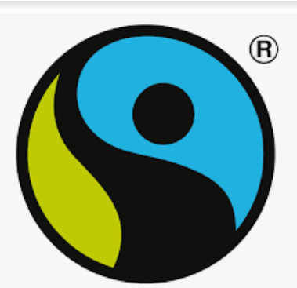 | A way of buying and selling things that makes sure Farmers are paid fairly.

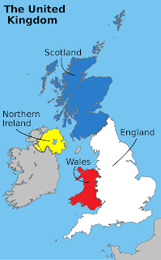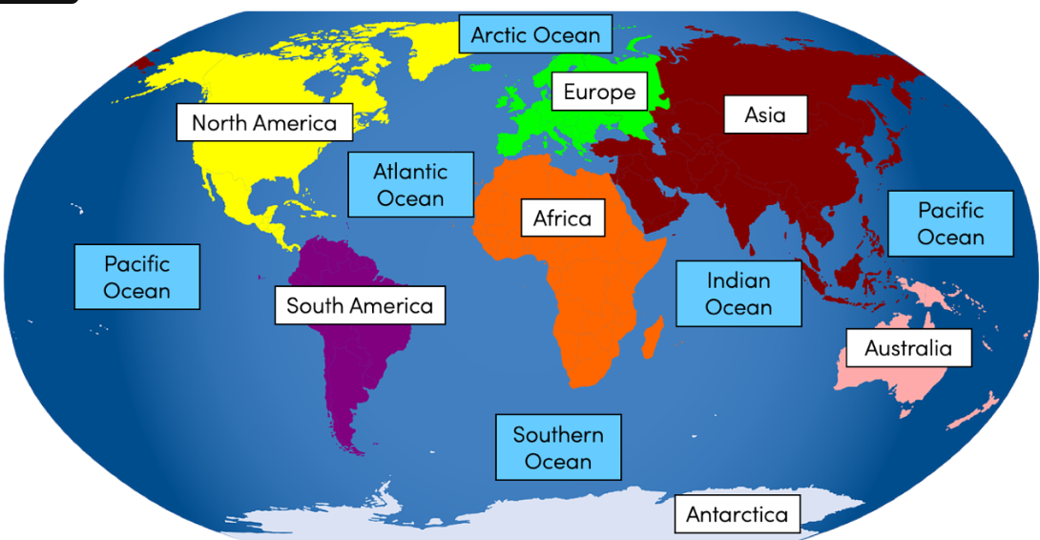
This Photo by Unknown Author is licensed under CC BY-SA-NC

