To my lovely Year 6s
How’s it going? Are you managing to stay inside and keep safe? I hope so. I have been planning some lovely things for us to do in the summer term plus walking Chesil on Chesil beach! What a weird name for a dog! I have also painted a world map on the wall of my conservatory – something I have wanted to do for ages.
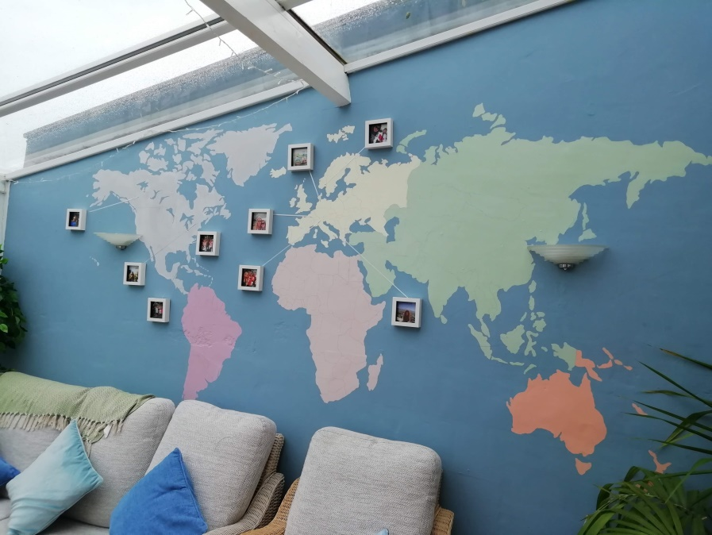
I miss seeing all your lovely smiling faces in the morning but not to worry, the important thing is to keep safe and hopefully you will all be back before the end of term. We have sooo much to do! How did you get on with the home learning work over the last 2 weeks of term? Some of you have emailed me, which is great (50 HP each) , and shared what you have been up to. If any of you have created or done something brilliant, send me a picture so I can share it with the rest of the Y6 gang. I hope you are visiting our web page as I am gradually adding extra bits for you to look at. Have you seen Haydn’s fancy foot work, Kieran’s poem or Lucas’s moment in the spot light? Well check it out!
I am back in school on Monday and will endeavour to phone you all to check you can access the work I’ve put up. This term I thought we would focus on problem solving and reasoning with maths and our topic will be Charles Darwin. Hopefully you know something about him as one of the tasks last term was to research him. Don’t worry if you haven’t done it – there is plenty to do now. So below is a rough timetable for you to follow.
The maths is a PDF below this letter. There are two to do – reasoning and problem solving. I suggest you aim for 1 task/topic per day. Do more if you wish but let me know if you run out. Sumdog also needs completing. Continue practising your spelling – do you know all of them yet? There are some writing ideas on the topic sheet. Aim to do about 3 hours a day. Oh, and are you following Joe Wicks on YouTube? He is on at 9.00am each morning. I am –I wonder if Mr Toohill is? He has given me some good ideas for our P.E. warm ups. Try to keep some sort of routine going with the work. I know it’s difficult when the sun is shining and your mates are messaging you but it’s really important you try. Y6 is an important year and I want you all to be ready to move onto secondary school in September. I want you all to hit the ground running when you get there (not literally)!
So I will be in school on Monday and Tuesdays if you need anything like paper, paint, printouts, science equipment ect. Also you can e-mail me all week as I will be at home on my computer Wed, Thurs and Fri. If you find it easier to work from a pack, let me know and I will print it all out for you. I can either deliver it to your house or you can come and get it from school on your daily walk.
Bye for now and take care
From Mrs Franklin.
Weeks 1,2,3,4.
 | Non-negotiables | Topic
Mon | Sumdog Challenge  Reasoning Topic 1- Place Value  Problem Solving Task 1  Spellings – Learn 10 a week using a method that you enjoy most.  Reading –Aim to finish a book in 4 weeks. Then write a book review.  Writing – see topic choices. | Session 1 – Who was Charles Darwin? Week 1 only.
Tues | Sumdog Challenge  Reasoning Topic 2  Problem Solving Task 2  Spellings – Learn 10 a week using a method that you enjoy most.  Reading –Aim to finish a book in 4 weeks. Then write a book review.  Writing – see topic choices. | Choose I suggestion from the list. You can take as long as you need over each one but make sure you include some detailed writing.
Wed | Sumdog Challenge  Reasoning Topic 3  Problem Solving Task 3  Spellings – Learn 10 a week using a method that you enjoy most.  Reading –Aim to finish a book in 4 weeks. Then write a book review.  Writing – see topic choices. | Choose I suggestion from the list. You can take as long as you need over each one but make sure you include some detailed writing.
Thurs | Sumdog Challenge  Reasoning Topic 4  Problem Solving Task 4  Spellings – Learn 10 a week using a method that you enjoy most.  Reading –Aim to finish a book in 4 weeks. Then write a book review.  Writing – see topic choices. | Choose I suggestion from the list. You can take as long as you need over each one but make sure you include some detailed writing.
Fri | Sumdog Challenge  Reasoning Topic 5  Problem Solving Task 5  Spellings – Learn 10 a week using a method that you enjoy most.  Reading –Aim to finish a book in 4 weeks. Then write a book review.  Writing – see topic choices. | Choose I suggestion from the list. You can take as long as you need over each one but make sure you include some detailed writing.

