Mrs Kranky’s Bus
Mrs Kranky always gets on the bus at Kranky Farm.
a. If she gets on at 9:08, how long does it take her to get to Wonky Road? ______________
b. Mrs Kranky gets to the bus stop at 9:20. How many minutes must she wait for the next bus? _______________
c. What is the latest time Mrs Kranky can get on the bus if she wants to get to Rottertown before 10:30? ___________________
d. Mrs Kranky gets on the bus at 9:27 and gets off 23 minutes later. Which stop does she alight at? __________________
e. Mrs Kranky takes the 10:08 and decides to get off at Foulview Terrace and walk the rest of the way into Rottertown, which takes her 20 minutes. How long did her journey take her altogether, starting from Kranky Farm? __________________________

George’s Mum – Mrs Kranky

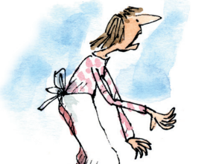

Bus Timetable
 | Kranky Farm | Wonky Road | Gusto Garage | Foulview Terrace | Rottertown
1 | 9:08am | 9:20 | 9:31 | 9:45 | 9:58
2 | 9:27 | 9:39 | 9:50 | 10:04 | 10:17
3 | 9:56 | 10:08 | 10:19 | 10:33 | 10:46
4 | 10:08 | 10:20 | 10:31 | 10:48 | 10:56

