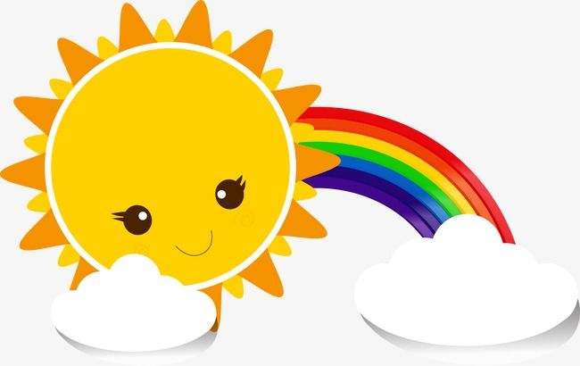
Week four

Hi Gang,
I hope you are all well and learning new skills. Thank-you to those of you who are sending me photos of your work or just a friendly e-mail. It’s great to stay in touch. For those who haven’t….why? I want to hear from you all! Have you all visited our web page? I have been putting up all your lovely work – there is some lovely poetry by Ruby and amazing drawings of birds by Kian to name but a few.
I have a couple of important messages for you.
- Your parents are about to receive an e-mail from your secondary school explaining how things are going to work. Have a read so you also know.
- Your parents will receive an e-mail from me asking for a list of friends you would like to be with in your new class and your chest measurement for the hoodies. Make sure they send it back as soon as possible.
The final thing I want to mention is about the Bridport Lockdown Project. Have you heard about it? It sounds really good. Check out their website. Anything you create send it to me and I will submit it to the project. It has to be a memory of the lockdown but in any format – photos, drawings, models (Will/Haydn?) stories, poems (Kieran, Ruby?) recounts etc. Be as adventurous as you want but make it unique and interesting. Anything you create, send it to me and I will submit it to the project.
Ok well that’s all for now, take care, keep safe and be creative.
Mrs Franklin x
P.S. We are in for some more sunshine next week.

