English – List Poems

We have already learnt about shape poems, calligrams in Year 2. Now we are going to learn about list poems.
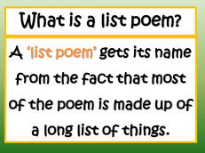

Here are some examples.

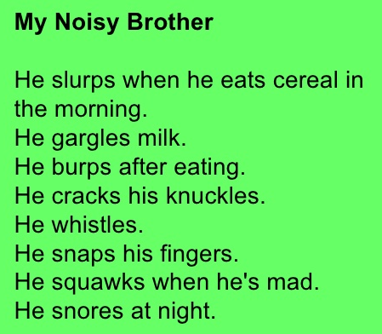 | 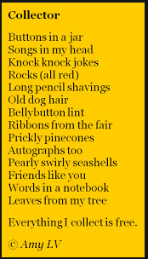

You have three tasks to complete about list poems.

Task 1: A Weather list poem.
Complete the list of nouns by using an adjective to describe each one.

Task 2: A Christmas list poem.
Write a list of nouns (objects related to Christmas and choose an adjective to describe each one.

Task 3: Practice your Christmas list poem so you feel confident to read it to the class on your return to school.

You may also like to try to learn it off by heart.

