**2. Structures and representations**

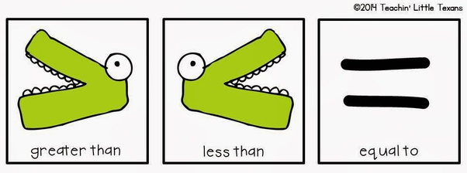

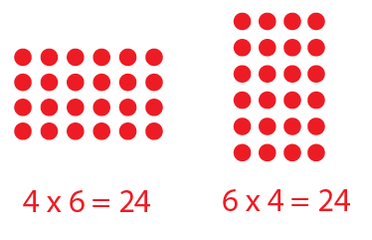 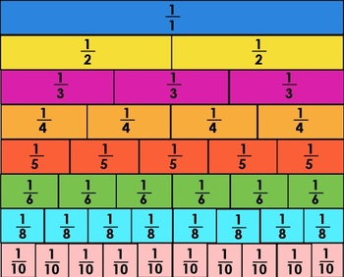

**3. Vocabulary**

­ **Multiplication and Division:**

multiplication statement ­ grouping, groups, equal, total, repeated addition ­ correspondence, multiply, divide, combinations

**Fractions:**

tenth, hundredth ­ equivalent fraction ­ improper fraction, mixed number ­ simplify, simplest fraction part, whole, equal parts, fraction, unit fraction, non-unit fraction, denominator, numerator

1. **Concepts**

**Dividing**

**Multiplying**

**Fractions**