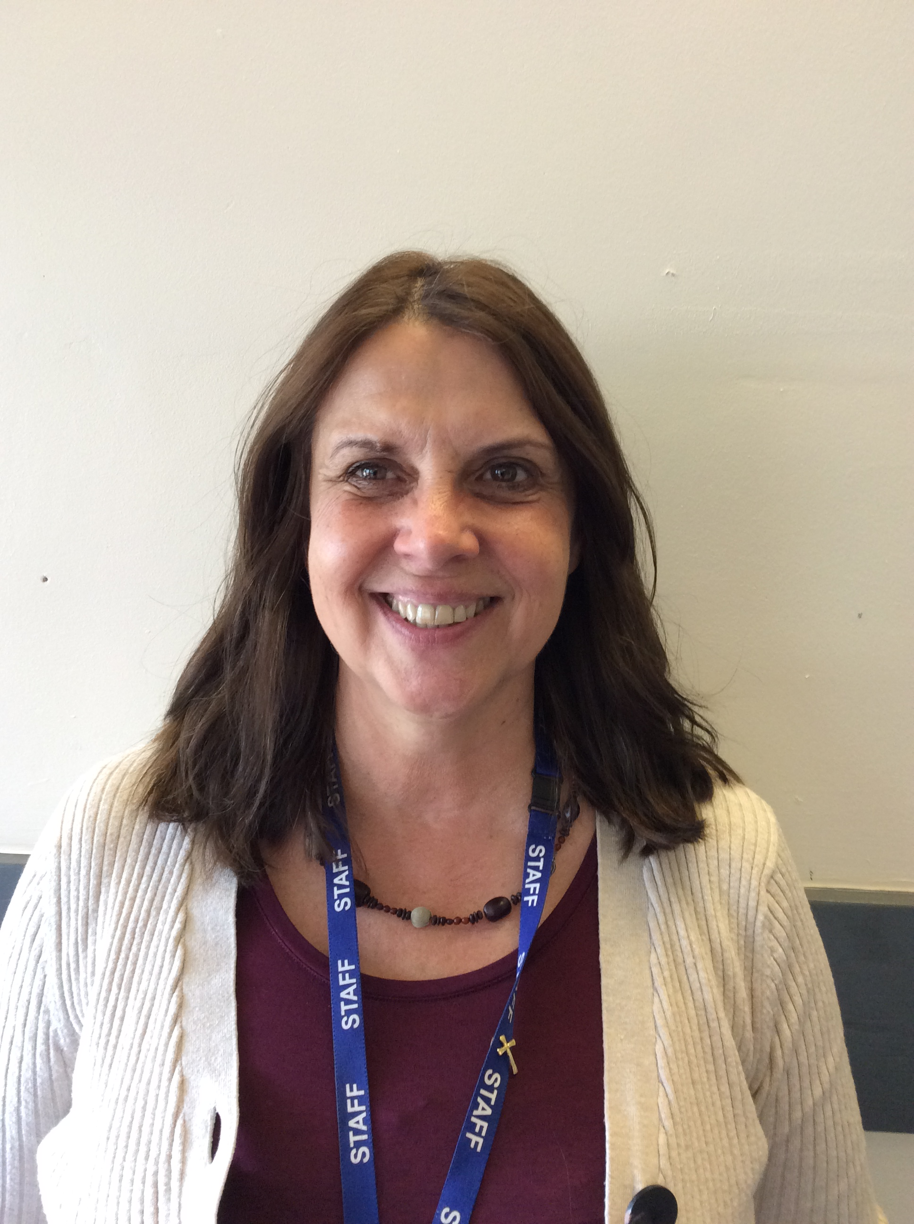
Mrs Terrey Mrs Blake Mrs Harris
We are all here to listen, you can speak to any of the adults in our school.

Speak to us, we are here to listen to you.
St Catherine’s
Safeguarding Team
Is something worrying you ?

.

You can speak to any member of staff and they will speak to us.
Teachers Teaching Assistants

Lunchtime Supervisors Office Staff

Volunteers / Club Organisers Governors

Remember you can also write your worry down and post it in the worry box.

