St Catherine`s
Catholic Primary School

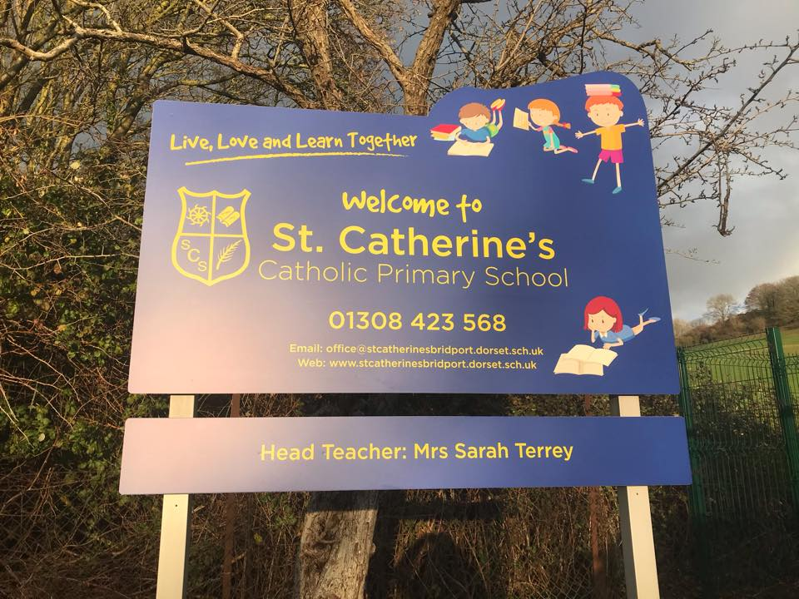

Prospectus for New Pupils &
Parents

St. Catherine’s Catholic Primary School

Pymore Road
Bridport
Dorset
DT6 3TR
Tel: (01308) 423568
Fax: (01308) 421291
Email: office@stcatherinesbridport.dorset.sch.uk
Website: www.stcatherinesbridport.dorset.sch.uk

Contents

- Letter From Headteacher
- Introduction to our school
- CAST Mission Statement
- Our School – Staff
- School Routines and Procedures
- Our Curriculum
- Tapestry
- British Values
- Attendance and Leave of Absence
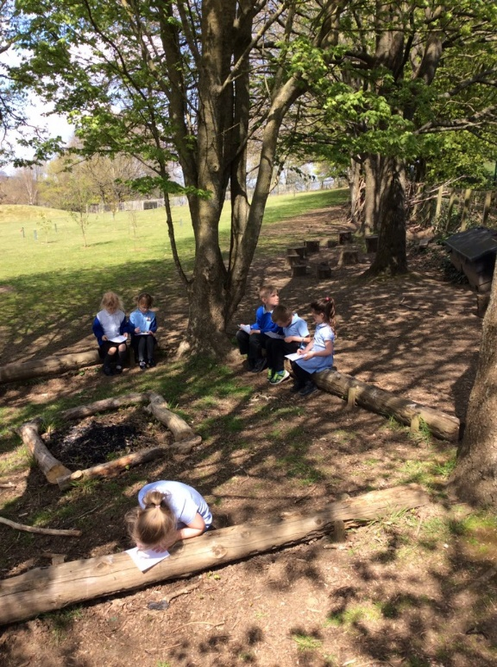
- School Uniform
- Free School Meals
- Pupil Premium
- RE at St Catherine`s
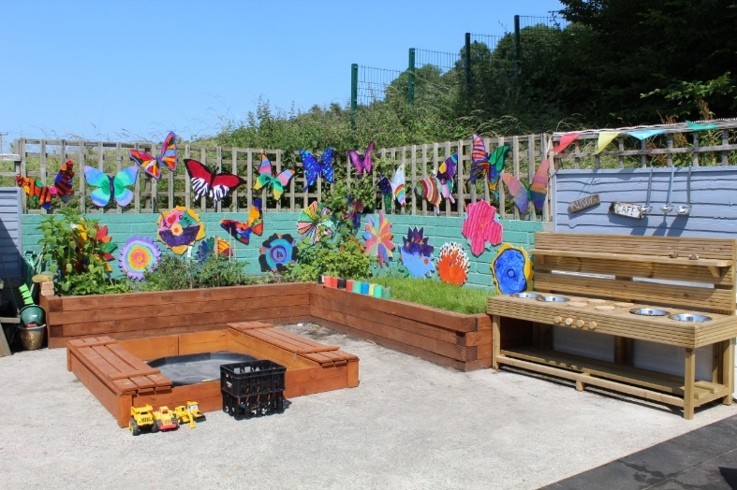

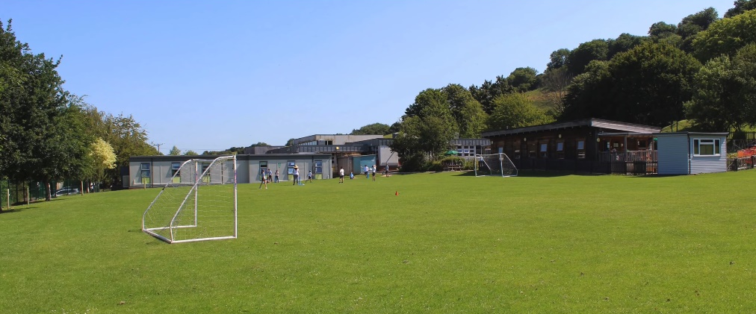

St. Catherine’s Catholic Primary School Head Teacher Mrs Sarah Terrey

Pymore Road Tel: (01308) 423568
Bridport Fax: (01308) 421291
Dorset Email: office@stcatherinesbridport.dorset.sch.uk
DT6 3TR Website: www.stcatherinesbridport.dorset.sch.uk
Plymouth CAST Multi Academy Trust,
The Edmund Rice Building,
St Boniface College,
21 Boniface Lane,
Manadon Park,
Plymouth,Devon, PL5 3AG.
Dear Parents,
Welcome to St Catherine’s Catholic Primary School.
We hope that this will be the beginning of a long and happy membership within our school community. By entering your child into our school you invite us to be a partner in his/her education and this is a privilege that we value. We wish to work closely with you to ensure that your child’s primary years are happy and productive.
St Catherine’s is the Catholic primary school serving Bridport and its neighbouring areas in West Dorset. As a Catholic school our principle aim is to maintain and teach our faith and this permeates all areas of school life. We enjoy the support and close liaison of the parishes we serve in Bridport, Chideock and Beaminster.
We provide a caring community known for its very effective education and offer children maximum opportunities to discover and develop their personal talents and to use them positively for the benefit of all. We offer quality teaching with high expectations for all the children. We can only attain these aims with full confidence and trust in the three-way partnership of parent, teacher and child.
We hope that you and your child will feel that you belong and that you are proud that this is your school.
Yours sincerely,
Mrs Sarah Terrey
Headteacher

Introduction to our school
The governors, staff and parents at St Catherine’s aim to create a caring Christian community where children can flourish in a stimulating learning environment. Our core Christian values help us make decisions about how we behave, create a stronger sense of community and improve our social and relationship skills. They are a guide to how we – children, staff and governors alike – aim to live our lives, influencing our attitudes and actions, encouraging us all to take responsibility for our own learning and behaviour.
Developing children’s academic, spiritual, social and personal skills is a central part of the school’s aims and children are given opportunities to pray and reflect throughout the school day.
Our mission statement underpins all our activities as we endeavour to live the message of the Gospels by doing our best, working hard together in a place of love, warmth and safety, following the teachings of Jesus.

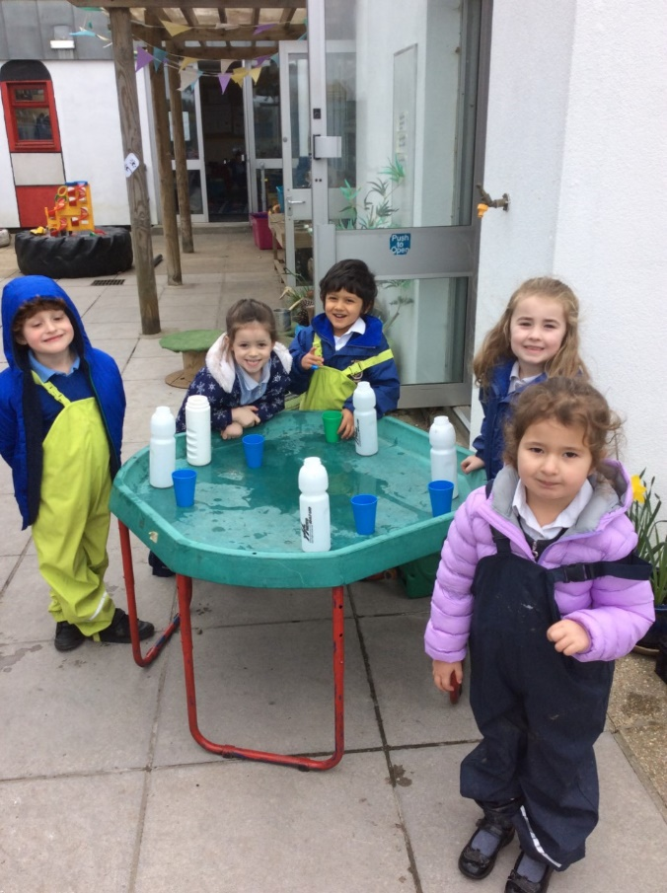
Mission statement
Live, love and learn together
We aim to:
* Work hard to be the best we can be, celebrating and enjoying our achievements.
* Love, value and respect each other as Jesus taught us.
* Reach out to those who need us both near and far.
* Say sorry with honesty and courage and learn to forgive each other.
* Create a happy atmosphere, lasting friendships and wonderful memories.
* Create an environment where we feel spiritually, emotionally and physically safe, and our thoughts and feelings are listened to.
Different faiths and beliefs
Whilst we are a faith school, many of our pupils are not Catholic. Every pupil in our school is valued as an important member of our school community. We have high expectations of all our pupils and we are committed to developing every child to the best of their ability regardless of age, academic level, race, gender, religion or physical ability.
Our school mission statement reinforces the requirement to love and value each other, and our RE curriculum, Christian values and behaviour management Choices policy encourage children to live lives of empathy, compassion and tolerance.

CAST Mission Statement

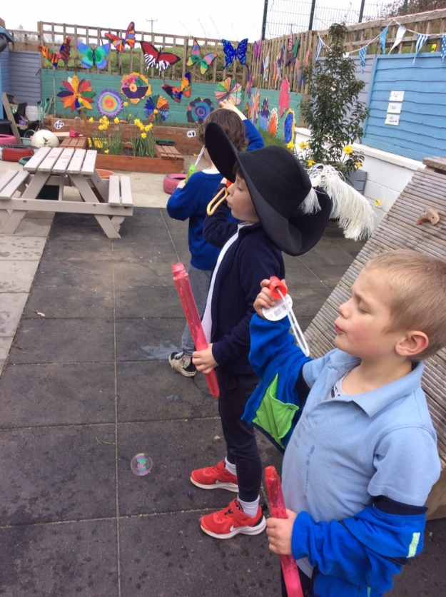
Our mission is to be a community of outstanding schools in which our pupils flourish in safe, happy and stimulating environments and leave us with the knowledge and skills, personal qualities and aspirations, to make the world a better place, inspired by the Gospel.
Our Vision Statement
The Church insists on the highest standards of academic achievement in its schools, so that our young people leave us as ‘agents of change’ – educated and caring people who have the qualifications, knowledge and skills they need to flourish as human beings and make the world a better place. Inspired by our Teacher, Jesus Christ, and his good news to the poor, we have a commitment especially to those who are disadvantaged. We are determined that a child’s start in life need not determine their future. We are committed to the well-being of the earth, our common home, inspired by the example of Pope Francis: to live wisely, think deeply and love generously.
In all our schools we will develop a culture of high expectation and aspiration, based on our fundamental belief in the dignity of all human beings. We want all our pupils to flourish in safe, happy and enriching environments, taught and supported by adults who are skilled, motivated and committed to our shared vision and values. We will work together as one Trust, one family of schools, a community inspired by a vision for excellence. We commit ourselves to deepen our mission and raise standards in order to provide an excellent Catholic education for every child in our care.
When this vision becomes a reality, our pupils will leave us with:
• A sense of their dignity and worth as a person loved by God
• A sense that creation is God-given and good and we have a duty of care towards our common home
• The best academic qualifications they were capable of achieving to allow them to flourish in adult life
• A sense of service to the world, especially to the disadvantaged
• A sense that they are gifted and called to a vocation of service in life
• Happy memories of their time in school, especially of how adults made them feel – a sense of belonging

Our School
Headteacher
Mrs S Terrey – SENDCO/ English Lead
Deputy Headteacher
Mrs L Blake –Designated Safeguard Lead
Teachers
Mrs C Best – Year 2 Teacher / Pupil Voice
Mrs L Blake - Yr ¾ Teacher/ PE Lead/ IT lead
Mrs G Dickson - Year 2 Teacher / Science Lead
Mrs J Franklin – Year 5/6 Teacher / Maths Lead
Mrs L Harris – Year 4/5 Teacher / RE Lead
Mrs K Middleton - EYFS Teacher/ MFL Lead
Mrs B Treble- EYFS Teacher/ EYFS Lead/ Humanities Lead
Teaching Assistants
Mrs M Tyrrell
Mrs B Pattinson-Smith
Mrs L Pirus
Ms K Ivory
Mrs L Butchard
Mrs E Tschuchno
Mr L Toohill
Mrs M Friedman

Support Staff
Mrs T Sherrin – Senior Office Administrator
Ms E Fearn – Admin Assistant
Mrs M Hosking / Mrs L Burgess / Mrs N Daubney – Lunchtime Supervisors
Mrs M Coombs – Lead Cleaner
School Routines and Procedures

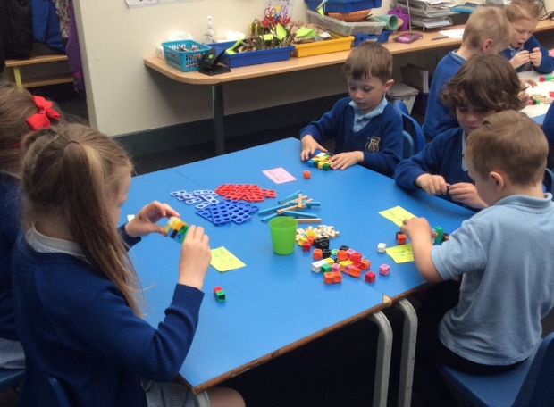
The School Day
8.30am Children arrive to begin their school day with registration at 8.45am
10.15 -10.30am Playtime for KS1
10.30-10.45am Playtime for KS2
12-1pm Lunch time
3.00pm School day ends

Medicines
Parents are asked to provide the school with up-to-date information (DfE Template B found in the appendix of ‘Supporting Children with Medical Conditions and Managing Medicines’ Policy) so that arrangements to manage their short or long term medical conditions can be implemented in partnership. Parents MUST deliver medicine to school if it is not possible for this to be administered outside the school day. Medicine should be provided in the original container(s) ensuring that the medicine is not out-of-date and that it has been stored correctly.
All medicines MUST be marked with the following information clearly indicated:
• the child’s name on the medicine;
• when the medicine should be given;
• the prescribed dose and pharmacist’s instruction, e.g., after meals.

Parents are expected to notify the school immediately (in writing) of any changes or alteration to a prescription or recommended treatment so that adjustment can be made to Individual Healthcare Plans or previous agreement. It is important that the school is aware and informed by parents about other issues or symptoms their child may have experienced over night or before school; this is particularly important for asthma conditions. Only medication prescribed by the Doctor and required to be given 4 times a day will be accepted in school. You will also be required to complete a ‘consent form’. Please note that unfortunately we are unable to administer medicine such as ‘Calpol’ or cough medicines. If medicine needs to go home at the end of the day, it is the parents’ responsibility to collect it from the office staff. Children will not be given medicines to take home without an adult. Please refer to ‘Supporting Children with Medical Conditions and Managing Medicines’ policy for more information.

Signing in / out during the school day: If your child arrives after 8.45 a.m. or has to be taken out of school during the school day, please make sure that you sign them in or out at the school office.

Sickness: If your child is away from school for any reason, please telephone or email the school office by 9.00am on the day of absence to let us know the reason for your child’s absence.

Parking in school: Please note that parking in the school grounds is not allowed. The current arrangements are for the main school gates to be closed and locked to all traffic between the times of 8.40 a.m.to 3.15 p.m. If you are visiting the school during the school day we ask that you park within the spaces outside our school gates. The gates will be kept locked for the safety of your children. Please be considerate of passing traffic along Pymore Road and consider where you park your car to drop children off. Please note cars are not permitted to park in front of the school gates to drop off and pick up.

End of the Day: Please could you ensure that your child knows how they are getting home at the end of the day – it is very confusing for everyone when arrangements change during the day. Please could you telephone the school office before 2pm with any changes to going home arrangements.

Absence request forms: Parents can request for their child’s absence from school during term time, but it will only be authorised in ‘exceptional’ circumstances. All family holidays will be ‘unauthorised’ in-line with DCC policy. We ask that all routine medical, dental & optical appointments are made outside of school hours if possible. If your child has an appointment, i.e. medical or dental please provide the school office with a copy of the proof of appointment.
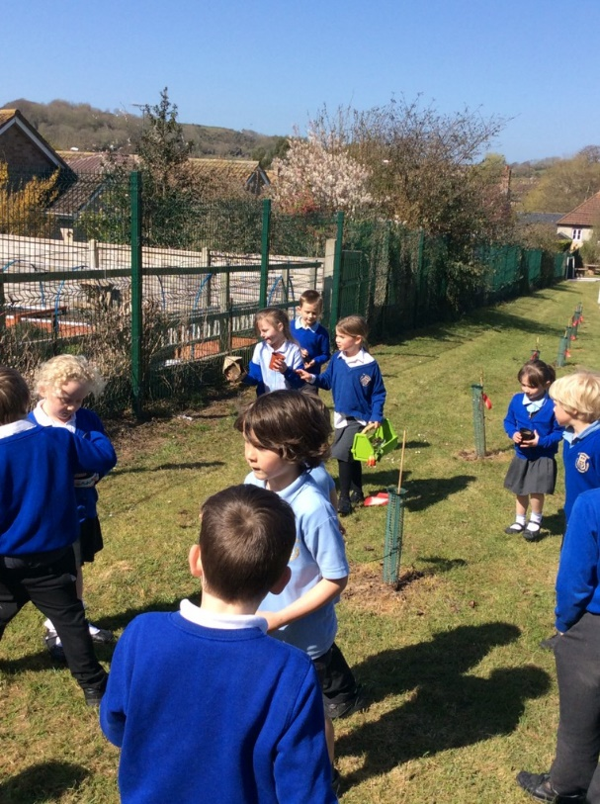
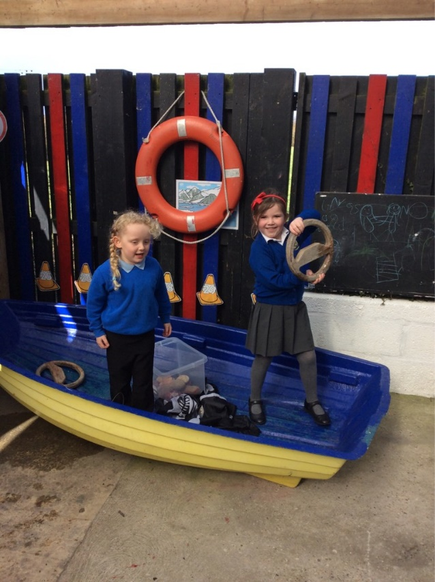

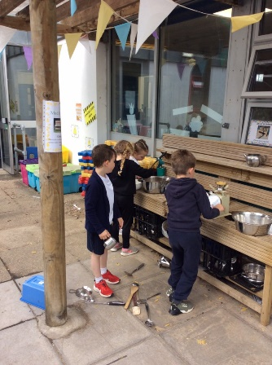
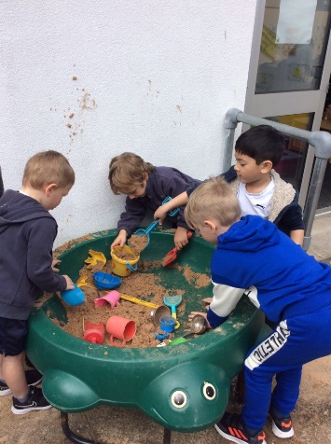

Live, Love, Learn
St Catherine`s Curriculum Intent
St Catherine`s Primary School is a Roman Catholic School which reflects the teaching of Jesus Christ in the Gospels. With Jesus in our hearts and the children at the centre we welcome and reach out to potential – to “Dream Big” as Pope Francis said.

We have designed our curriculum with pupils learning at the centre with the aim of ensuring that all pupils make progress. We recognise that a curriculum has to be broad, balanced and offer pupils opportunities to grow as individuals as well as learners. As a Catholic school the teachings of the Gospels are at the centre of everything we do and pupils are taught to treat each other with respect and to support each other living the Gospel values of:

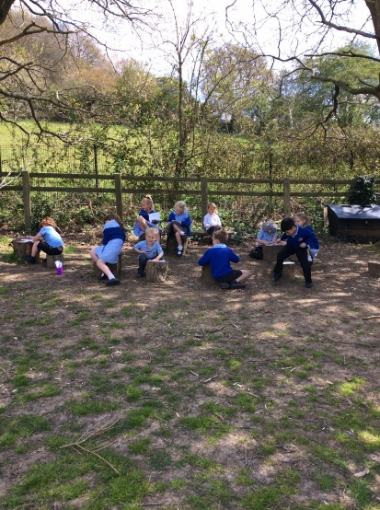
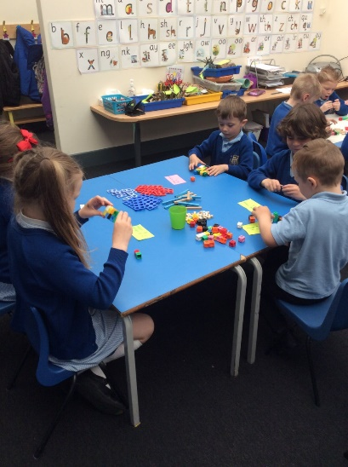
- Compassion
- Humility
- Forgiveness
- Peace
- Courage
- Justice
- Integrity

Implementation

At St Catherine`s Catholic Primary School we aim to deliver a knowledge-engaged cross-curricular approach to learning that is exciting, engaging and challenging. Our curriculum is delivered in the context of our Catholic community and allows each child to develop their gifts and talents alongside their faith in a safe and fun environment. All our cross curricular topics begin with an innovative event to inspire and make children curious and excited to learn more. The children will be researching, presenting, designing, writing and making to answer and solve lots of challenges. The lessons will focus on Geography, History, Science and link to PE, games, Art and DT, Music, Maths, English and ICT. The curriculum is planned to ensure that where there are mixed aged classes key knowledge and skills are taught in a 2 year cycle.
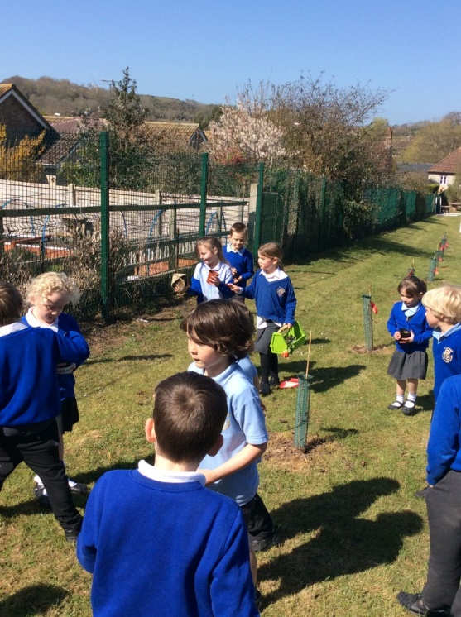
Impact

As a result of engaging with our curriculum pupils at St Catherine`s will be:

Spiritual and Secure
With Jesus in our hearts and the children at the centre we welcome and reach out to our community in the Christian spirit

Ready Readers
The ability to access the written word is given a high profile as an essential life and learning skill for daily life. With a love of reading, imagination and vocabulary our children will flourish as articulate learners.

Healthy and Happy
All members of our school community will be healthy both physically and mentally.

Confident Communications
It is important that our children can speak with confidence and fluency. We will help children find their voice encouraging talk in all parts of learning.

Amazing Adventurers
St Catherine`s children will be curious to ask questions and to explore the world through experiences and aspirations beyond the classroom.

Our Children will:
Visit a church  Visit a Cathedral  Take the lead in prayers  Visit Museums  Link with global communities  Dress up for special theme days  Share a camp fire  Cookery  Publish a poem  Visit a farm | Learn outdoors  Learn to ride a bike  Have their own library of books  Visit Parliament  Fundraise for others  Share learning with their families  Share a Nurture breakfast  Sporting events  Enter writing competitions  Perform in front of audiences | Water sports  Residentials  Theatre Trips  Visits to London  Participate in Pupil Voice  Build a den  Learn and Instrument  Display a piece of Art  Visit and Art Gallery  Visit a local beach – Fossil Hunting  Forest school

Within EYFS we use Tapestry the Online Learning Journal to document your children’s progress. Tapestry allows us to make observations for your children where we can attach photos and videos, as well as include assessments which we can use to track children’s development and progress.

On Tapestry, parents/guardians and other relatives can view, like and comment on the observations we make for your child/ren. You can also add your own observations of what your child does outside of the setting.
If you give your permission, we will set you up with your own individual account using your email address. This account will be directly linked to your child/ren’s account/s, which means you will only be able to see observations that include your child. You will then be able to login with your email address and password to either the browser version of Tapestry (tapestryjournal.com) or to the app.
Once we have set you up with an account you will be able to login using any web browser from tapestryjournal.com or by downloading the Tapestry app from the Play or App store, depending on what type of device you are using. Remember, if you are going to use the App version of Tapestry to ensure auto updates are turned on for your device so you always have the most up to date version of the app.
We will set you up using your email address and once this has been done, you will receive an activation email from which you can set up your own password to login with. You will also be asked to set up a 4-digit PIN which you can use on the Tapestry app to quickly log back in once you’ve initially logged in. Do remember to keep an eye out on your spam/junk folders for this email.
Tapestry securely stores all the data we input to our account on their servers. If you want to find out more information about how Tapestry keeps our data safe and secure, you just need to go to https://tapestry.info/security.html.
Please fill in the slip below with your child’s name and your email address and then sign. Once you return this to us, we will then provide you with details about how to access and use your Tapestry account. You can provide more than one email address if both parents would like to receive the updates.
If you have any questions or queries about this, please get in touch with Mrs Treble (Early Years Lead)

Many Thanks

For Prospective EYFS and Year 1 Parents

I give permission for a Tapestry account to be created for [name of child]:

The e-mail address I would like to link with the account is:

The e-mail address I would like to link with the account is:

I give permission for a Tapestry account to be created for me (please sign and date):
Full Name(s):

Full Name(s):

Signature(s): Date:

Signature(s): Date:

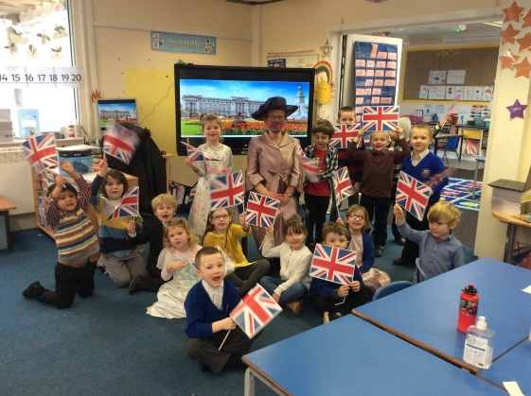
British Values
The examples that follow are an indication of some of the many ways we seek to embed British values into our curriculum at St Catherine’s Catholic Primary School and should be seen as an indication of our approach rather than an exhaustive:
• We ensure all pupils within the school have a voice that is listened to, and demonstrate how democracy works by actively promoting democratic processes such as a school council whose members are voted for by the pupils;
• We consider the role of extra-curricular activity, including any run directly by pupils, in promoting fundamental British values
We also promote British Values through some of the examples given below:

Democracy
• We have an active school council
• Children are encouraged to present fund-raising and other ideas to the school council
• During lessons pupils are given opportunities to express and discuss opinions
• Highlighting the development of democratic ideas in history lessons
• Allowing pupils to vote for House Captains
• Ensuring all pupils are listened to by adults
• Visiting parliaments, assemblies and local councils

The Rule of Law
• Classes creating “class rules”
• Having a clear behaviour policy that is explained to all with clear sanctions and reward structure
• Organising visits from the police service to reinforce the message of right and wrong
• Highlighting the rules of the Church and God in the RE curriculum, for example the 10 commandments
• Teaching about the development of the Rule of Law in English Law, a legal system created uniquely in a Catholic England, inspired by Christian values and becoming a major influence across the world

Individual Liberty
• Encourage pupils to be independent in their learning
• Provide pupils with opportunities for reflection as they take responsibility to discerning their vocation

Mutual respect
• Having a mission statement and school values that are inclusive
• Constantly promoting respect for others such as good manners
• Reinforcing the value of everyone’s opinions in class debates
• Having an effective anti-bullying policy (Sharing and Caring)
• Emphasising in RE lessons that every person is unique and “created in the image of God”
• Having active educational links with other schools
• Supporting charitable works (e.g. CAFOD; Shoe Box) Tolerance of those with different faiths and beliefs
• Highlight how Religious Education provides pupils with a deep understanding of their own faith as well as awareness of the faith and traditions of other religious communities
• Show how Jesus encouraged tolerance in stories such as The Good Samaritan and The Women at the Well
• Celebrate other faiths through ‘Faith Weeks’ and visiting speakers.
Attendance and Leave Requests

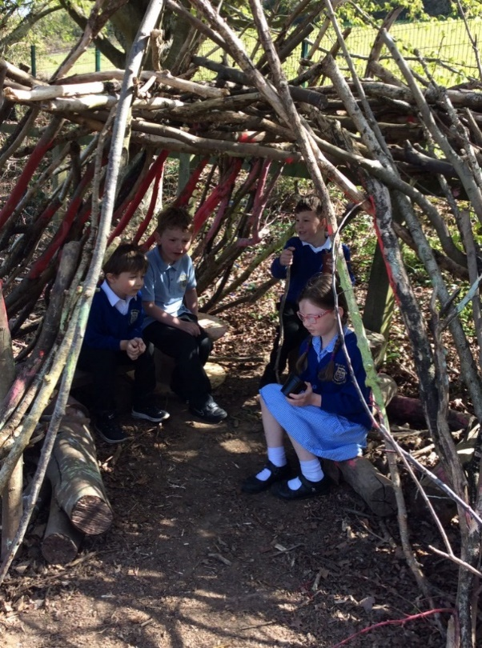
It is essential that children form good habits of regular attendance at school from an early age and that good attendance is maintained throughout their school career. St Catherine`s is committed to working together to ensure that there is a consistent approach to school attendance. It is a legal requirement that all children should attend their educational provision and it is the parent/carer’s responsibility to ensure that their children attend school.

St Catherine`s has agreed the following:

• It is important that pupils are in school on time. Time keeping is not only important in obtaining maximum benefit from education but is also a key skill for adult life. Lateness is monitored by the school and contributes to absence rates.
• St Catherine`s will monitor the attendance of our pupils and work closely with Dorset County Council’s School Attendance Service to support children whose attendance levels are causing concern.
• Whilst we understand that children do become ill on occasions, children who lose a lot of time at school can suffer in the long term from significant gaps in their learning. If a child’s health continues to affect their education schools are obliged to make a referral to School Health to ensure that appropriate medical advice and support is provided.
• If a child is ill it is the responsibility of the parent/carer to ensure that they inform the school. St Catherine`s operates a targeted “First Day Call” system, which means that they will contact you to ask why your child is not in school and when they are expected to return.
• No Leave of Absence will be granted during term time, except in exceptional circumstances. • We are therefore informing parents/carers that, should you wish to take your child out of school for any leave of absence, holidays or otherwise, request will not be routinely granted. It is essential that any requests for leave of absence are discussed with the Head Teacher prior to the request being made. Any absence which has not been authorised by St Catherine’s will be recorded as “unauthorised” and this has the potential to impact on your child’s overall absence figure and could result in legal action.

St Catherine’s is committed to ensuring that every learner had the opportunity to thrive and achieve, and recognises that good attendance is central to this.

School Uniform

We are a ‘uniform’ school. We believe a uniform looks smart, wears well and contributes to a feeling of belonging to the school. All pupils are expected to wear basic uniform. School clothing should be clearly marked with the owner’s name.

Shoes
Children should wear sensible shoes not trainers. They will need a pair of plimsolls or trainers for outdoor games lessons and these should be kept in their PE bags or brought to school on the required day.

Girls Winter Uniform
Grey or Black pinafore or skirt, polo shirt, royal blue V-neck cardigan or jumper with school logo (preferable but not required), white socks or navy tights. Grey or Black trousers can also be worn in winter. Sensible flat heeled black shoes.

Girls Summer Uniform
Navy blue check dress, royal blue V-neck cardigan or jumper with school logo (preferable but not required),. Sensible black shoes or flat heeled sandals with straps (white or navy) and white socks.

Boys Winter Uniform
Charcoal grey or black trousers or shorts, polo shirt royal blue V-neck cardigan or jumper with school logo (preferable but not required), grey socks.

Boys Summer Uniform
White or blue polo shirt (short sleeved), charcoal grey trousers or shorts, , royal blue V-neck cardigan or jumper with school logo (preferable but not required) Sensible black shoes or sensible black sandals and grey socks.

PE Kit
White polo shirt, navy shorts (or skirts for girls) and plimsolls or trainers. All kit to be clearly named and kept in a strong drawstring bag. In very cold weather older pupils can bring in tracksuits for outdoor games. Children representing the school at sporting fixtures will be provided with a school kit. Earrings must be removed or covered during PE lessons.

Hair and Appearance
In the interests of hygiene and safety, children’s hair should be tied back if it is long enough to reach the shoulders. Hairstyles should be smart, and not extreme in nature, as these styles can become a distraction, or a source of social isolation. This includes tramlines, colours or ‘Mohican’ styles - if in doubt please ask first. Hair accessories should be discrete and reflect the school.

Our personalised uniform with the school logo can be obtained from
http://www.brigade.uk.com/content.php?page=select_school&for=parents

Free School Meals

Who qualifies for free school meals?
Your child may qualify for free school meals if you receive any of these benefits:
• Income Support
• income-based Jobseeker's Allowance
• income-related Employment and Support Allowance
• support under part VI of the Immigration and Asylum Act 1999
• the guaranteed element of Pension Credit
• Child Tax Credit; this is as long as you're not entitled to Working Tax Credit and your annual gross income is no more than £16,190
• Working Tax Credit 'run-on' payment (paid for 4 weeks after you stop qualifying for Working Tax Credit)
• Universal Credit: this is as long as your household income is less than £7,400 a year (after tax and not including any benefits you get)

The school doesn't see any specific information about your income or the benefits you receive. Children who are paid these benefits directly, instead of through a parent or guardian, can also get free school meals.

Apply for free school meals
The application should only take a few minutes to complete. Dorset Council will need your National Insurance number or Asylum Seekers Service number so they can make automated checks to confirm your entitlement. You may still have to upload your benefit documents to prove your entitlement. Dorset Council will let you know straight away if you qualify for free school meals and will send you a confirmation email shortly after. You can access the Dorset For You website using the following link: https://www.dorsetforyou.gov.uk/education-and-training/schools-and-learning/at-school/freeschool-meals.aspx

If one of your children has just started school and their siblings already get free school meals, you will need to reapply, so that they can add them to the award.

All children who currently receive free school meals will remain eligible until at least 31 March 2022. This also applies to any new children who are approved. This means between now and 31 March 2022, you do not need to contact us to cancel free school meals, even if you feel your child is no longer eligible. From 31 March 2022, any child receiving free school meals will remain eligible until they have finished that school phase, for example, a child in reception on 31 March 2022 would remain eligible until they finish primary school in 2028. This protection has been put in place while the government rolls out Universal Credits nationally.

Universal infant free school meals
Your child can get free school meals if they're in:
• Reception
• Year 1
• Year 2
However, if you receive any qualifying benefits, you should complete a free school meal application anyway, even if your child is in reception, year 1 or year 2. This has no effect on your entitlement, but it could provide extra funding for your school. This extra funding is called pupil premium, please see Pupil Premium Document for further information.

Our Hot School Meals
Local Food Links make delicious school meals, delivered fresh from their Dorset kitchens every day. These are organic and freshly made, mainly using local ingredients. They're better value and more filling than lunchboxes, and more convenient for busy parents too. A healthy, tasty lunch means better concentration in the afternoon... and best of all, children LOVE them! Even fussy eaters.
These need to be pre-ordered through Local Food Links website. https://my.localfoodlinks.org.uk/

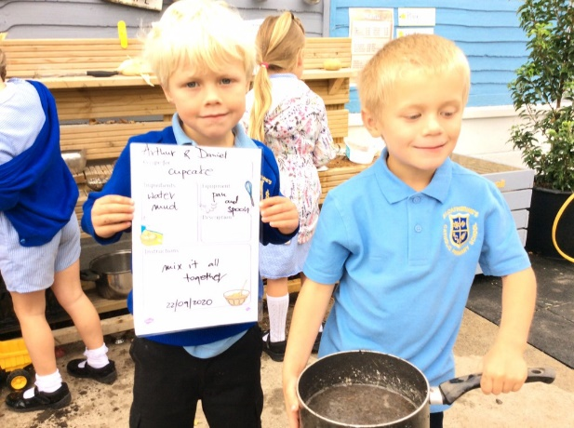
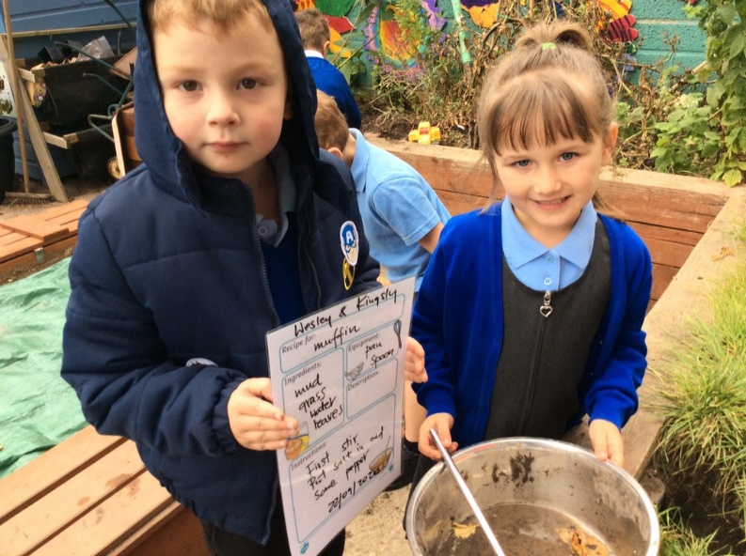

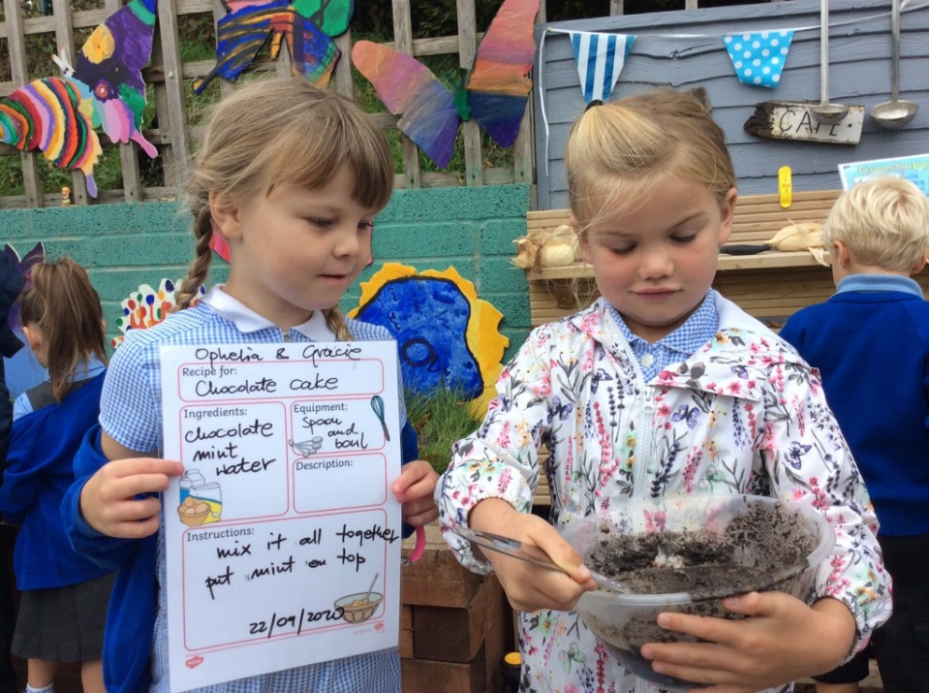

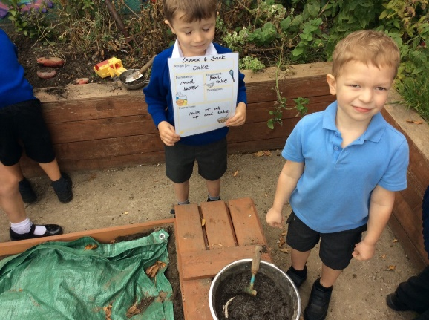

Pupil Premium

As you are aware, the school receives additional funding from the Government to support your child/ren through the Pupil Premium initiative.

Primarily the aim of this additional funding is to support your child/ren academically with their learning in school. This may be in the form of small group or 1:1 interventions or prioritized support in the classroom. Some children may also receive additional, tailored support for their emotional and social learning.

Some funding is also used to support attendance at school. It is known that just a 10% reduction in attendance can result in a drop of one GCSE grade, so it is really important that good habits are formed at primary school, that will enable your child/ren to go on to succeed to the best of their ability in the future.

In addition to academic and emotional support, some funding is also available to enhance curriculum provision to enable all children to have access to similar experiences.

The full Pupil Premium strategy document is available to read on the school website.

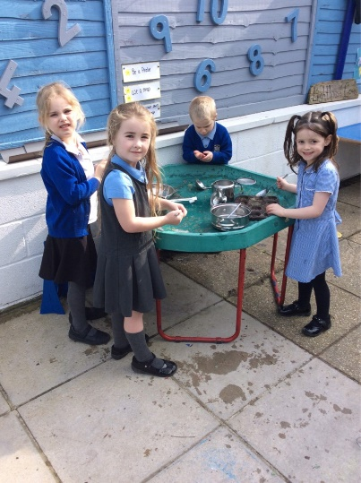
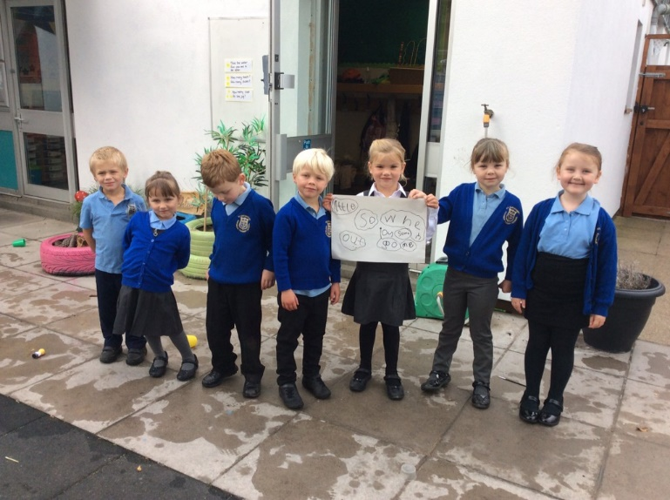

Religious Education Policy
Our Mission
At St Catherine’s our mission is to
‘Live, Love and Learn Together’
The family of St Catherine’s Catholic Primary School helps everyone to do their best, to work hard together in a place of love, warmth and safety, following the teachings of Jesus.

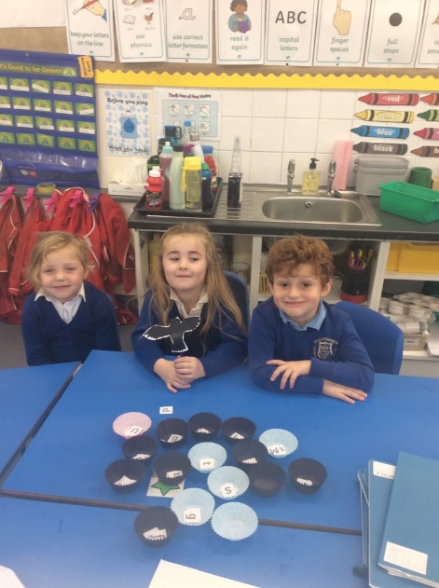
You will see us
- Work hard to be the best we can be, celebrating and enjoying our achievements.
- Love, value and respect each other as Jesus taught us.
- Reach out to those who need us both near and far.
- Say sorry with honesty and courage and learn to forgive each other.
- Create a happy atmosphere, lasting friendships and wonderful memories.
- Create an environment where we feel spiritually, emotionally and physically safe, and our thoughts and feelings are listened to.
Rationale:
As a school, we understand that the primary goal in religious education is to help pupils come to know and experience God through learning about and reflecting on the life of Jesus. It provides opportunities to reflect on fundamental questions of life and develop values and beliefs through exploration of the Gospel. Children and staff are encouraged to live out these beliefs and values in the daily life of our school.
Aims & Objectives:
The aims of Religious Education at St Catherine’s are:
- To invite children to form a personal relationship with Jesus.
- To support children to grow in their knowledge and understanding of Catholic faith and life.
- To provide children with opportunities for prayer and reflection.
- To develop children’s ability to listen, to think critically, to question, to reflect and to make informed judgements.
- To encourage children to see themselves as part of the wider parish and world community.
- To encourage children to learn about and respect the beliefs and traditions of other major world faiths.
- While Catholic in nature, the RE learning journey at St Catherine’s welcomes, respects and celebrates those from all faiths and none.

Gospel Values:
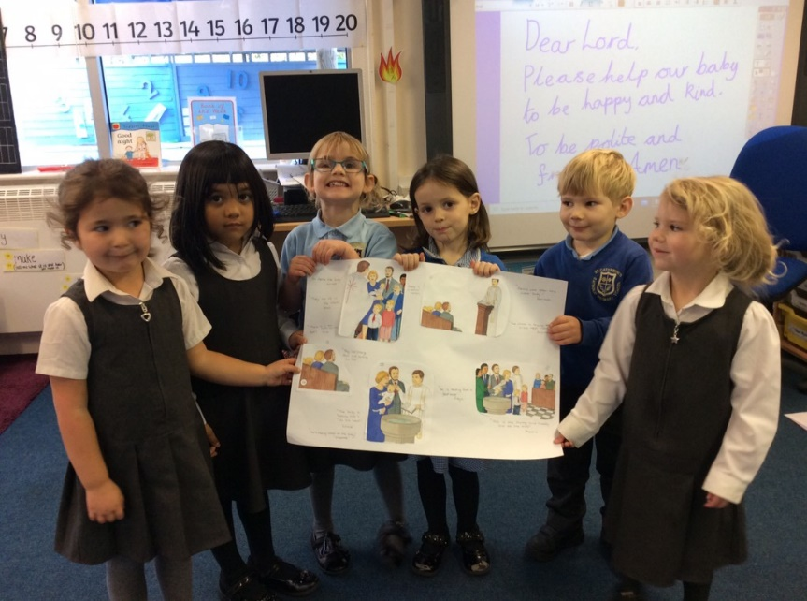
At St. Catherine’s our Gospel Values are interwoven throughout RE and all curriculum subjects. The curriculum is planned and linked to RE teaching and looking after our Common Home, through the inclusion of Laudato Si’ topics.

Children at St. Catherine’s are helped to understand and develop their potential so they are prepared to take their place in the World, knowing they too can make a difference to the World’s current challenges in age-appropriate ways.

Curriculum:

RE at St Catherine’s is a core subject and is underpinned by our School Mission Statement. Since September 2020, the RE curriculum follows the Come and See programme over nine topics, all linked to the Church's Liturgical Year.

In each topic, children are challenged through a variety of differentiated learning opportunities which follows a common structure. This informs the process of each topic opened up through: Explore, Reveal and Respond.

In addition, at St. Catherine's children learn about four other faiths: Judaism, Hinduism, Sikhism and Islam.

Timetabled lessons (10% of the teaching time) are supported by liturgies, assemblies, prayer and worship (individual, class and whole school).
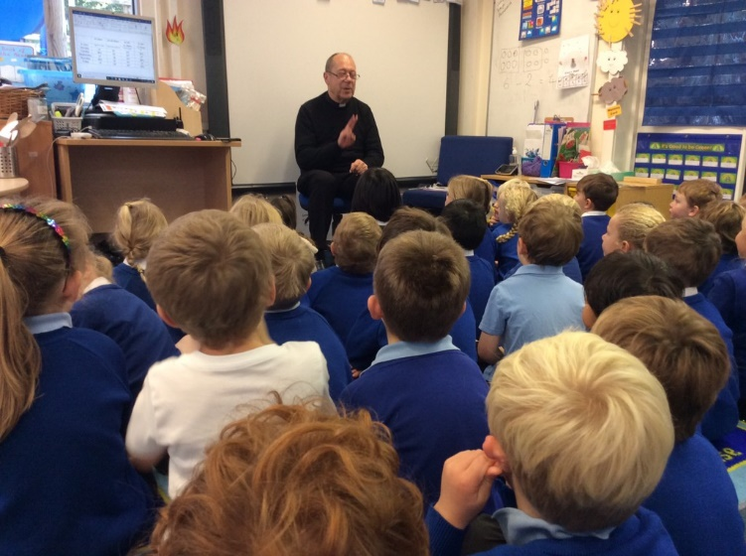
Prayer and Worship:
Prayer and worship is central to daily life at St Catherine’s. Morning, lunchtime and end of day prayer takes place in all classes across the school. After lunch each day, we have Christian meditation in class. There is a deep need in our world for stillness, simplicity and silence and we give our children an opportunity to have a special time to be still and silent with God.
Collective Worship happens as a whole school during Monday Liturgies and is led by the Head teacher with support from the GIFT Team - Growing In Faith Together. They will usually be based around the key theme of the Gospel of the previous Sunday (ie listening, forgiveness, love, compassion etc).

The children will be asked to actively make these values central to whatever they are doing during the coming week and they will re-visit this Christian theme during Thursday morning mini-liturgies in class.

At the Celebration Assembly on Friday, children are celebrated for demonstrating our Gospel Values.

There are also twice yearly special class liturgies to which parents are invited.
Mass takes place half-termly alternating between church and school. Each Key Stage 2 class takes it in turn to be responsible for the Mass. Parents, parishioners and extended family are warmly invited to attend.
Prayer & Worship Timetable:
At St. Catherine's we follow the Ten:Ten Collective Worship Programme which is in step with the liturgies of the Church and the Church's Liturgical Calendar.
Monday - Liturgy and celebration of our Values (Whole school when permitted)
Tuesday - Class Worship
Wednesday - Class Worship
Thursday - Class Worship
Friday - Celebration Assembly (Whole school when permitted)

Class Liturgies:
At St. Catherine's we have two types of class liturgy:
- A class-led liturgy which parents have been previously able to attend. This would take place twice-yearly. It is hoped that we will be able to return from September 2021.
- Each term, Father Keith visits each class to lead prayer.

Stations of the Cross
The children from Year 6 lead the Stations of the Cross during Lent and explain each Station and say a prayer. The whole school prays the Stations of the Cross with the Year 6 children as they move silently between them reflecting on Christ's journey.

May Procession
The children from all years process, carry flowers to honour our Blessed Mother, Mary, praying the prayers of the Rosary and singing hymns of praise. This is planned for the 21st May.

Forest School
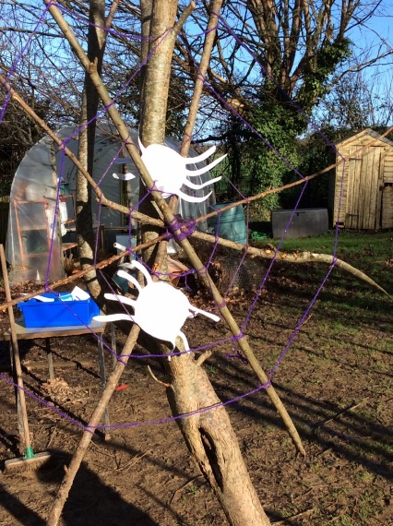
We are very lucky to have vast natural grounds facilitating outdoor learning within our setting. The children are actively encouraged to learn beyond the classroom where possible to spark curiosity and enquiry. We are pleased and proud to be able to offer a Forest School to all our pupils. Our Forest School is provided by Primary Forest School & Outdoor Education.
Their philosophy is;
We believe at Primary Forest School that all children have a right to outdoor education, both self-exploratory and structured learning, within and outside of school, regardless of ability, age, disability or finance, to achieve a greater understanding and respect for the natural world around them while acquiring lifetime skills alongside the company’s morals and values.
Forest School is a fantastic experience for our pupils. It is a child-centred inspirational learning process, that offers opportunities for holistic growth through regular sessions. It is a long-term program that supports play, exploration and supported risk taking. It develops confidence and self-esteem through hands-on experiences in a natural setting.
Forest School roots reach back to the open-air culture, Friluftsliv, or free air life, seen as a way of life in Scandinavia where Forest School began. It arrived in the UK in 1993 and has grown from strength to strength since then.

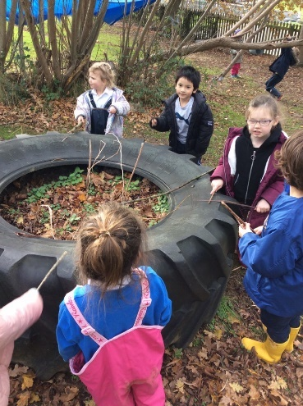
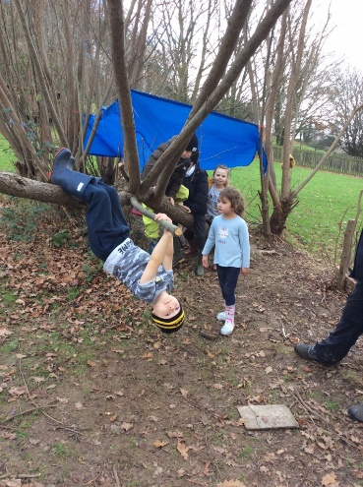
The children at St Catherine`s will participate in forest school provision each academic year for the duration of half a term. Forest school enables our children to experience new things as well as build different skills. In addition, St Catherine`s host forest school holiday provision, within the school holidays, which many of our children enjoy.
