Humanities Knowledge Organiser – EYFS/YR1 – Spring Term 1 – History Theme
Heroes and Heroines
Florence Nightingale
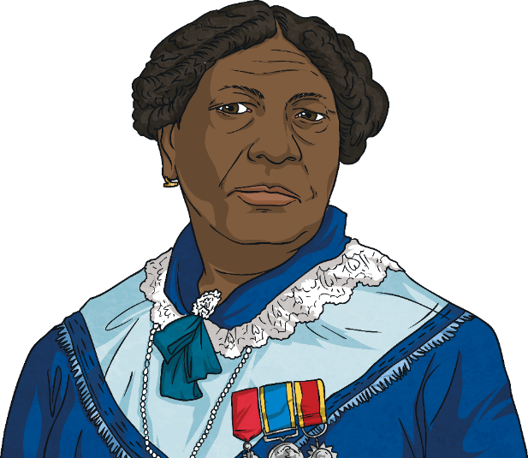
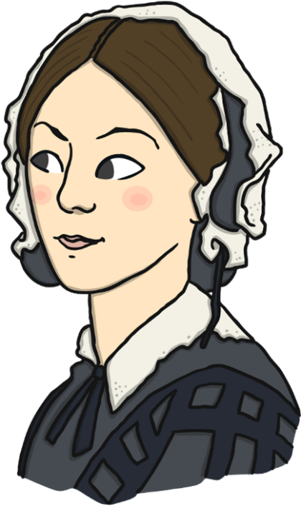
Florence Nightingale was born in 1820.
She was named Florence after Florence in Italy, where she was born.
She died in 1910.
She is still famous today.
She became a nurse and helped soldiers who were hurt in the war
She is known as the ‘Lady of the Lamp’ because she carried a lamp with her when she checked on her patients in the night.

Mary Grant was born in 1805 in Kingston, Jamaica.
Her father was a Scottish soldier and her mother was a Jamaican “doctress.” A doctress was a healer who used African and Caribbean herbal remedies.
Mary learned nursing skills from her mother, who ran a boarding house for injured soldiers.
In 1853, the Crimean War began. Mary wanted to help the soldiers.
She travelled to London to visit the War Office.
She wanted to help with the work Florence
Nightingale had started.
Although Mary had very good references,
her offer of help was turned down. This was
because she was black.

Mary Seacole
Key Vocabulary
Doctress | A healer who used African and Caribbean herbal remedies.
Vaccine | a fluid that helps your body to become immune to a disease caused by certain germs

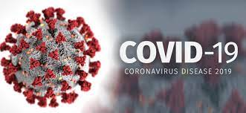
The Coronavirus Pandemic
On the 31st December 2019 the World Health Organization (WHO) was informed of a Virus detected in Wuhan City, China.
On 12 January 2020, it was announced that a coronavirus had been identified. This was the cause of the outbreak.
As of 22 February 2021, over 109 million cases have been diagnosed globally with more than 2.4 million fatalities. In 14 days more than 5.7 million cases were reported.

Coronaviruses are a large family of viruses with which cause you to feel unwell. Some less serious viruses cause colds, and flu, but more serious viruses cause problems with your breathing.
Key Word | Definition
Pandemic | Disease spread across the country or world.
lockdown | Where people are unable to visit different people and must stay at home.
fatalities | When someone does not survive
Vaccine | Medicine to prevent serious illness
medicine | Substance to make people feel better.

The UK and Coronavirus
8th March 2021
Children can return to school
16th March 2020
Prime Minister orders everyone to stay at home.
National lockdown 1 (the first ever UK lockdown)
5th November 2020
PM announces a second lockdown in England to prevent a “medical and moral disaster” for the NHS
(4 weeks long)
6th January 2021
Third national lockdown
10th May 2020
Phased re-opening of schools and shops
12th January 2020
Coronavirus identified
31st December 2019
Virus reported in
Wuhan City, China

