Humanities Knowledge Organiser – Year 5/6 - Autumn Term 1 – History Theme
Ancient Greece
Key People | Civilization
Gods and Goddesses  The ancient Greeks believed that their gods and goddesses controlled everything and should be respected and honoured.  • Temples and shrines were built as places of worship.  • Festivals were held to celebrate the gods and goddesses and people would make offerings to them in the hope of being granted  good fortune.  • It is believed that the 12 most powerful gods lived on Mount Olympus.  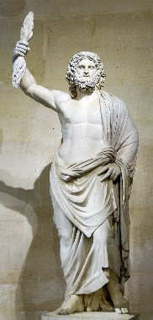  • Stories were told about the gods and goddesses and included heroic quests and scary beasts.  Zeus  • The most powerful of all the gods.  • God of the Sky and the King of Mount Olympus.  • His temper affected the weather, and when he was  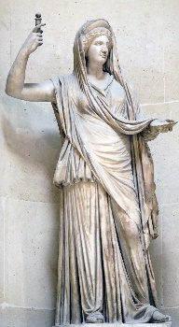  angry he threw thunderbolt.  Hera  • The sister and wife of Zeus.  • She was powerful and beautiful but very jealous and vain.  • Hera is an earth goddess and the goddess of family and marriage. | Battles took place between different city states but when an outside enemy attacked, these city states would sometimes join forces.  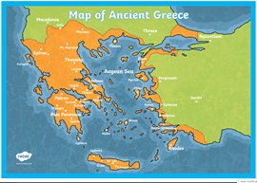  The Battle of Marathon  • The Athenians were being invaded by the Persians and needed more soldiers to help them fight.  • Pheidippides was sent to run to Sparta to ask them to join forces with the Athenians. He ran 26 miles from Athens to Sparta which took him two days.  • The Spartans said they would help but only after they had finished celebrating a festival.  • Pheidippides ran all the way back to Athens to tell them they would have to wait.  • The Athenian army couldn’t wait and unbelievably, with strong fighting strategies, they were victorious.  • Pheidippides ran all the way back to Athens to tell them of the army’s victory but when he arrived after delivering the message, he died.  The Trojan War  • The Trojan War is a famous story told by the famous Greek writer, Homer.  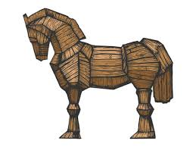  • The Greeks had a plan to win a battle against the Trojans… they gifted a large wooden horse to the city which the Trojans thought was a sign that the Greeks had given up.  • Hiding inside the horse, was a group of Greek soldiers, who, in the dead of night, climbed out and let the rest of the Greek army into the city to fight.  • Finally, the city of Troy was destroyed.
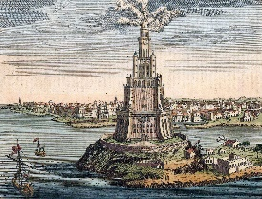
Achievements
Lighthouse of Alexandria
The Lighthouse of Alexandria was the first lighthouse to be constructed in the World; construction started in 120 BC and took 20 years to complete. The Lighthouse was built to help guide ships into the port, and many people followed the Greeks in building lighthouses off coastal shores to welcome ships home. Most lighthouses are tall structures with a form of light inside.

The Olympic Games
The Greeks started the Olympic Games almost 3000 years ago in 776 BC. They were held nearly every four years for over a thousand years until they were stopped in 393 AD.
In order to participate, athletes had to be a free man (no slaves) who spoke Greek.
The winners of the games were considered heroes. They got olive branches for winning, but also became famous. Sometimes they received large sums of money from their home town.
Today the Olympics continues every 4 years hosted in different countries all around the world featuring many sporting events. In 1960 the Paralympics was started to enable everyone including those with disabilities to compete.
Inventions
While the Greeks loved to observe and study the world, they also applied their learning to make some practical inventions.
- Watermill - A mill for grinding grain that is powered by water. The Greeks invented the waterwheel used to power the mill and the toothed gears used to transfer the power to the mill.
- Alarm Clock - The Greek philosopher Plato may have invented the first alarm clock in history. He used a water clock to trigger a sound like an organ at a certain time.
- Central Heating - The Greeks invented a type of central heating where they would transfer hot air from fires to empty spaces under the floors of temples.
- Crane - The Greeks invented the crane to help lift heavy items such as blocks for constructing buildings.
- Archimedes' Screw - Invented by Archimedes, the Archimedes' screw was an efficient way to move water up a hill

