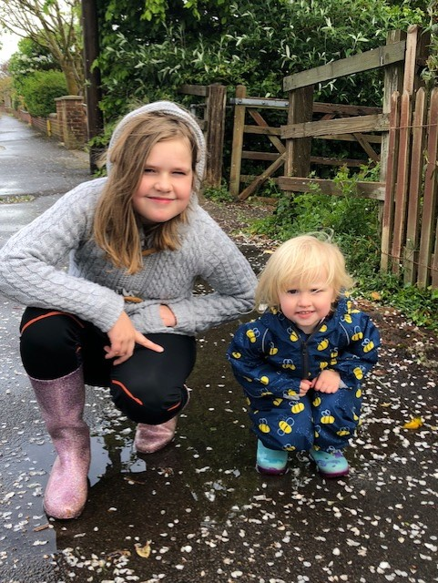
Lola has cooked her family a lovely 3 course meal.
Bacon and egg muffins to start,
spaghetti and meatballs for main and
chocolate mousse for pudding.
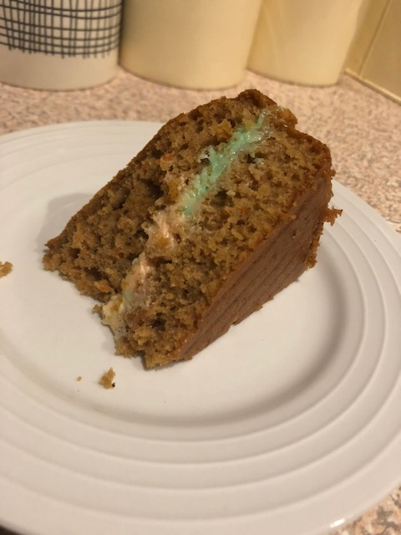
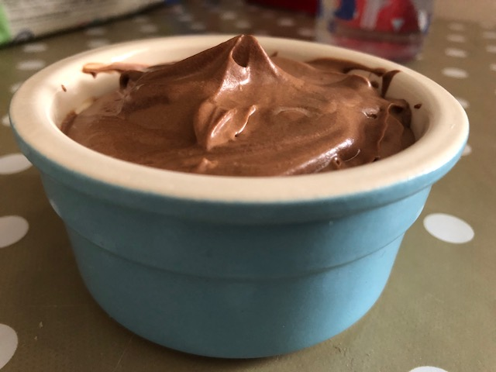
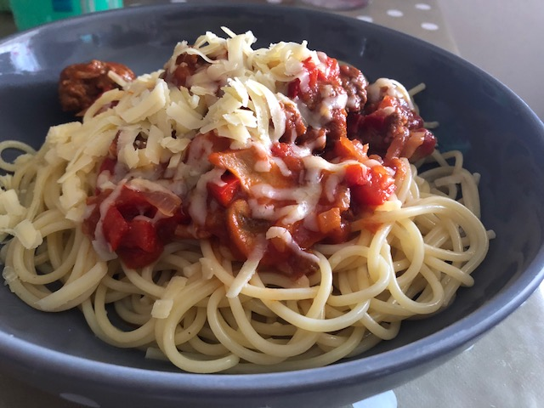
She’s also baked a green and orange carrot cake.
Who wants an invite to Lola’s restaurant?
Opening soon in Bridport!

