Staying Safe at

St Catherine’s
Catholic Primary School
If you have any concerns about the safety of others or the safety and wellbeing of yourself, speak to one of the members of staff pictured below.
Mrs Sarah Terrey  Designated Safeguarding Lead | Mrs Lydia Blake  Deputy Designated  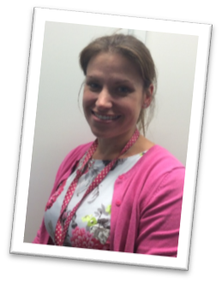  Safeguarding Lead | Mrs Liz Harris  Deputy Designated  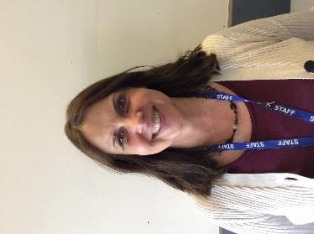  Safeguarding Lead

Safeguarding is the responsibility of all at St. Catherines’s. You can ask for advice or refer a concern to the Children’s Advice and Duty Service (CHAD) yourself : 01305 228558 ( Professionals) or 01305 228866 ( Families and members of the public number)
If you have any concerns about a staff member, contact the Senior Leadership Team if appropriate, or the Local Area Designated Officer (LADO). Tel: 01305 228327
Remember – in an emergency or if you have an immediate concern, dial 999
If you are not happy with how a concern has been dealt with, or would like to speak to someone else, you can contact Social Care and Health, Ofsted, LADO, or the NSPCC helpline.
Speak to us - we’re here to help and to listen

