Humanities Knowledge Organiser – Year 4/5 - Spring Term 1 – History Theme

Anglo - Saxons

Who were the Anglo Saxons?

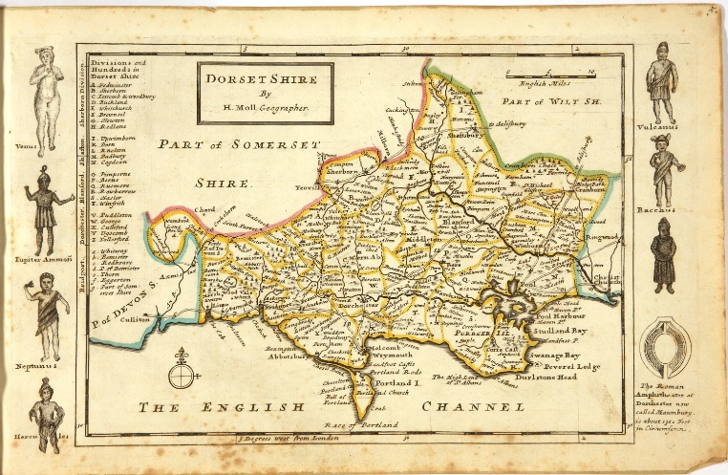

Anglo Saxon impact on Dorset

Most Dorset place names are of Old English or Anglo-Saxon origin.

Puddletown features the Saxon word pidele, a stream name today seen as Piddle. It originally described a wetland although, as a river name, is applied to the running water draining the marsh or fen.

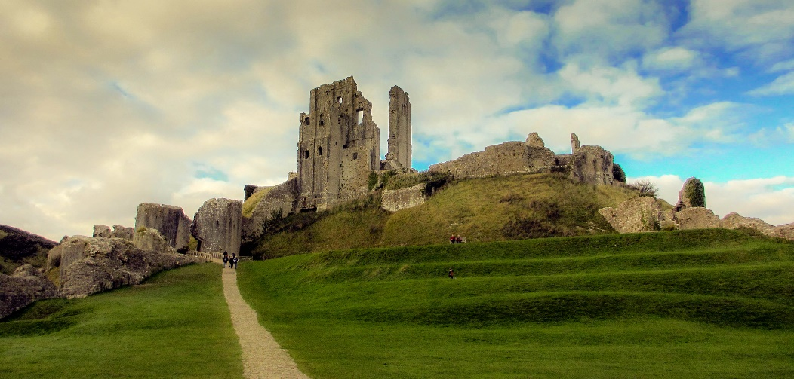

During the Saxon settlement Twineham (Christchurch), Wareham, Shaftesbury, Dorchester and Bridport were probably the most important centres in the Dorset area.

The Saxon kings established monasteries, which soon became important landowners and centres of power. St Martinms church at Wareham is reputedly the oldest church in Dorset, although there are many other known Saxon foundations including Shaftesbury Abbey and Sherborne Monastery. At the start of the 8th century the large diocese of Winchester was split in two and St Aldhelm of Sherborne was appointed first bishop of the West Saxons.

Dorset played an important role in Saxon politics.

King Edweard, whose accession to the throne in 962 almost caused a full-blown civil war, is thought to have been murdered at Corfe Castle (Corfe is Saxon for 'gap') by his stepmother Elfryda, who wanted her own son, Ethelred the Unready, on the throne. Edweard’s body was taken to Wareham and then to Shaftesbury, where he is now remembered as a saint, while Ethelred is buried at Wimborne.