Humanities Knowledge Organiser – EYFS/Year 1 - Summer – Geography Theme

Heroes and Heroines – Famous World Explorers

**Sir Francis Drake**

Sir Francis Drake was an Elizabethan Sea Captain, navigator and slaver who became the first Englishman to sail around the world, from 1577 to 1580.

Francis Drake's earliest expeditions in the 1560s were to capture and enslave people from Africa. Drake and his men kidnapped African people from their villages and sold them to Spanish colonies.

Drake and his men raided Spanish ships and stole their gold and silver. This made Drake and the Spanish mortal enemies, with the Spanish seeing him as a pirate.

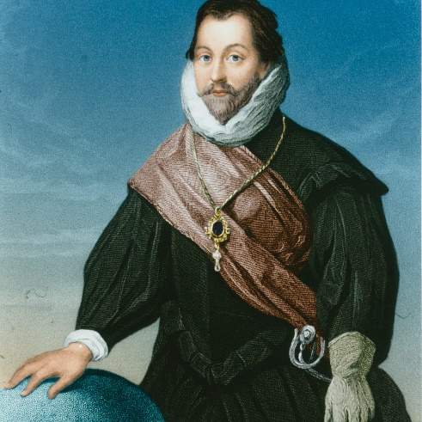

**A Pirate**

Major Tim Peake

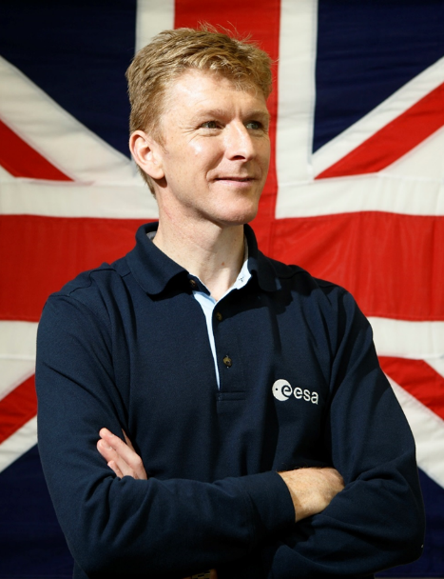

Major Tim Peake became the first British astronaut in space for over 20 years when he blasted off for the International Space Station on 15th December 2015.

When he applied to be an astronaut he was selected from 8000 applicants. As part of his training he has learnt Russian, spent 12 days under the sea and completed a winter survival mission.

Major Peake returned to Earth on the 18th June 2016.

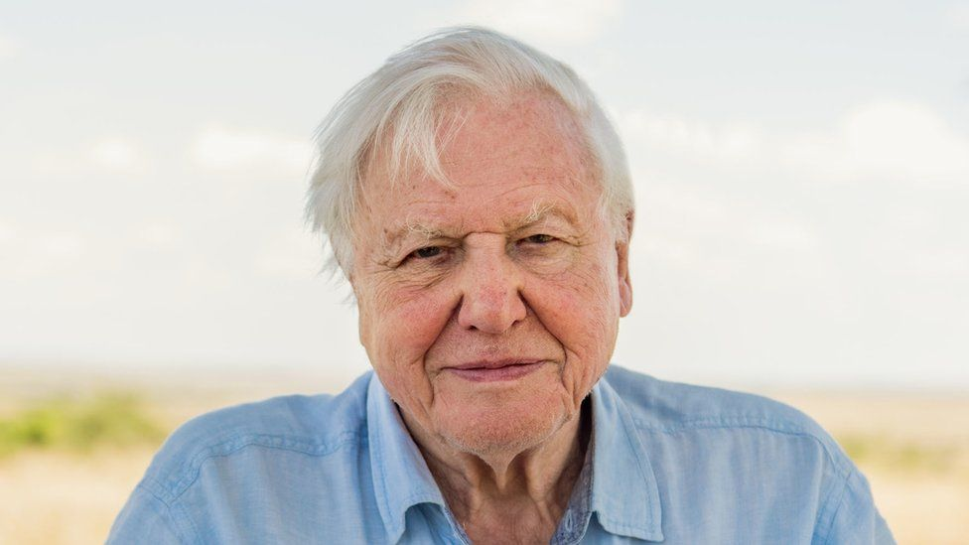

Sir David Attenborough

Sir David Attenborough is an English broadcaster and naturalist and is extremely well known for his documentaries for the BBC.

He is often referred to as a ‘national treasure’ in Britain and was knighted in 1985, earning him the title of Sir David Attenborough.

David Attenborough is 95 years old and still filming nature documentaries.

From an early age, David had an interest in natural history. As a young boy, he had a large collection of fossils and stones.