Humanities Knowledge Organiser – EYFS/Year 1 - Autumn Term 1 – Geography Theme

Heroes and Heroines - Home Sweet Home

**UK**

Bridport

What Countries make up the United Kingdom – UK?

Bridport is a market town in the county of Dorset. On the coast and within the town's boundary is West Bay, a small fishing harbour previously known as Bridport Harbour.

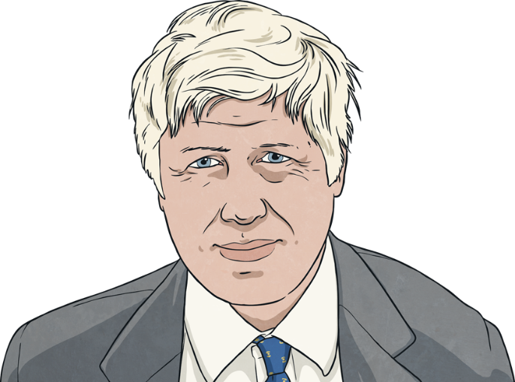

Elected as MP on 12th December 2019. Grew up on a farm in Sherborne. Chris worked for South West Railway. He was able to ensure more trains ran from Dorset to London.

**Chris Loder**

**Local MP**

Guy Fawkes took part in the Gunpowder Plot of 1605, which aimed to blow up the Houses of Parliament to kill King James I and his government.

**Guy Fawkes**

Boris Johnson is the current Prime Minister of England. He was elected in 2019. Boris is a member of the Conservative Party.

Boris Johnson has worked alongside other members of Parliament to support the nation through the COVID 19 Global pandemic. He has made very important decisions to keep us all safe.

**Boris Johnson**

**Prime Minister**