Humanities Knowledge Organiser - Year 2 - Autumn Term 1 – History Theme
Heroes and Heroines
Benjamin Jesty
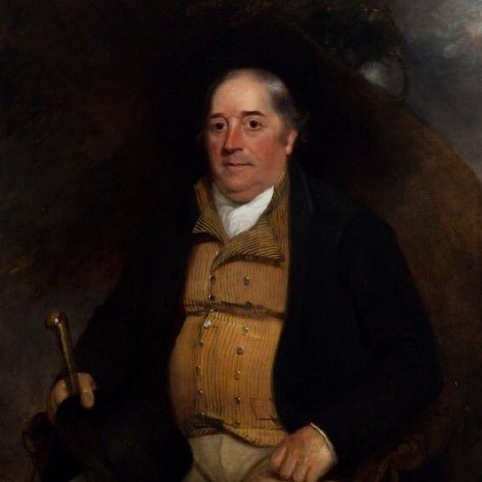
Benjamin Jesty is the first known vaccinator (a person to provide protection against diseases). He was a farmer who lived in the village of Yetminster in North Dorset. During 1774, in the face of a smallpox epidemic, he vaccinated his wife and two sons with cowpox lymph taken from wounds on the udder of an infected cow.

Edward Jenner
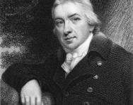
Edward Jenner was a very famous English scientist whose name has gone down in medical history. Edward Jenner was responsible for discovering the world's first-ever vaccine and his work saved so many lives. He was born in 1749 in Gloucestershire, where he trained as a doctor and became famous for his discovery of the smallpox vaccine. His discovery was a huge medical breakthrough; in 1980, the World Health Organisation declared the dangerous disease smallpox an eliminated disease.

Key Vocabulary
Vaccinator | a medical practitioner who protects people against diseases
Vaccine | a fluid that helps your body to become immune to a disease caused by certain germs

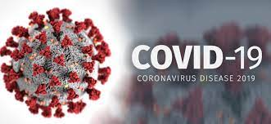
On the 31st December 2019 the World Health Organization (WHO) was informed of a cluster of pneumonia cases with unknown cause were detected in Wuhan City, China.

On 12 January 2020, it was announced that a coronavirus had been identified in samples collected from cases and results suggested that this was the cause of the outbreak.

As of 22 February 2021, over 109 million cases have been diagnosed globally with more than 2.4 million fatalities. In 14 days more than 5.7 million cases were reported.

Coronaviruses are a large family of viruses with some causing less severe disease, such as the common cold, and others causing more severe disease, such as Middle East respiratory syndrome (MERS) and Severe Acute Respiratory Syndrome (SARS) coronaviruses.
5th November 2020
PM announces a second lockdown in England to prevent a “medical and moral disaster” for the NHS
(4 weeks long)
14th October 2020
A new three-tier system of Covid-19 restrictions starts in England
16th March 2020
Prime Minister orders everyone to stay at home.
National lockdown 1 (the first ever UK lockdown)
8th March 2021
Children can return to school
6th January 2021
Third national lockdown
10th May 2020
Phased re-opening of schools and shops
12th January 2020
Coronavirus identified
31st December 2019
pneumonia cases reported in
Wuhan City, China

