History - Homes and Houses

Vocabulary

Landmark bungalow

Building cottage

Stone apartments

Concrete buildings

Wood shelter

Brick landmarks

Houses church

Flats school

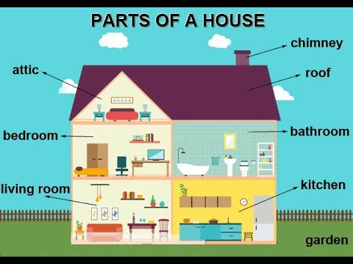

Big Questions

How have homes changed from the past?

What are the significant differences between towns and villages/ towns and cities?

How might homes look in the future?

Information I have found out