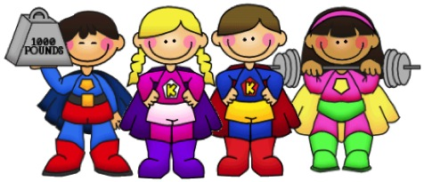

**Autumn Term**

**Maths (Power Maths)**

Exploring numbers up to and beyond 10. Addition. Shape.

**Experiences**

Trip to Bridport Market. Late night Cinema experience. School Nativity. Bike ability.

**Science**

Why does our weather change? Why do the trees change?

Exploring the everchanging seasons, from weather, to physical change. Exploring the four seasons as well as the months of the year the children will explore why the change is good and how we know a new season has started.

**IT**

How can we be safe online? How do we log on a computer using a username? What is a keyboard? How does it work? How do I select this program?

All of these questions will be answered as children are introduced to computing. Using our chrome books the children will be introduced to the technology and how to navigate their way around it.

**English, Communication and Language (The Write Stuff)**

This term the children will be embarking on a vocabulary building writing journey. Through the use of stories children will be engaging in a variety of vocabulary linked to the FANTASTICs (senses and emotions). Using their new acquired vocabulary the children will be able to converse linked to key themes and imaginative play. For our Year 1 children the new acquired vocabulary will be showcased in sentence stacking activities which enable them to become independent writers, Stories this term include: The Rainbow Fish, Handa`s Surprise, Little Red Riding Hood.

**Art**

Inspired by the work of Jackson Pollock the children will be exploring colour and texture using paint to create their own masterpiece in the style of Jackson Pollock. Mixing a variety of shades to create a theme and using splatting, flicking, dragging, strokes and textured substances to create the desired effect for their work. A gallery will be open for parents to experience once completed.

**Healthy Heroes & Heroines**

**DT**

What big eyes you have!

The children will be making a character puppet from the story of Little Red Reding Hood. Experimenting with different materials and binding these together the children will create their own puppet to use when retelling the popular story.

**History**

The Gunpowder Plot – was Guy Fawkes a Hero or a Villain? We will be exploring the Gunpowder plot. What happened? Why did it happen? What is parliament like now? We will be debating whether the main accused was a hero to attempt such a plot or a villain for trying to cause so much destruction.

**Geography**

This term we will be exploring our local area of Bridport. We will be using maps to locate our town, our school and exploring Google Earth to find our home country. We will look at the beautiful landmarks around us and think about what makes Bridport such a special place to us.