Year 4

Autumn Term 2019

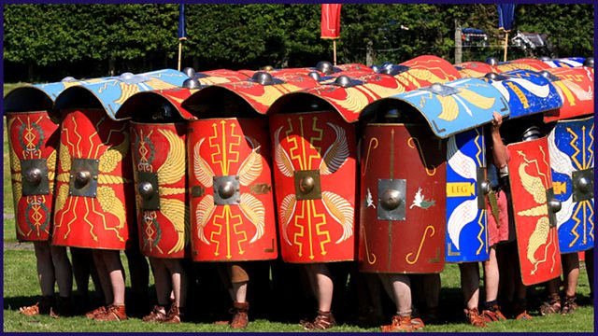

Over the course of Year 4, we will be investigating the colourful and exciting world of Invaders and Settlers.

We will begin our exploration this term with the Romans.

**Homework:**

The priority focus for homework will be based on developing basic skills: daily reading and times tables. Weekly Maths on-line Sumdog challenges will also be set, alongside project work linked to our class topics every half term. (Further details given on homework guidance.) Additional maths homework may be given to those needing practise on written methods of number as the term progresses.

**Spellings:**

Weekly spellings will no longer be sent home. In school, we are following the Babcock ‘No Nonsense Spelling’ programme which encourages revisiting of spellings and independence through a carefully structured approach. Spelling assessment is built into the programme. Please help your child to read and spell the Y3/4 words (copy will be given). On-going spellings to practise will be recorded in your child’s reading record book.

**Other events:**

You are welcome to join us for a Class Liturgy at 8.40 on 27th September. We will keep you posted about other events as they occur!

**Help in Class:**

If you are able to help out in class, especially with hearing readers, please let me know. If you have any books or artefacts that would help us this term, or have any links with our Topics we could use, we would also be very grateful.

**English**We are linking our English work to our topics across the curriculum, starting with an exploration of nature through poetry and persuasion: how small changes can have a big impact on the environment. We will then have a heated discussion on Boudicca! Later this term, we will write reports about Romans and use a range of interesting texts to explore this theme. A Year 4 grammar programme will also be followed.

**Maths**

This term we will be focussing on Number – Place Value, Addition and Subtraction, Multiplication and Division.

We will be focussing on developing both oral and written methods for the above topics and also securing our knowledge and understanding of times tables.

We follow the White Rose scheme for Maths.

**Year 4**

**Autumn 2019**

**ART/DT**  
We will study observational drawing, learn the art of watercolour painting and later use a range of skills to create Roman artefacts.

**Humanities**We will focus on the Roman Empire and its impact on Britain, looking at the reasons for invasion. We will use evidence to reconstruct life in the time studied and look for links to today – ‘What did the Romans do for us?’

**Science Living Things and Habitats:** We will be learning all about how to classify animals using keys.

**Electricity:** Children will be identifying insulators and conductors and constructing simple series circuits.

**PE**  Ball Skills/Building Stamina and personal fitness through a range of activities/Activities linked across the curriculum including learning how to be fit enough to be a Roman legionary! We also run a Daily Mile.

**SEAL**

Our year 4 focus for this term is on:

Autumn 1: New Beginnings

Autumn 2: Getting on and Falling Out

**French**

Children will learn to discuss themselves and their family in French, alongside basic vocabulary, focusing on oral skills.

**Music**Music making will link to our topics and will focus on pitch.

**Computing**

The childrenwill look at internet safety, how to research cleverly using the internet.

**RE**

Children will learn about religious stories and make links between beliefs and actions. Topic covered include: Creation, Prayers, Saints and Feasts, Sacraments, Advent and Christmas. They will compare their own and other people’s ideas about questions that are difficult toanswer.