WALT: To count money in pounds (£) and pence (p).
Mike has saved the money shown in his purse.
He is then given £20 for his birthday.
How much does he have in total?
EXT: He was given more than one note.
What could have he been given?

Fluency
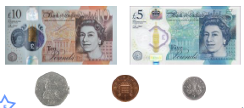
- Circle the notes and coins that make £15 and 55p.

- Circle the notes and coins to make thirty one pounds and 23p.
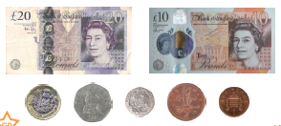

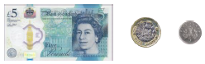
- True or False? The amount shown in £5 and 25p.

Problem Solving

- Which child has the most money?
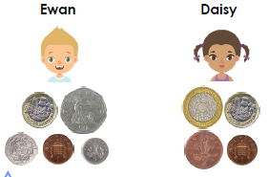

- Nate has been saving his pocket money for a ball. He is given £10 which he adds to his savings. How much does he have in total?
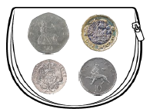

Rose has two notes and four coins. The total she has is £32 and 30p.

What coins and notes might she have?

