Humanities Knowledge Organiser - Year 2 - Autumn Term 1 – History Theme

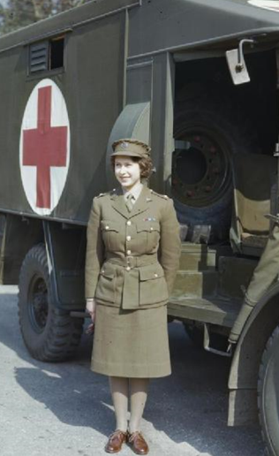

Childhood

Our Queen

Princess Elizabeth was taught at home, not at school.

She studied art and music and enjoyed drama and swimming.

When she was 11, she joined the Girl Guides.

During the Second World War, Elizabeth served in the army as a mechanic.

Elizabeth Alexandra Mary was born on 21st April 1926 in Mayfair, London.

She was the first child of The Duke and Duchess of York (King George VI and Queen Elizabeth).

The Queen’s birthday is officially celebrated in Britain on the second Saturday of June each year.

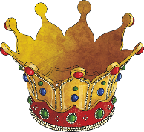

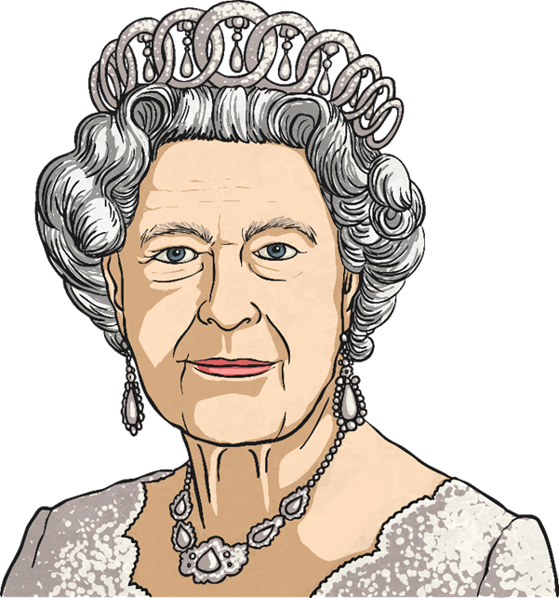

Legacy

Coronation

In 1952, when she was just 25, Elizabeth’s father, King George VI, died.

Elizabeth was in Kenya when she heard the sad news. She immediately returned home and it was decided that Elizabeth would be queen.

In 2021, her Majesty Queen Elizabeth will have reigned for 69 years. On 9th September 2015, she became the longest-reigning British monarch, surpassing her great-great-grandmother Queen Victoria, who reigned for 63 years and seven months.

Queen Elizabeth II

Family

Her father, Henry VIII was well known for having many wives!

Queen Elizabeth I’s mother was Anne Boleyn but King Henry VIII was not happy as he wanted a baby boy!

King Henry VIII had Anne Boleyn (Queen Elizabeth’s mum) beheaded because he thought she would never give him a son.

Queen Elizabeth was sent to live with her sister, Mary.

King Henry VIII remarried someone called Jane Seymour and she gave him a son.

Queen Elizabeth I

Queen Elizabeth I was a famous Queen who ruled England, Ireland and Wales from 1558 – 1603. The time that she was Queen is known as the Elizabethan Age.

Elizabeth I father was King Henry VIII and her mother was Anne Boleyn. She became Queen when she was 25 years old.

Queen Elizabeth I ruled England all by herself!

She did not marry which meant she had no husband or king to help her.

This was very unusual for the time.

It was also a very exciting time as there were new ideas about religion, wars with Spain and English explorers discovered new places.

Why is she famous?

Who?