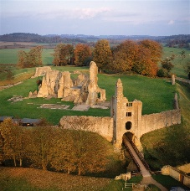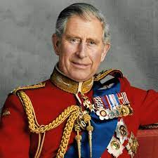

**English, Communication and Language**

**Reception**

Read Write Inc Phonics – we will be learning new sounds throughout this term. We will be sounding out and blending 5 sound words and beginning to read ditty sentences and books.

**Year 1**

Read Write Inc Phonics – we will be continuing to work through Set 3 sounds with a specific focus on identify special friend sounds in all word to enable us to read them.

**Year 1 Write Stuff –** we will be working through the story of The Queens Hat and exploring language and vocabulary and implementing this is our writing.

**Maths (Power Maths)**

**Reception**

Unit 14: Counting on and counting back

Unit 15: Numbers to 20

Unit 16: Numerical patterns

Unit 18: Measure (Volume and capacity)

Unit 20: Time

**Year 1**

Unit 9: Numbers to 50

Unit 12: Multiplication

Unit 13: Division

Unit 14: Halves and quarters

Unit 15: Position and direction

Unit 16: Numbers to 100

Unit 17: Time

Unit 18: Money

**History**

**What is a Monarch?**

Exploring the Royal Family, with a focus of King Charles III and his coronation celebrations. Looking at the family tree of previous and future monarchs. Exploring the reign of Queen Elizabeth II and her predecessor Queen Elizabeth I. Thinking about the homes of past monarchs across the country and locally.

Summer Term 2023

**Art and Design**

**What is a sculpture?**

Using clay to sculpt for different purposes using a variety of tools. Children to design and make a clay sculpture of the new King.

**Experiences / Events**

* Forest school every Friday summer term 2
* Trip to Sherborne Castle 12th May
* Kings Coronation school concert 5th May
* Sports Day TBC

**Oak Class**

**Science**

**What are materials?**

Exploring materials and their properties, thinking about how materials can be identified and grouped as well as selecting appropriate materials for different purposes.

**What is the difference between coniferous and deciduous?**

Exploring plants and their features. Comparing coniferous and deciduous trees and plants within our local area and identifying key features.

**Computing**

**How can I gather data?**

Using technology to record data from class discussions and show how this data can be represented in pictograms or pie graphs using different computer software with interactive features.

**Design Technology**

**What is a structure?**

Exploring various castle structures and creating our own using pulley systems and tripod structures. Thinking about the purpose of a castle and incorporating this into our own designs and creations.