**Year 3**

**Home Learning**

**Autumn Term 2 2019**

**Daily Basics (suggested 30 mins)**

**Reading**

**Spelling**

**Maths**

**Applying Skills Weekly (suggested 30 mins)**

**Topic Project**

If you would prefer your child to have a book to record their daily practise of spelling and times tables, please ask.

Evidence of practise of basic skills will be rewarded.

|  |  |  |
| --- | --- | --- |
| **Topic Homework**  **due in Monday 9th December**  The expectation is that everyone completes **at least one** of these three tasks. You are free to do two, or all three to gain the maximum points | | |
| **Modelling**  **3 House Points**  During the Bronze Age people began to mould clay and metal items. Using a modelling clay or a metal such as tin foil, make a replica Bronze Age pot, plate, item of jewellery or weapon. | **Write About**  **3 House Points**  In the Bronze Age people were buried alongside special or important belongings in mounds. Which belongings are particularly special to you?  *Focus:*  • Think of 3 special belongings you would not want to lose  • Explain why they are special to you  *Remember, special might not mean expensive.* | **Visit**  **3 House Points**  Maiden Castle, just outside of Dorchester, is one of the largest and most complex of Iron Age hillforts in Britain. Go and have a look around and imagine what it might have been like to live there.  Photographic evidence can be sent to: [office@stcatherinesbridport.dorset.sch.uk](mailto:office@stcatherinesbridport.dorset.sch.uk) with the **subject heading Year 3 Maiden Castle** |

**Christmas Homework   
due in Monday 16th December**

Design and make a secret Christmas car d for a classmate. You will be given the name of the person you are making it for on Monday 2nd December. As well as a design on the front, you should include a message in the format of a Christmas poem you have written (Acrostic? Rhyming? Free-verse?) or a Christmas wish especially for them.

**Daily Spelling** 

**Please help your child to read and spell the Y3/4 words.** If you need another copy of these please let us know. Just pick two or three at a time, especially if they follow a sound or letter pattern. Remember these words are for year 3 AND 4, so go at a pace that is suitable for YOUR child.

Check your child’s reading record book for words that they are misspelling in their writing. They should be copying these in on a weekly basis. **Please help your child learn these words as a priority.**

In class, we have used a range of strategies to learn key words. Your child may use any method they are comfortable with. **Any evidence of home practise will be rewarded.**

**Daily Reading**

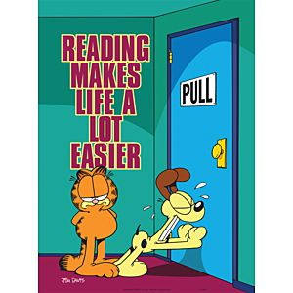

**It is vital that your child reads daily.** This can includebeing read to, reading their levelled reading book to an adult or reading any other text they choose independently.

**Please remember to sign their reading record book when your child has read – even if reading independently.** These will be checked weekly. **3 x signed reads a week will lead to a pink sticker.**

**Reading Challenge**

Try learning a new skill using only a non-fiction book to guide you. Make your reading record entries more focussed by recording any new facts you have learnt. **Did you know…?**

**Daily Maths**

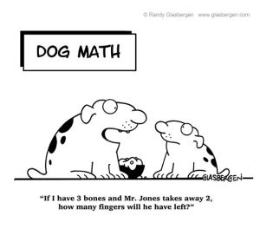

**Please help your child to practise their times tables daily. Don’t forget the division facts!**

**Focus for this half term: X3, X4, X 8**

Your child needs to be fast and accurate with their times tables in order to meet the government requirements and on-line times tables test at the end of Year 4.

**Weekly Sumdog Challenges will also be set based on these. Any evidence of home practise (either on paper or on Sumdog) will be rewarded.** Weekly times tables scores will be recorded in their reading record books and be based on the above times tables.

**Times Tables Challenge**

Your child should challenge themselves to beat their daily score/time. They also compete against someone else in their family!

**Other Maths Skills**

This term we will be focussing on securing our formal methods of: Addition and Subtraction and later on - Multiplication and Division. **A child needing further practise on these or other basic skills may be given additional homework.**