Growth Mindset at St Catherine’s Primary School

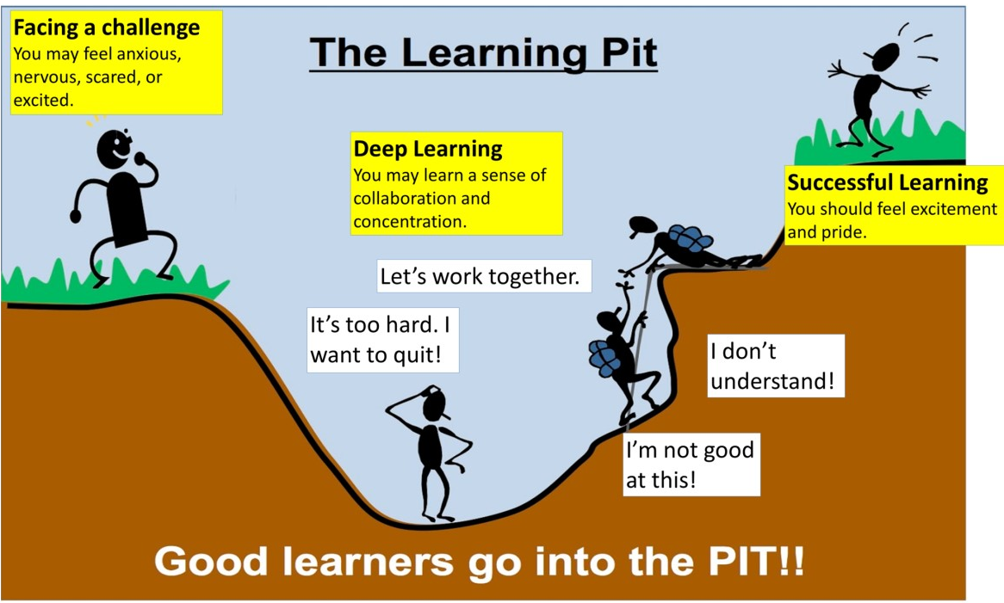

Celebrating Success

Phrases that encourage a Growth Mindset
The power of “not yet”
Say:
“You can’t do it yet”
“ You don’t know it yet”
“But if you learn and practice you will!”
You tried very hard and you used the right strategy !
You did not give up, I bet you feel proud !
when your child gets stuck
- What have you tried already?

- Are there other ways you can do it?
That challenge was hard and really helped your brain grow, well done!
You learnt from your mistakes and can now understand the tricky problems.

- What things have you got that could
help you?

- You have worked so hard, don’t give
Recognise your own Mindset
Be mindful of your own thinking and of the messages you send with your words and actions.
up now.

- You are so close, keep trying

- Remember how good you will feel if
you succeed

- I believe in you

- Remember when we …..

- Let’s move on and come back again

- Mistakes will help you improve
…..from Carol Dweck herself “If parents want to give their children a gift, the best thing they can do is to teach their children to love challenges, be intrigued by mistakes, enjoy effort, and keep on learning.”
- What did you learn with this mistake?

