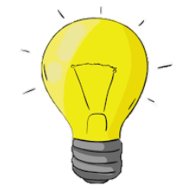
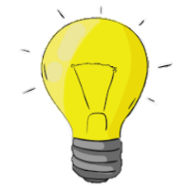
LIGHT
KNOWLEDGE ORGANISER
Y3

Some types of light (e.g. light from the sun) can be dangerous for our eyes and skin. This is because they contain UV rays that can cause damage. There are several things that we can do to protect ourselves in the sun.
Overview |  |  | Transparent, Translucent and Opaque
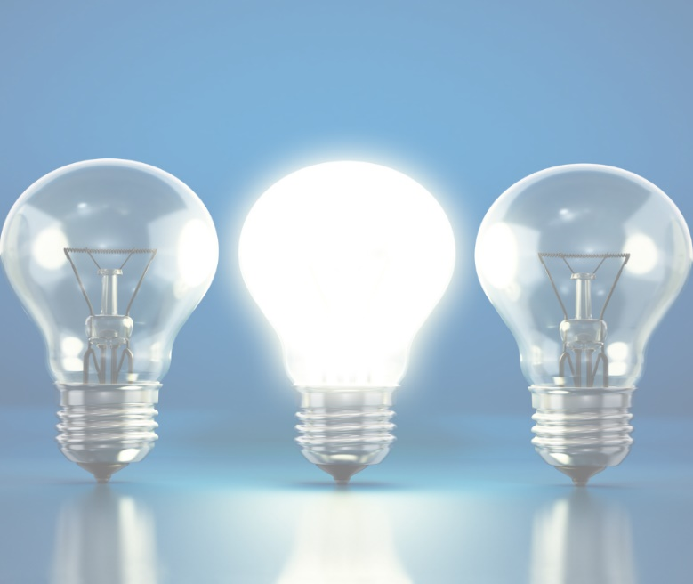  -Light is a form of energy that makes it possible to see.  Light is given off some objects (for example the Sun). Darkness is when there is no light.  -Light can reflect off surfaces (e.g. mirrors)  -Objects can be labelled as transparent, translucent, or opaque, depending on the amount of light that they let through.  -Shadows are formed when light is blocked by an opaque object. |  |  |  | 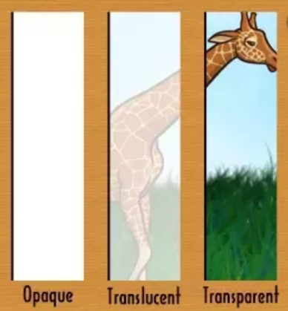 | When light hits an object, it can be absorbed by the object, reflect (bounce off) the object, or (transmit) pass through an object.  The three key terms below tell us how much light objects let through them.  Transparent – Transparent objects allow all of the light to pass through them. This means that we can clearly see through them.  Translucent – Translucent objects only allow some light to pass through them. This means that we can partially see through them.  Opaque – Opaque objects do not allow any light to pass through them. This means cannot see through them at all.
Light – Key Terms
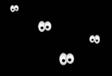  Dark  -Darkness is the absence of light. In other words, where there is no light, it is dark!  -Human vision is unable to see colours when there is high levels of darkness (too little light).  -At nighttime, the sky is darker because there is a lack of light from the sun. | 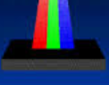  Absorption  -When light hits an object, it may be absorbed into the object.  -This means that it doesn’t bounce off or pass through the object.  -Some examples of materials/objects that absorb light include wood, brick and stone.
 |  |  | Protection from Light
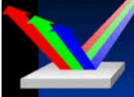  Reflection  -Light may also reflect off the surface of an object.  -This means that light bounces off the object, sending it in another direction.  -Some examples of materials/objects that reflect light include mirrors or polished metal surfaces. | 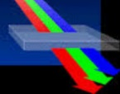  Transmission  -Light can also be transmitted through certain objects.  -This means that it passes through the object. It can be seen from the other side of the object.  -Some examples of materials/objects that transmit light include windows and clean water. |  |  |  | 1. Wearing sunglasses – Sunglasses reduce the amount of light (and also the UV rays) that reaches our eyes.  2. Covering up – Clothes can help to block some of the UV rays that can damage our skin.  3. Sun cream – This stops our skin from absorbing as many UV rays, protecting it from harm.
 |  |  |  | 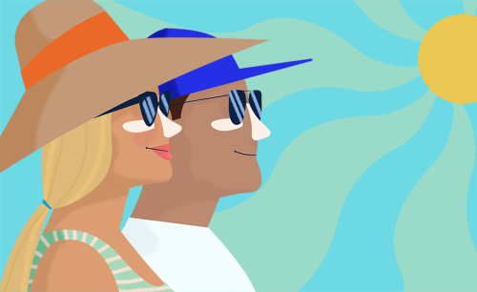

Opaque Objects
Translucent Objects
Transparent Objects
Plastic Milk Carton
Brick
Sofa
Table
Flower Petals
Tracing Paper
Frosted Glass
Air
Water
Windows

