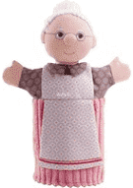

**The Write Stuff in EYFS**

“Grandma fantastic what`s in your basket?”