Humanities Knowledge Organiser – Year 5/6 - Spring – Geography Theme

Marvellous Maps

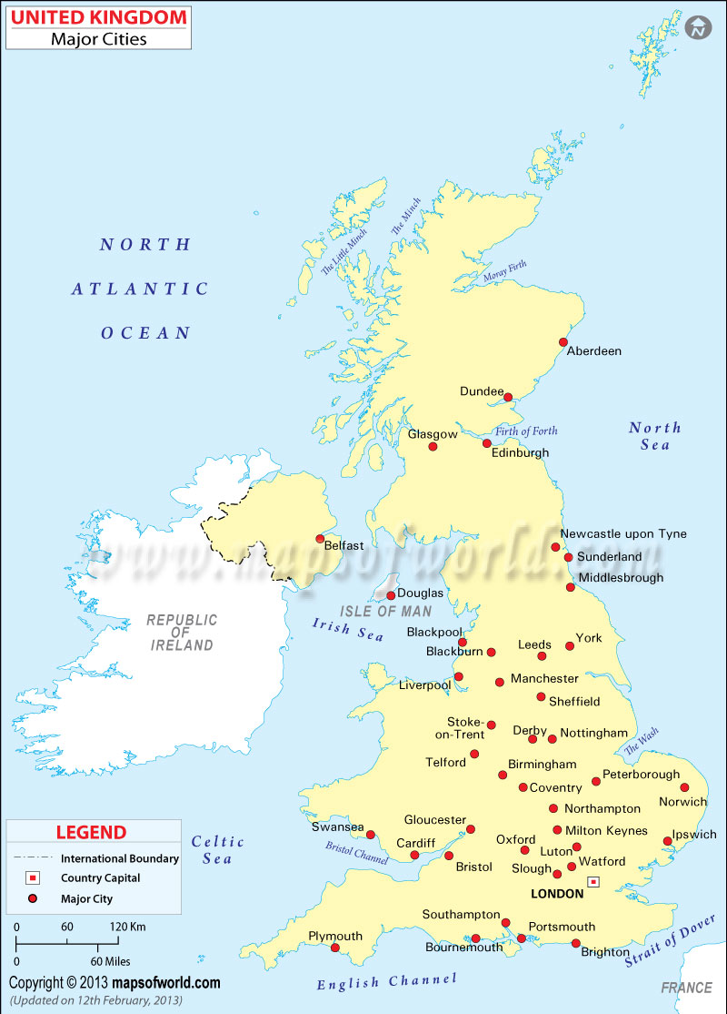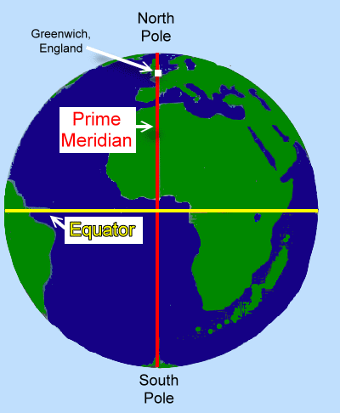

Cities in the UK

Longitude is a system of imaginary north-south lines called meridians. They connect the North Pole to the South Pole. Meridians are used to measure distance in degrees east or west from the prime meridian. ... The prime meridian is also called the Greenwich meridian because it passes through Greenwich, England.

Grenwich and the Meridian