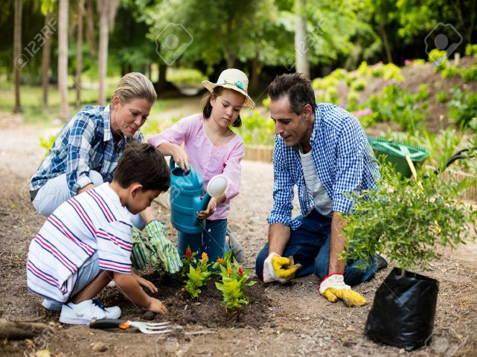
Family Gardening Challenge

So many of you have been enjoying growing things in your garden already.
Who will take on the family gardening challenge this Summer?

The Family Challenge:
Who can grow the tallest sunflower/ greatest length of runner bean/ greatest number of broad beans?

Science
- Investigate the question "Which conditions are best for a plant to grow?".
- Decide whether to grow sunflowers, broad beans, runner beans.... Everyone must choose the same plant to make the test fair.
- Decide how many seeds each person has to grow. I would suggest 6.
- Then decide on the different places you will place the planted seeds in order to test the question.
- Will a seed placed in the fridge grow more quickly than one placed in the dark?

Art
- Make your own pot
- Decorate your pots
- Draw your plants as they grow
- Create a watercolour of your adult plant
- Photograph the different stages of your plants growth
- Can you make a time-lapse video of your plant?

English
- Keep a diary of your challenge.
- Write about the different stages of your plant's growth.
- Describe what it looks like.
- Write a poem about it.

Maths
- Record the growth of your plants in a table.
- Measure them at the same time every week.
- Keep a record of how many beans you harvest - you could weigh them or count them or both.
- When you have finished, use the data in your table to draw a graph. Which kind of graph would be best? A bar chart? A line graph? Why?

Ideas provided by the fantastic Mrs Haylock who many of you will remember!

