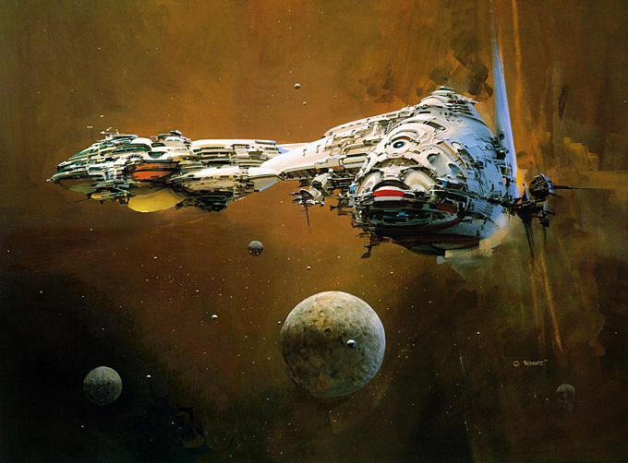

**Welcome to**

**Autumn Term**

**in**

**Year 5!**

**Trips and Wow Days**

**Whole School Celebration – 4th October**

**Class Liturgy – 18th October**

**School Photographs – 25th October**

**Peter and the Wolf play – 25th October**

**Parents Evenings – 6th and 7th November**

**Whole School Celebration – 22nd November**

**Stargazing at School – 29th November**

**Apprentice Fair – 6th December**

**Literacy**

**Writing** - Explanation texts, diary writing, myths, persuasive writing and descriptive writing.

**Grammar** – Relative clauses, modal verbs, adverbs, and revision of previous Year 4 grammar.

**Spellings** will also continue through spelling lessons.

**Reading** – Cosmic by Frank Cottrell Boyce and Time Riders: The Mayan Prophecy by Alex Scarrow.

**Year 5**

**Autumn 2019**

**Maths**

In Maths, they will be looking at place value, addition and subtraction, statistics, perimeter and area, multiplication and division.

There will also be time tables tests four times a week.

**ART/DT**  
In Art, they will be looking at John Conrad Berkey and Claude Monet, as well as looking at drawing and painting skills.

In DT, they will be looking at designing and making their own space ship and Mayan temple.

**Music**In Music, they will be looking at the history of music.

**Humanities**

**History** – They will be studying the Maya Civilisation this term, looking at the way they lived and how they impacted the world around them.

**Geography** – They will be locating cities, using maps and looking at time zones.

**French**

In French, they will be learning number, calendars, weather, getting to know each other and all about themselves.

**RE**

In RE, they will be looking at Creation, Sacraments, Prayers Feasts and saints, Advent, and Christmas.

They will also look at Islam.

**P.S.H.E.**

In PSHE, they will be looking at new beginnings, and getting on and falling out. They will be looking at Anti-Bullying and looking at the British Values of Mutual Respect and Tolerance.

**Science**

In Science, they will be looking at Earth and Space. They will be looking at how the world and solar system works, as well as looking into space itself. They will also be looking at forces and how they help us, such as gravity and friction.

**Computing**In Computing, they will be looking at E-Safety and understanding computer networks including the internet and using search technologies effectively.

**PE**

In PE, they will do outdoor games with Mr Toohill and gymnastics with Miss White.