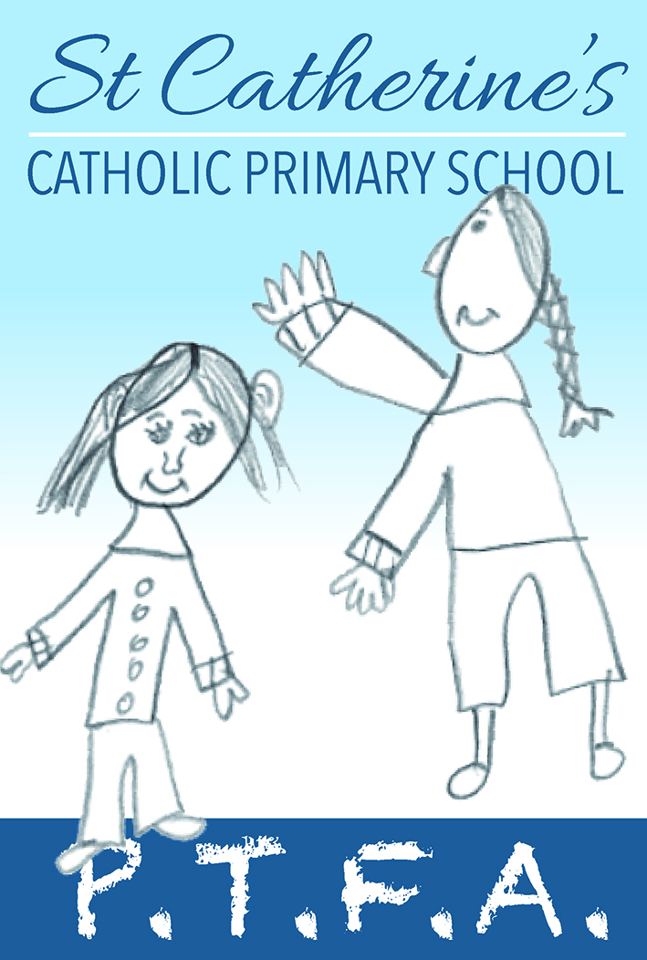

PTFA NEWS UPDATE – FEBRUARY 2020

Welcome to the first PTFA newsletter of 2020. We haven’t had an update for a while so lots of news, events and thank yous to share.

Firstly, some thank yous:

Our autumn disco danced its way to raising £432.50. While the cake sale raised £61.00

Christmas - huge thank you to everyone who helped and visited the Christmas Fair. We had tombolas, Christmas crafting, Santa’s Grotto, the festive café and of course, Jolly Jars. The children had loads of fun and we made £849.42. Plus, the Christmas raffle which sold £142.00 of tickets. Thanks a lot for your support.

The PTA ran the café during the KS1 nativity play and raised £27.00.

100 Club - we’ve got 27 members so far but would really like some more, so please join up for your chance to go into the monthly draw for £25.00. It’s only £1 a month to join.

While we’ve been busy fundraising, we have also been busy buying some new equipment for the children:

We made a contribution of £1,305.53 for new outdoor play equipment for the Reception children to enjoy, which also included a new bench plus a writers’ retreat shed for quiet time and one-to-one work.
Lots of hard work has gone into enhancing the outdoor area to make it a bright and enjoyable place to play. Thank you to Mrs Stephens and her Yr 5 & 6 Art Club for design and making the lovely wall art, it’s great to see our children contributing to this space.

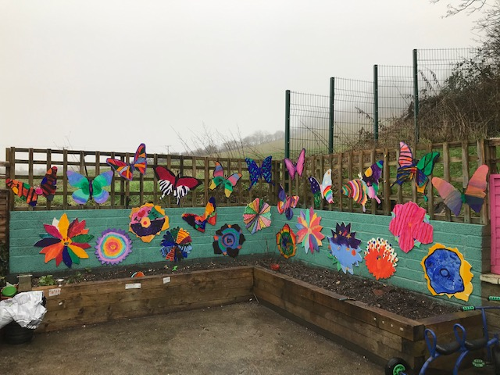

Following the flood, we bought some new brightly coloured alphabet and number rugs for KS1 and some new resources for Year 1.

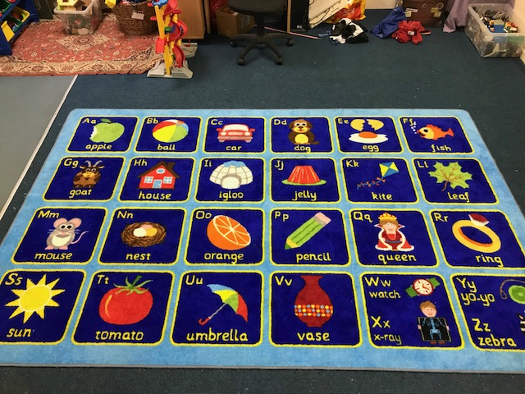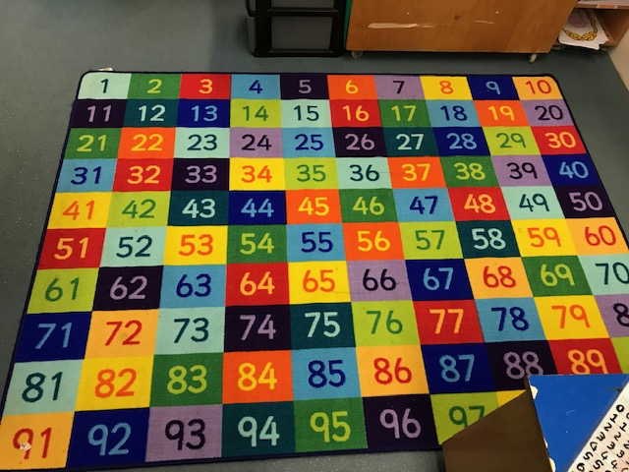

We also paid for the whole school to experience and see Peter & the Wolf play at the Arts Centre in October, which was a lovely end to the half term.

New events

We working on a full calendar of events for 2020 but have a few dates for your diary right now:

We’re holding a School Community Spring Sort Out Day for the top garden to get everything ready for forest school. It’s on Saturday 14 March which should give time for the garden to dry out – we hope! There’ll be tea, coffee and bacon rolls so please come down for some fresh air and to help make a great outdoor space for the children, it will be great to get together and make a difference.

In February we are planting 10 new trees on the field, date to be advised – would welcome any helpers with this once a date has been confirmed.

There will be a Spring disco, date TBC and a Family Easter Bingo night on Friday 27th March, more details to follow.

School Egg Hunt on Friday 3rd April

Annual Book Fair is 4th – 7th May – help us raise lots of money for new books which are so needed with the recent flooding in the Library.

And get the children in training as we’ll be doing our annual Julia’s House Run in the summer on Friday July 3rd. Last year we raised £1,183.20 in total, raising £591.60 for the school and the charity.

Don’t forget… www.easyfundraising.org.uk, search for St Catherine’s, find the retailer you want and start shopping. There are 3,700+ retailers you can shop with including John Lewis, ebay, Argos, M&S and booking.com plus loads more. The retailers make a donation every time you shop. It’s super easy and some schools are able to raise £100s

Thanks again for all your support and if anyone would like to help out at any events or get involved we would love to hear from you.

St Catherine’s PTFA
scptfa@gmail.com

