**Reception**

**Autumn Term**

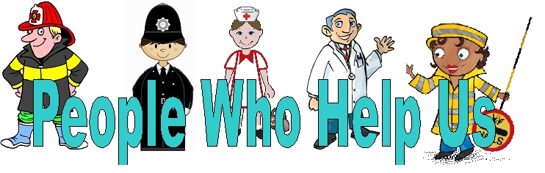

Our topic this term will be People Who Help Us and Winter after half term. We will talking about our families and when we were little. We will be looking at how our own families help us and then moving onto people in the community who help us e.g.- Police and Coastguard. We will then be moving onto winter where we learn about nocturnal animals and the Christmas Story.

**Dates to note:**

Thursday 17th October 8:40am – **Reception Parents Phonics Breakfast briefing (**If there is demand for it, we can find a time for a 5pm session as well).

Friday 25th October - School photos

Friday 25th October – Visit to the Arts Centre

Monday 4th and Tuesday 5th November - **INSET Days**

Wednesday 6th November and Thursday 7th November - **Parent’s Evening**

Wednesday 4th December 8:40am - **Class Liturgy**

**Welly Walk’s and Visits**

* Creation Welly Walk – Looking for beauty in the environment (in school grounds)
* Number Hunt Welly Walk – Searching for numbers in the local area
* Coastguard Visit to school
* Fire safety Visit to school
* Police Visit to school
* Friday 25th October Peter and the Wolf at the Arts Centre

Reading

* Home/school books
* Listening for enjoyment
* Reading key words
* Recognising letters
* Linking sounds to letters

**PSED**

* Routines and rules
* Recognising each other’s names
* Turn taking and sharing
* Social and Emotional Aspects of Learning
* Show and Tell after half term

**Reception**

**Autumn 2019**

**Maths**

* Counting and ordering
* Sorting and matching
* Tallest and shortest
* Recognising and forming numbers
* Shapes

**Physical Development**

* Different ways of moving
* Arms, hands and finger development
* Cutting
* Drawing
* Holding a pencil effectively

Writing

* Opportunities to mark make
* Write own name
* Begin to form letters
* Whole class story telling

**Communication and Language**

* Listening
* Role play
* Understanding and sequencing a story in play
* Sharing ideas

**Understanding of the World**

* Visit local area
* Ipads- introduction
* Physical Process
* History of own life

**RE**

* Creation
* Prayers, saints
* Advent
* Christmas

**Expressive Arts and Design**

* Music
* Dance
* Art
* Drama