Learning Intention: As a Geographer I can explain the importance and significance of volcanoes and earthquakes.

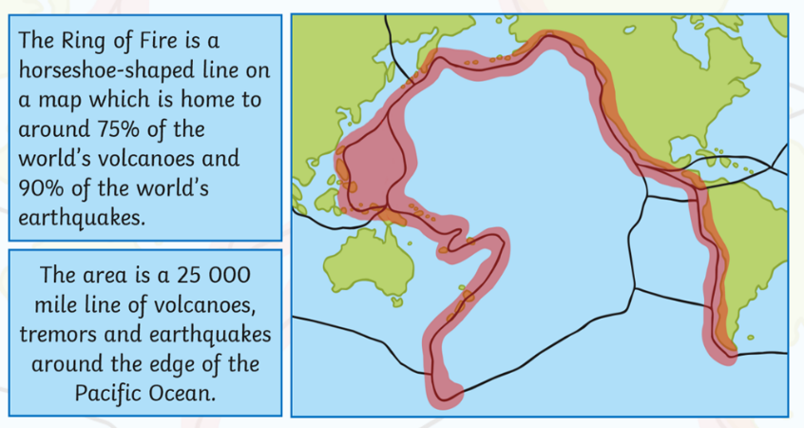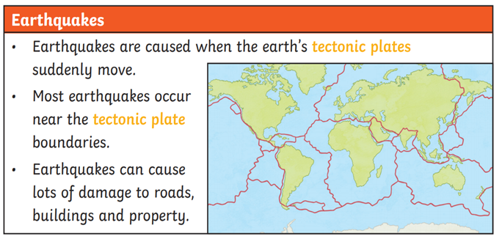

**Vocabulary to use …**

Earthquake

Volcano

Tectonic plate

Erupt

Magma

Erupt

Cumulonimbus cloud

Ring of fire

Active

Dormant

Extinct

Richter scale

Magnitude

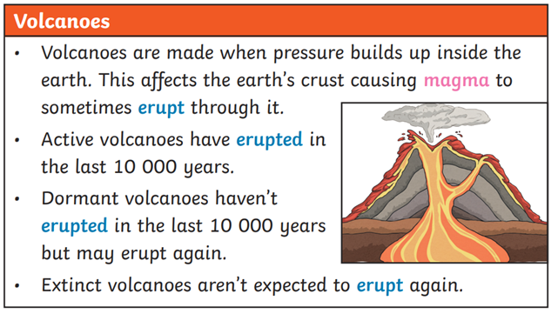

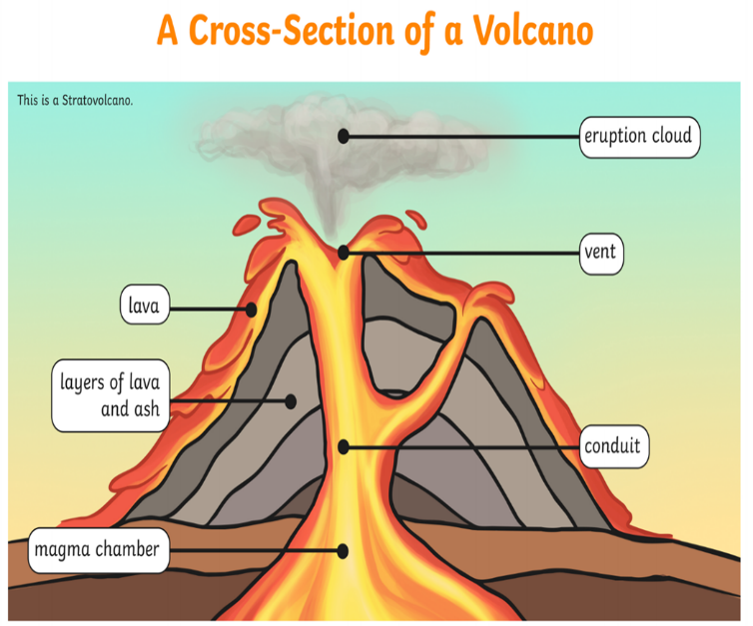

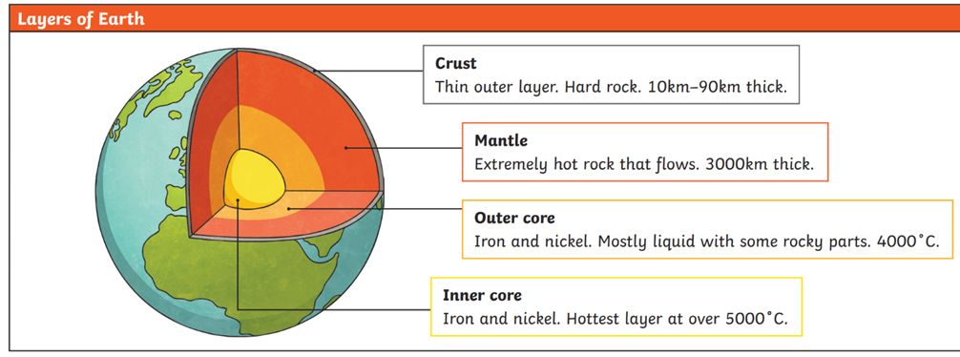

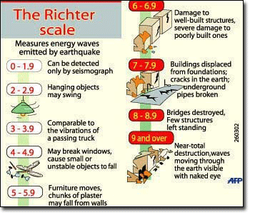

Things learnt along the way …

**Enquiry Questions …**

*Why do volcanoes erupt?*

*Where in the world are volcanoes?*

*Why do only some countries have earthquakes?*

*What is an earthquake?*

*How do you know what type a volcano is?*

*When do volcanos cease to exist?  
What causes an earthquake?*

What would I like to find out more about?