Friday 3rd April 2020
Hello Year 3
Dear me, I've been having an issue trying to record and upload video, so I've resorted to writing, which I like doing, so I mustn't end up making this too long!
First of all, I want to say a great big thank you to ELLIE REEVE who brightened my day with her smiley face and a lovely email about what she (and her dog Buster) have been getting up to. Thank you ELLIE.
Next, I want to say I hope you are all getting on well and finding fun things to do to keep you busy. Have you been learning anything new? With Easter coming up, I taught myself to make origami bunnies. It took me a while and I hade a few failed attempts - I just couldn't get its backside right! But I kept trying and I've got it now, and now I've got lots and lots of bunnies (well you know what they say) to give as gifts at Easter.
If you've learnt a new skill or had a go at something, be sure to let me know, and if you like I can post a picture up here for all our class to see. A virtual 'show and tell'!
So, as of Monday, it will be the first day of the School Easter holidays. I know that probably seems a bit weird after 2 weeks at home anyway, but the holidays it is, and so we won't be setting any special work for you to do at home. OF COURSE keep up with your reading and times table practice, but other than that, have fun, be helpful and enjoy the sun (it looks like it's going to get nice and warm).
There has been so much put out on the internet recently to help keep you busy at home, it's really hard to pick... but I know that some of you would just love what's going on at The Book Trust. Go to www.booktrust.org.uk and you'll find loads of COMPETITIONS to win books, sets of books and original drawings. Cressida Cowell, who is the Waterstone's Children's Laureate (most very amazing book person) and author and illustrator of the How To Train Your Dragon series, has a competition to create your own species of dragon. She'll pick the winning dragon and send you a signed original drawing of Toothless and Stormfly. I want to enter, but I think I may be a little bit to old. ☹ Also on www.thebooktrust.org.uk you'll find loads of stories to listen to and drawing lessons and quizzes about your favourite books.
So, yes, a rather long message as I suspected. So, much to say to you and not enough room!
A little bird told me that we have another birthday today, so from wherever you are reading this, can you shout a big Happy Birthday to Elspeth. xx
Have a lovely Easter everyone.
Miss T xx
P.S. I had a lovely chat with Mrs Lewendon this week and she has been really busy planning loads of great new topics for us when we get back to school . She sends her love and hopes you're having fun and singing lots. Singing keeps us smiling
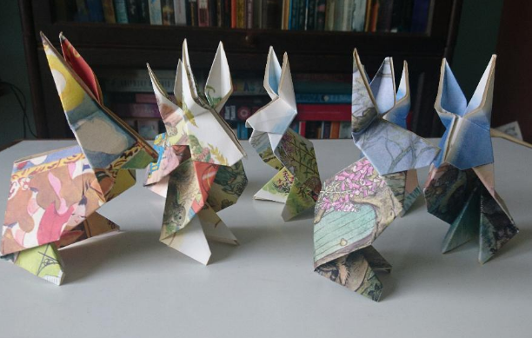
Bunnies galore!

