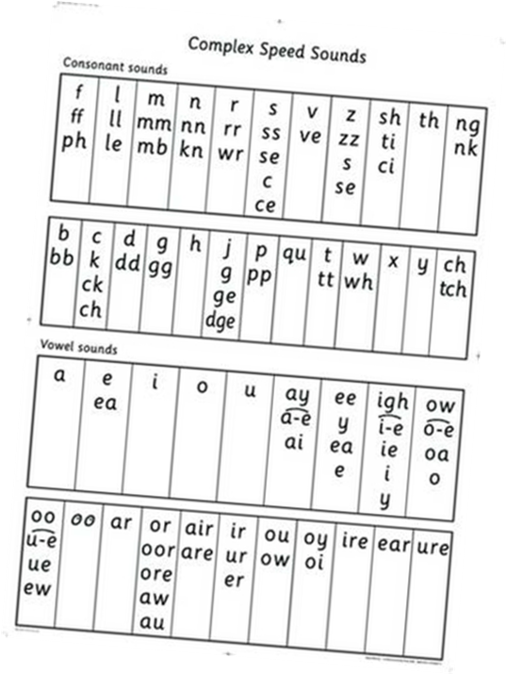
- Speed sounds – the sounds that make up words

- Special Friends – 2/3 letters that make one sound (ay, igh, a-e)
- Fred Talk- sounding out the sounds within a word
- Fred in your head – sounding out silently, saying the blended word aloud
- Green words – words that can be sounded out
- Red words – tricky / High frequency words (cannot sound out)
- Fred Fingers – sounding out a word before recording

- Every Thursday a book sent home based on the class based text.
- Questions for comprehension

